Content Rebranding Example
SkillsCommons contains content authored in a variety of formats. One format that has many advantages is SoftChalk (www.softchalk.com). Content authored and delivered through this product includes school branding in a header and author attribution in a footer.
This document shows the steps needed to quickly and easily convert content from one brand to another. This is one illustration of what can be done under the Creative Commons license. For example, here is an image of content from the Kenai Peninsula College and then rebranded to SkillsCommons.

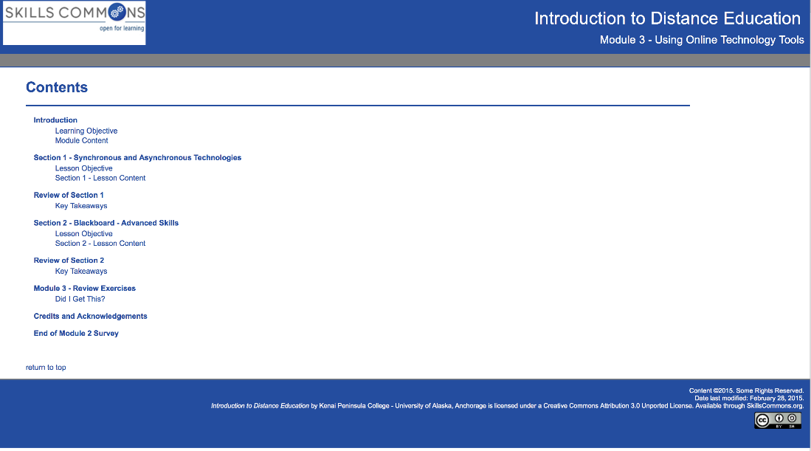
Visit the Skills Commons website (www.skillscommons.org).

Browse by subject or search for “Online Technology”

Click on “Introduction to Distance Education Module 3” for a closer look at the metadata for this submission.
Click on the link to the submission (a zip file) to download to your local machine.

The submission file was created with SoftChalk, a tool for authoring content and delivering it via website or learning management system. If you have SoftChalk, simple launch it; if not, SoftChalk is available (www.softchalk.com) for a 30-Day trial.
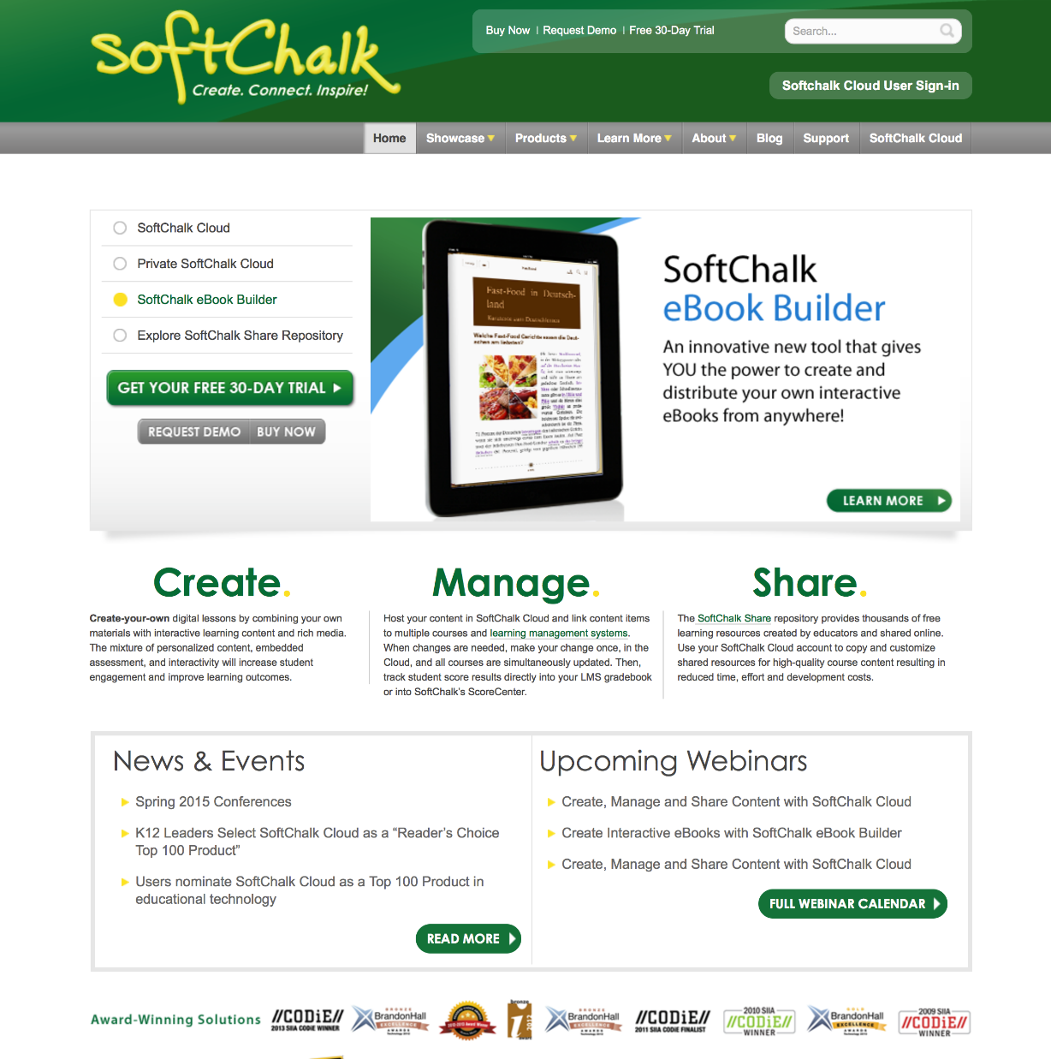

File-Open the downloaded file in the SoftChalk editor. Note that the editor is not what-you-see-is-what-you-get (WYSIWYG). To view the content as it will appear to the student, File-Save and then Preview.

Preview shows a navigable website with the Kenai Peninsula College logo and a Creative Commons license in the footer.

To rebrand the content, back in the editor, select Tools – Style Builder.

Modify the generic style with a revised banner include a logo image for SkillsCommons and a change to the banner and nav bar colors.
Continue applying appropriate colors and then Save the style. Next use the Properties – Style Properties menu and select the newly created SkillsCommons personal style.
On the Titles & Layout tab, update the license to include SkillsCommons.
Save and Preview again and view the website with the new SkillsCommons branding.
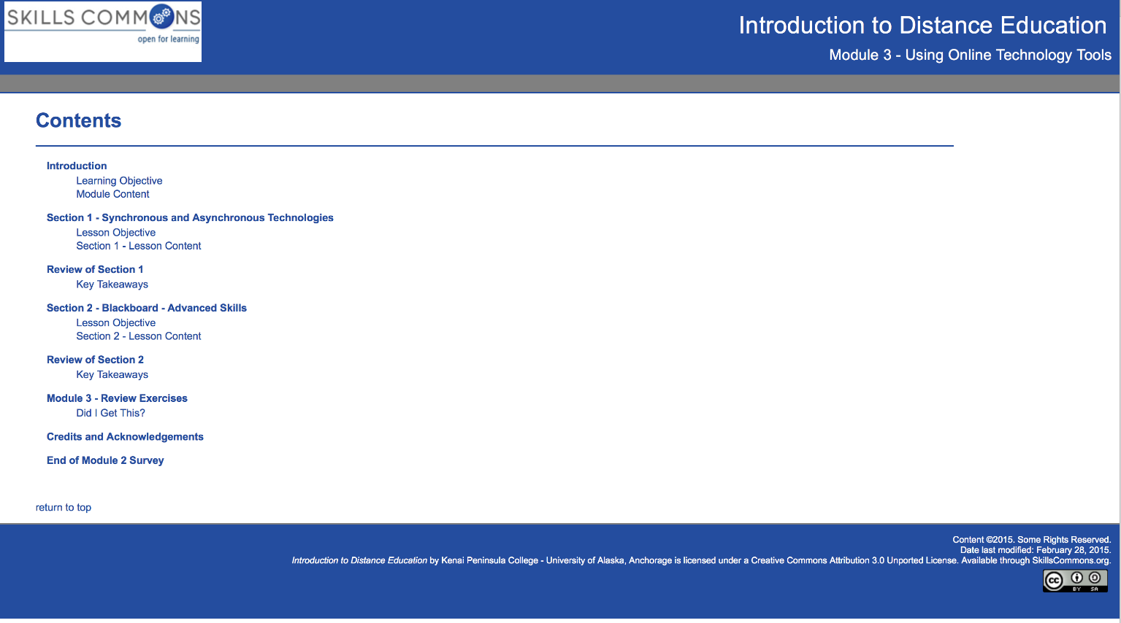
This document showed how in a manner of minutes one can convert content from one submission to the branding of another.

This work is licensed under a Creative Commons Attribution 4.0 International License.
This workforce solution was created through a cooperative agreement between the U.S. Department of Labor's Employment and Training Administration and the California State University-Multimedia Educational Resource for Learning and Online Teaching (MERLOT).

