SkillsCommons Content Exported From Jenzabar® in IMS Common Cartridge Format
Skills Commons (www.skillscommons.org) contains a variety of materials, including exports of courses developed in the Jenzabar (www.jenzabar.com) Learning Management System (LMS). If these exports are in the IMS Common Cartridge format, an importing LMS may report some issues.
Skills Commons is providing the following guidance to submitters so they can improve the quality these Common Cartridge packages.
One option is to import the cartridge and see if your LMS reports any errors. If there are no errors, you may want to assume the cartridge is fine. In any case, you will want to carefully review the result of an import from any source. Note that importing a cartridge, even if it is imperfect won’ damage your LMS. If there are errors or if you want to check the cartridge before you import it, there is a validator that is freely available to anyone.
The IMS Global Learning (www.imsglobal.org) is the standards body that developed and supports the Common Cartridge format. Since the purpose of the Common Cartridge is to allow content that is developed in one LMS to be imported into another, the community benefits from a way to validate cartridges. IMS provides a tool to do this (validator.imsglobal.org). The validator:
- Is a tool for cartridge developers, typically publishers or LMS vendors, to confirm their files are correct.
- Is a tool for customers to have confidence that they are about to import something that is properly formatted.
- The validator provides a way to assign responsibility, initially, for resolving issues. If the cartridge is valid, the onus is on the importing product to do the right things; if the cartridge is invalid, the onus is on the creating product to fix the issues.

To run the validator, visit the website http://validator.imsglobal.org/cc, and choose a file you downloaded from Skills Commons. Note the file likely has the extension “.imscc” is a v1.1 format. It is possible that the file if for another version, but start with the default if the extension is “.imscc”.

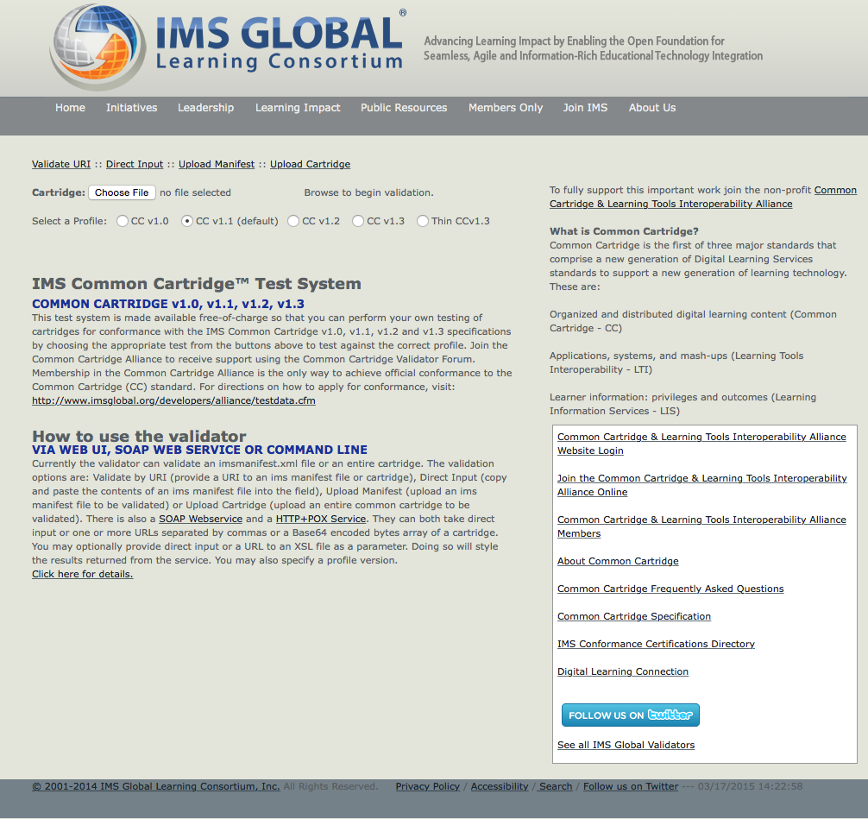
Once you choose the file, it is uploaded and processed. Then the validator produces a report something like this. If there are only green check marks, the cartridge is valid, if there are red x marks, there are some problems.
This is an example of a fully valid cartridge:

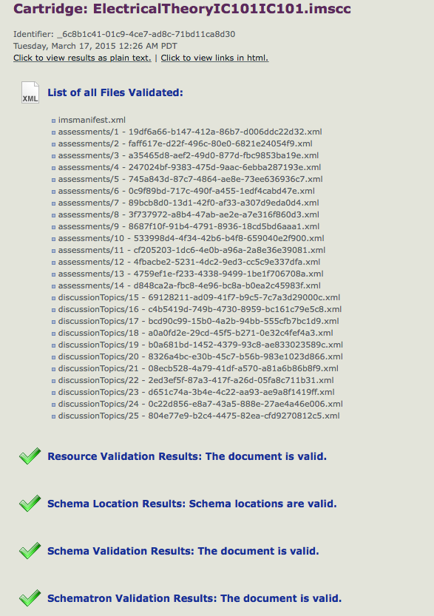
This is an example of a cartridge that contains errors:
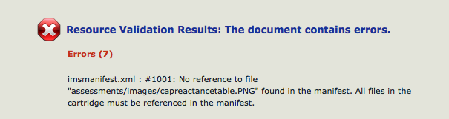
In the case of an export from Jenzabar or elsewhere, should you encounter an error, you can bring this to the attention of the LMS vendor. If you want to attempt to repair the cartridge on your own, here are the steps. If you get stuck, feel free to contact Skills Commons in case we can help.
First, unzip the cartridge; an imscc file is just a zip.
Second, the error message above may be referring to image files associated with assessment items. The image files themselves were not referenced in the imsmanifest.xml and must be listed there. The references to the image files in the assessment items used the pattern $IMS-CC-FILEBASE$../assessments/images. The two periods should be omitted.
So, change this:
$IMS-CC-FILEBASE$../assessments/images
to this:
$IMS-CC-FILEBASE$/assessments/images
Third, if you encounter an error like this:

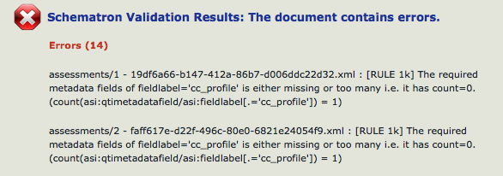
The assessment XML files are missing a qtimetadata field element near the top of each file.
So, for example, change this:
<assessment ident="Series/Parallel Circuit Lab" title="Series/Parallel Circuit Lab">
<qtimetadata>
<qtimetadatafield>
<fieldlabel>cc_maxattempts</fieldlabel>
<fieldentry>1</fieldentry>
</qtimetadatafield>
</qtimetadata>

to this:
<assessment ident="Series/Parallel Circuit Lab" title="Series/Parallel Circuit Lab">
<qtimetadata>
<qtimetadatafield>
<fieldlabel>cc_profile</fieldlabel>
<fieldentry>cc.exam.v0p1</fieldentry>
</qtimetadatafield>
<qtimetadatafield>
<fieldlabel>cc_maxattempts</fieldlabel>
<fieldentry>1</fieldentry>
</qtimetadatafield>
</qtimetadata>
Fourth, re-zip the package back to something with the extension .imscc.
Fifth, re-run the validator.

This document has covered how to run the IMS Common Cartridge validator in general and how to repair some known issues with files created by Jenzabar in particular. Since the specifications and products involved may change over time, consult with your LMS vendors, IMS, and Skills Commons as appropriate.

This work is licensed under a Creative Commons Attribution 4.0 International License.
This workforce solution was created through a cooperative agreement between the U.S. Department of Labor's Employment and Training Administration and the California State University-Multimedia Educational Resource for Learning and Online Teaching (MERLOT).

