Desire2Learn Content for Skills Commons

Export content from Desire2Learn

Use the following procedure to export D2L course material as a ZIP file suitable for import into Skills Commons. Note that this workflow can look and operate slightly differently depending on your version of D2L.

- Navigate to the course whose material you want to export.
- From the Admin Tools, select Import/Export/Copy Components.

- On the Import/Export/Copy Components page, select Export.

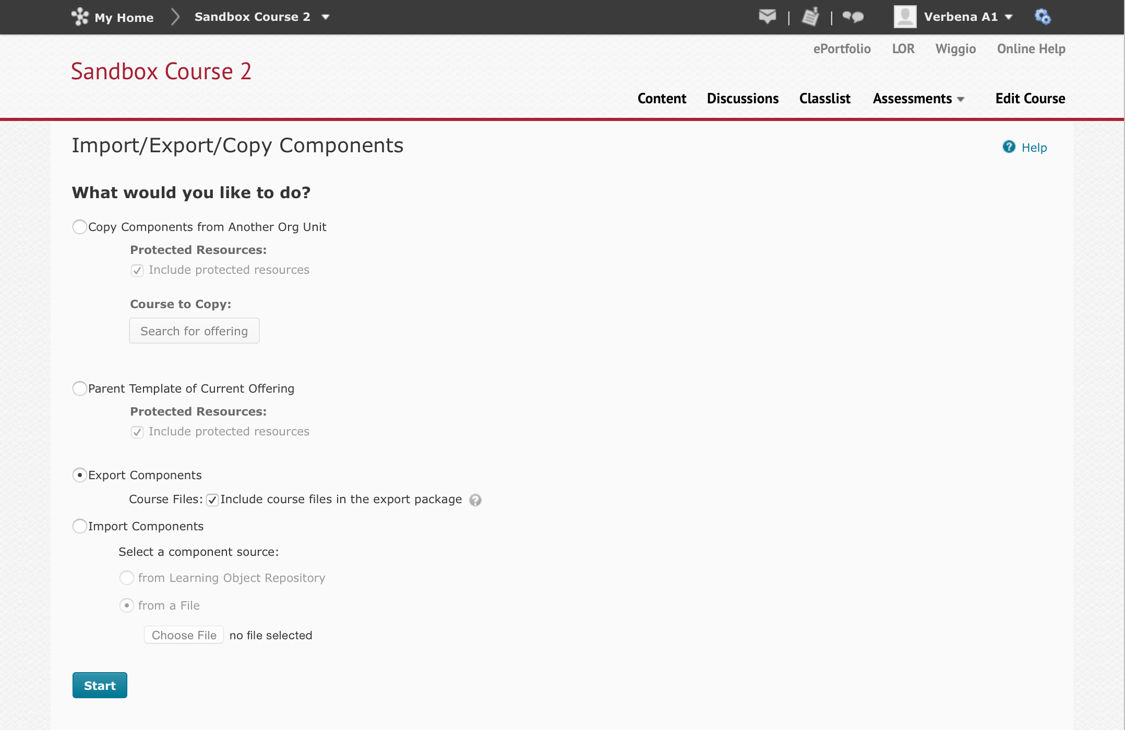

- Select which content to import.

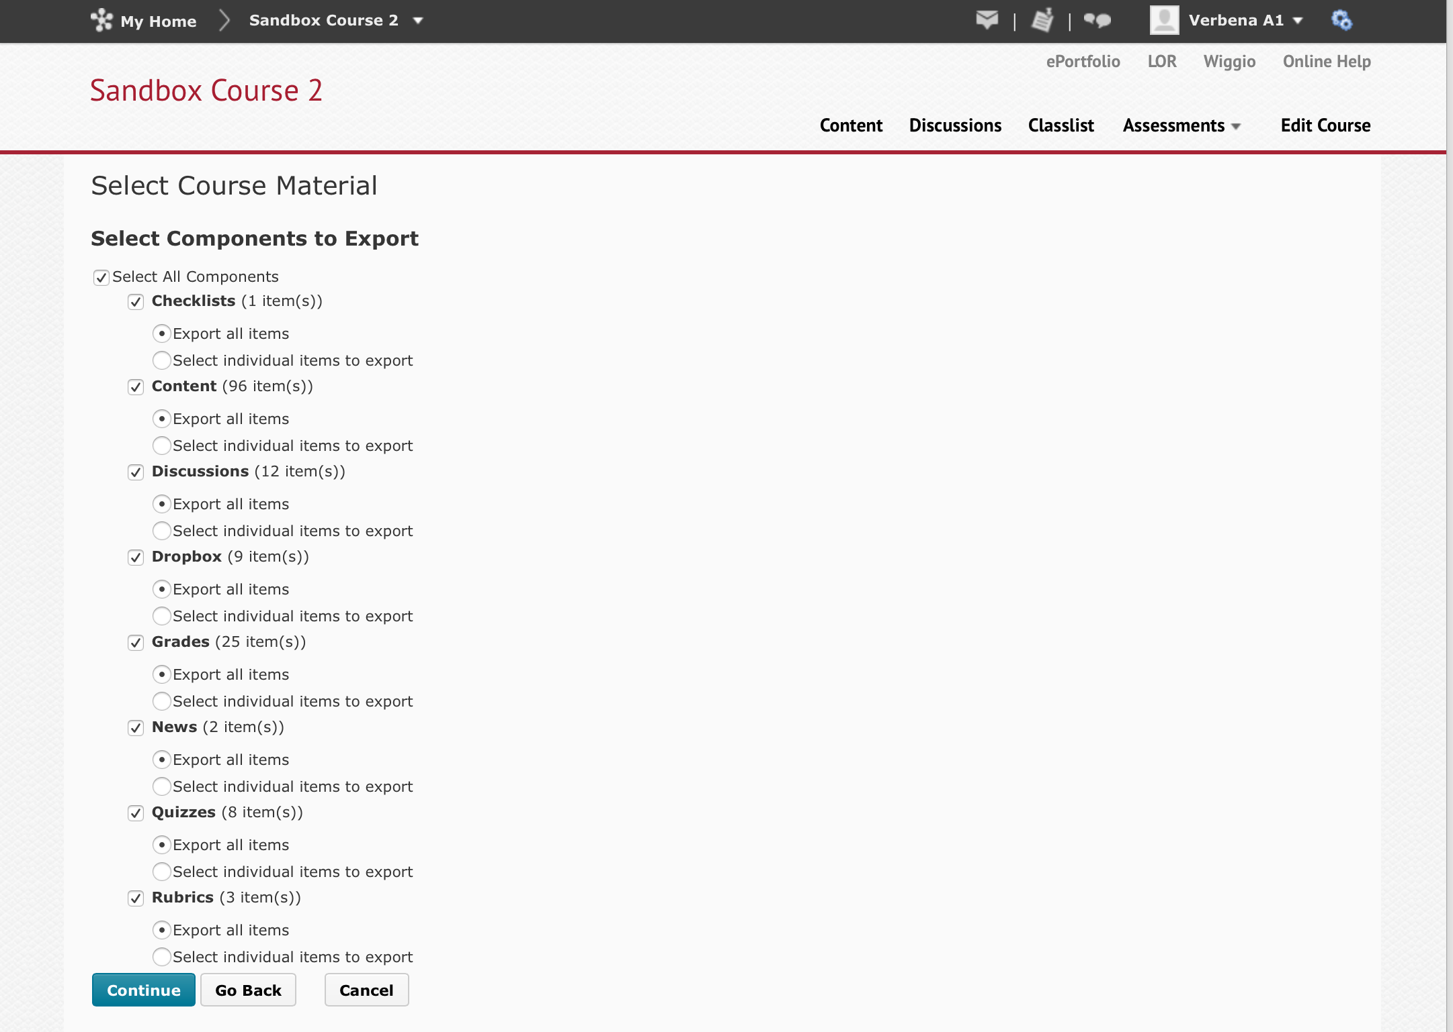

- Confirm your selections.

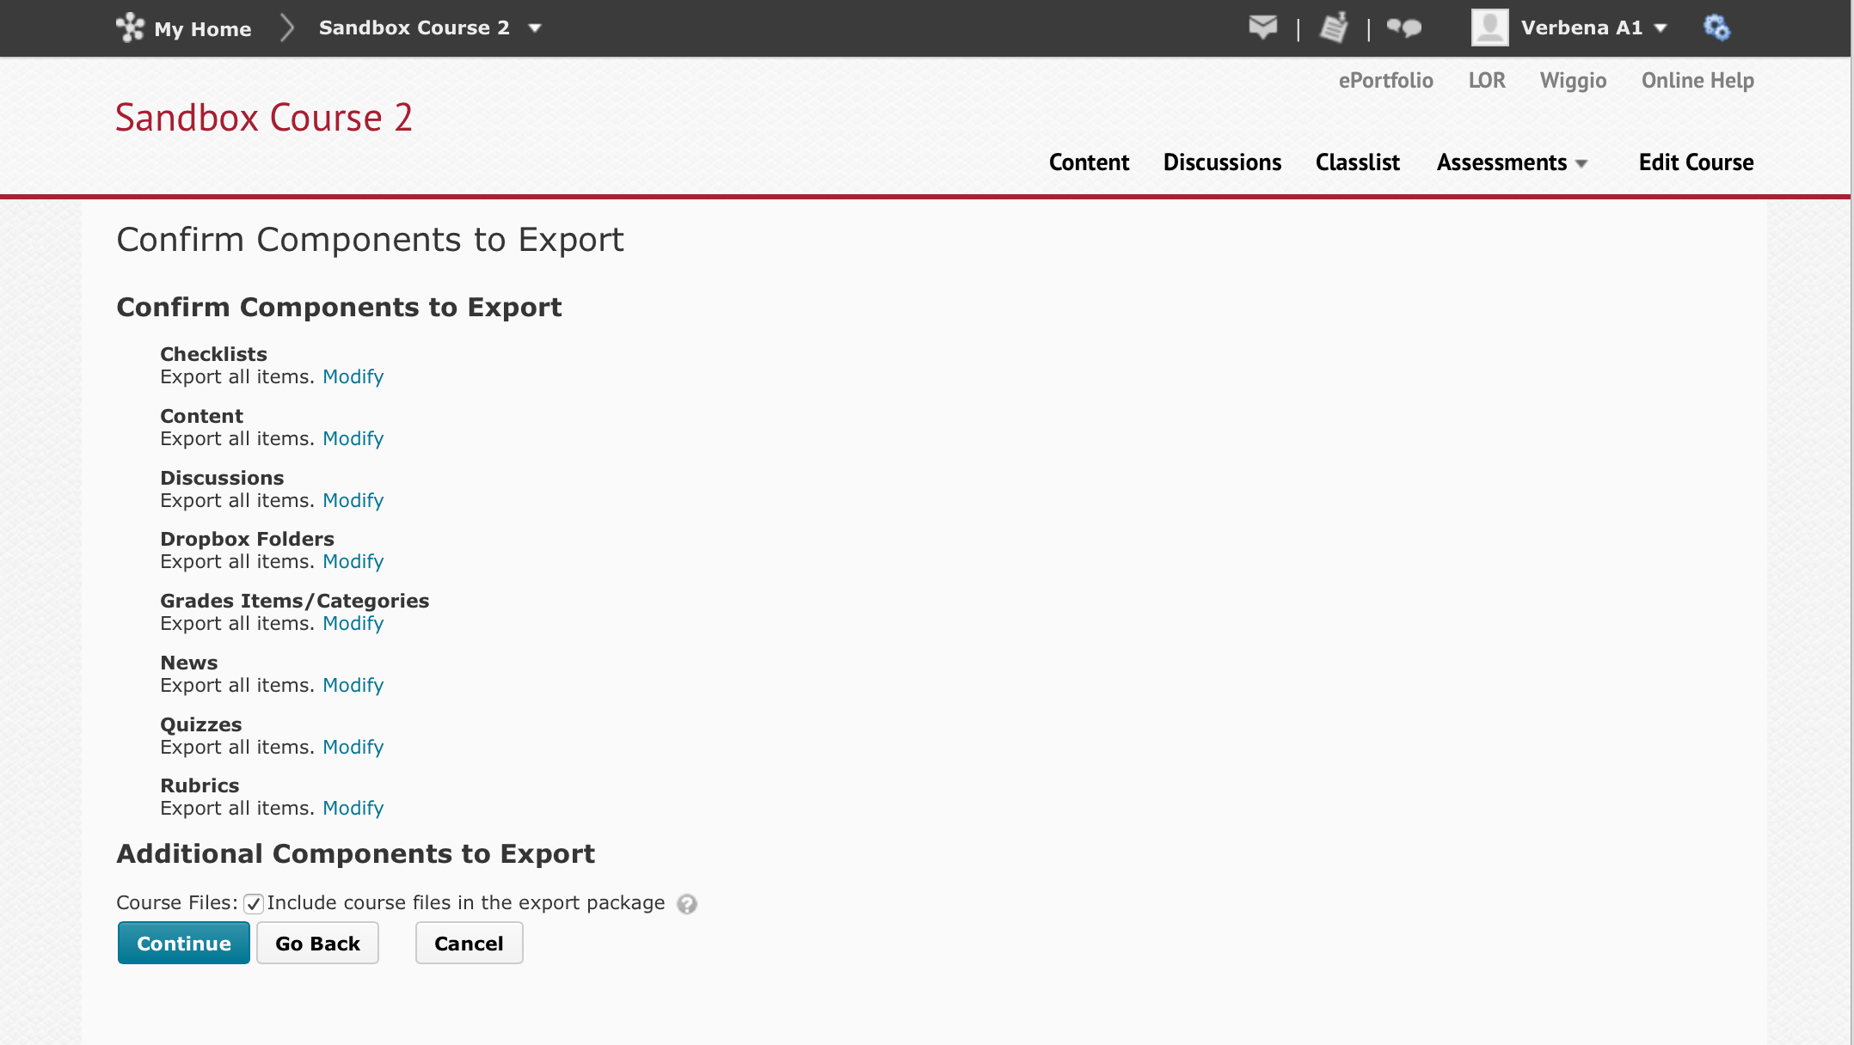

- D2L will finish the process.

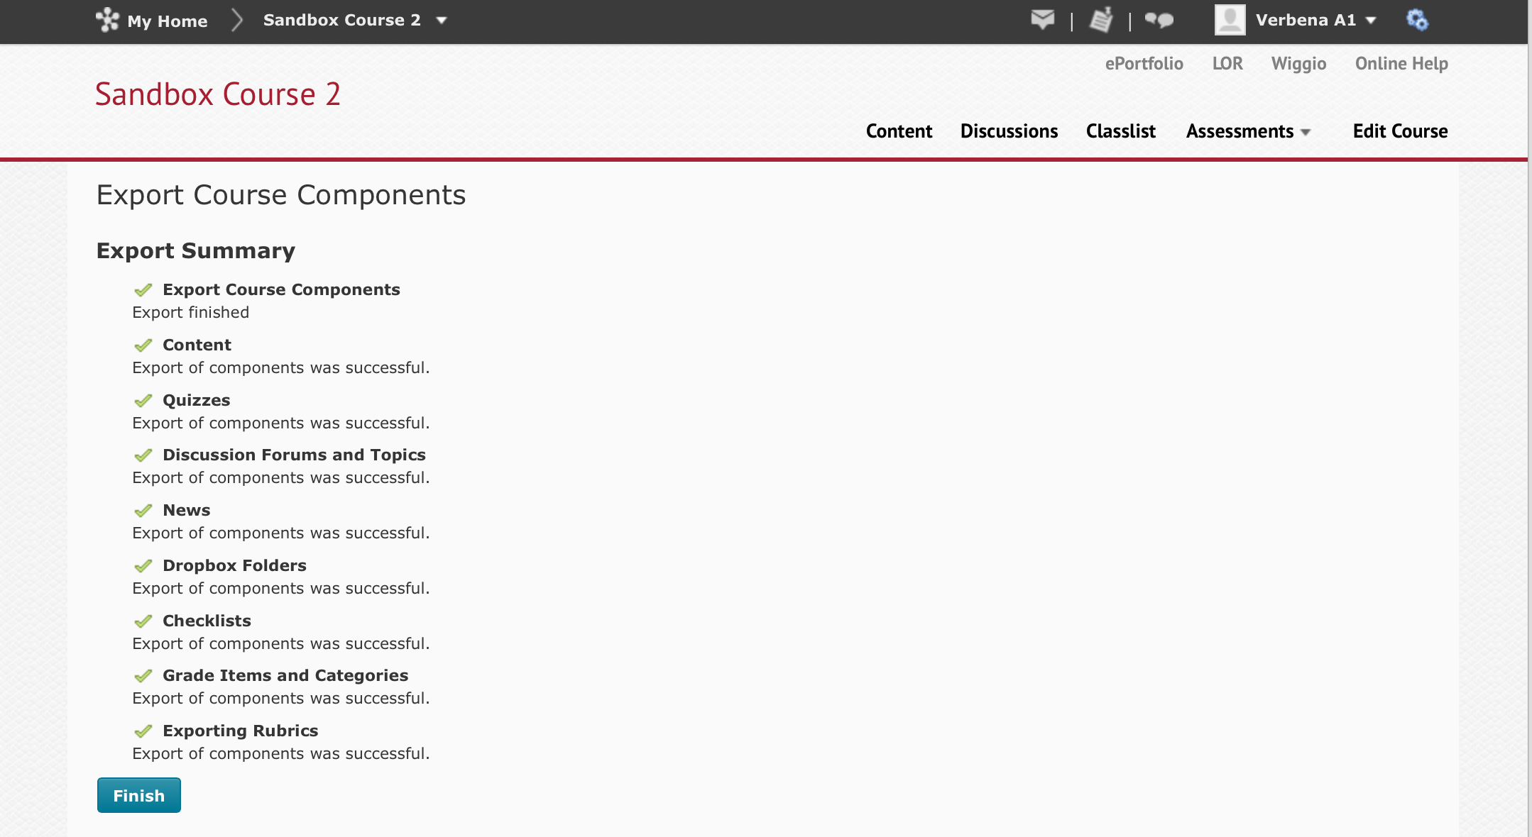

- The final step allows you to click on a link to download the file, which you can then upload to Skills Commons.

Import a Desire2Learn export into another instance of Desire2Learn

If the Skills Commons material is a D2L export, you can import it into your D2L instance with the expectation of a very high degree of fidelity between the original and what will result in your instance.

- Download the zip package from Skills Commons.
- Navigate to the course where you want to import the content.

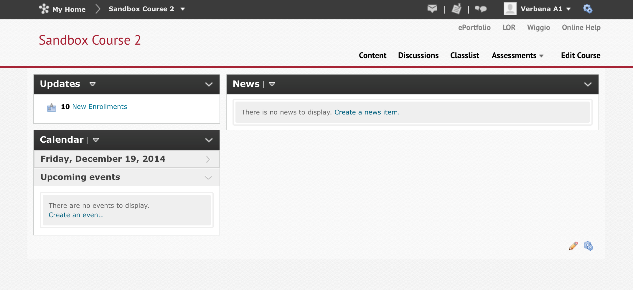

- From the Admin Tools, select Import/Export/Copy Components.

- On the Import/Export/Copy Components page, select Import, from a File, and click on the Choose File button to select the file you downloaded from Skills Commons.

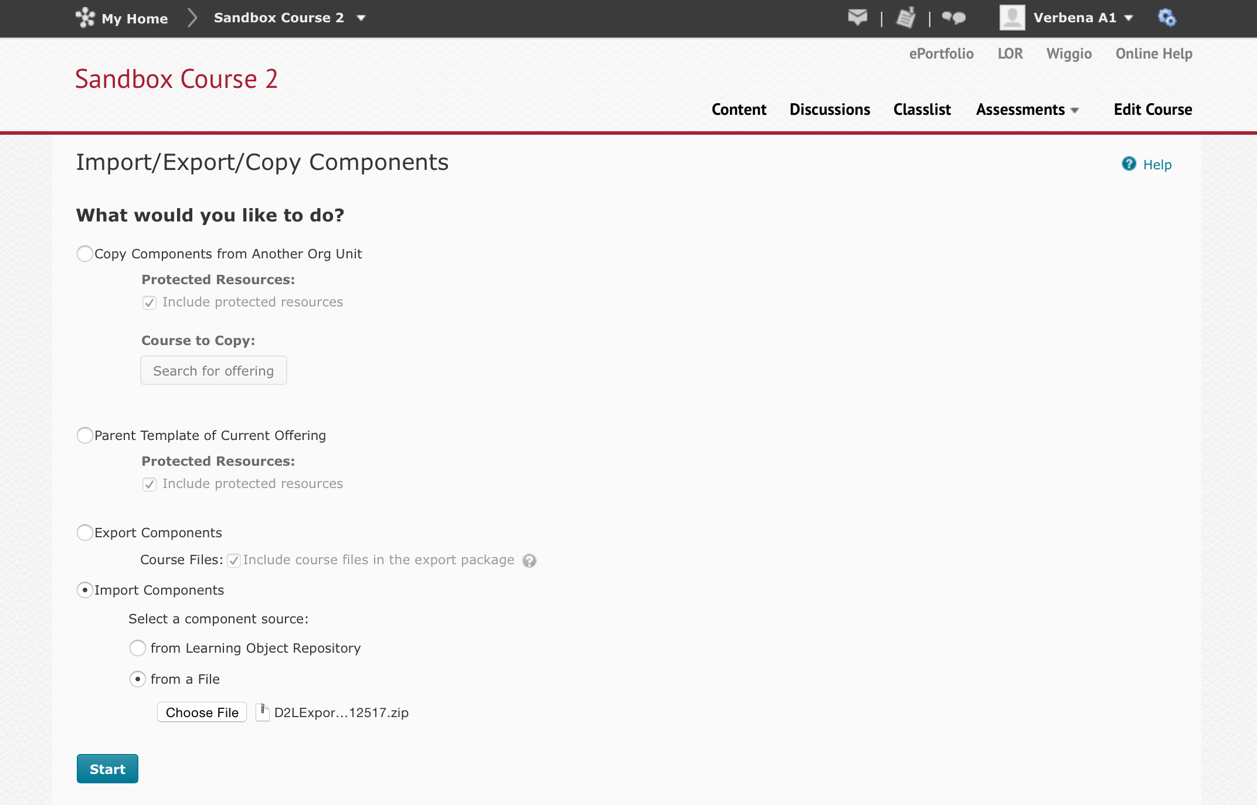

- D2L will read the file and present a preprocessing page. Simply click on Continue.

- Select which content to import.

- Confirm your selections.

- D2L will process the material and report the result.

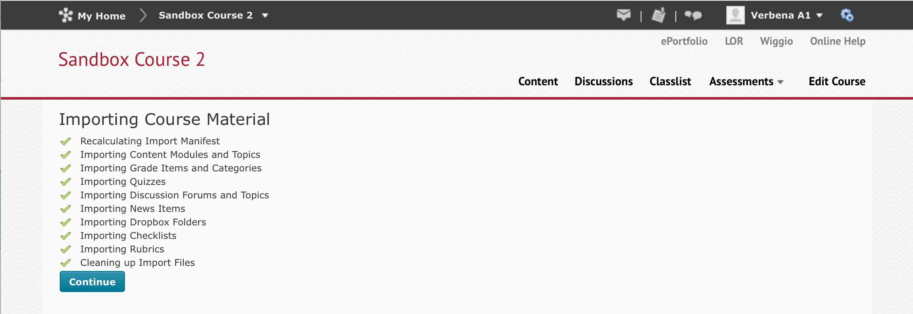

- D2L offers the option to import another file or view the content.

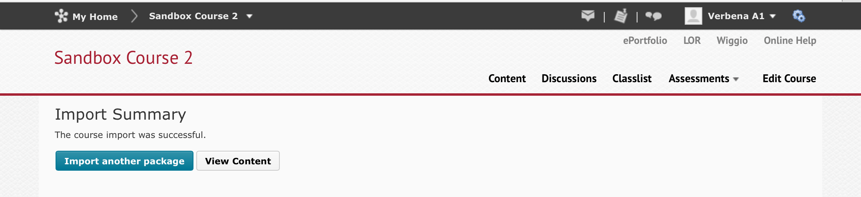

- The content will be imported into the course. This completes the process.

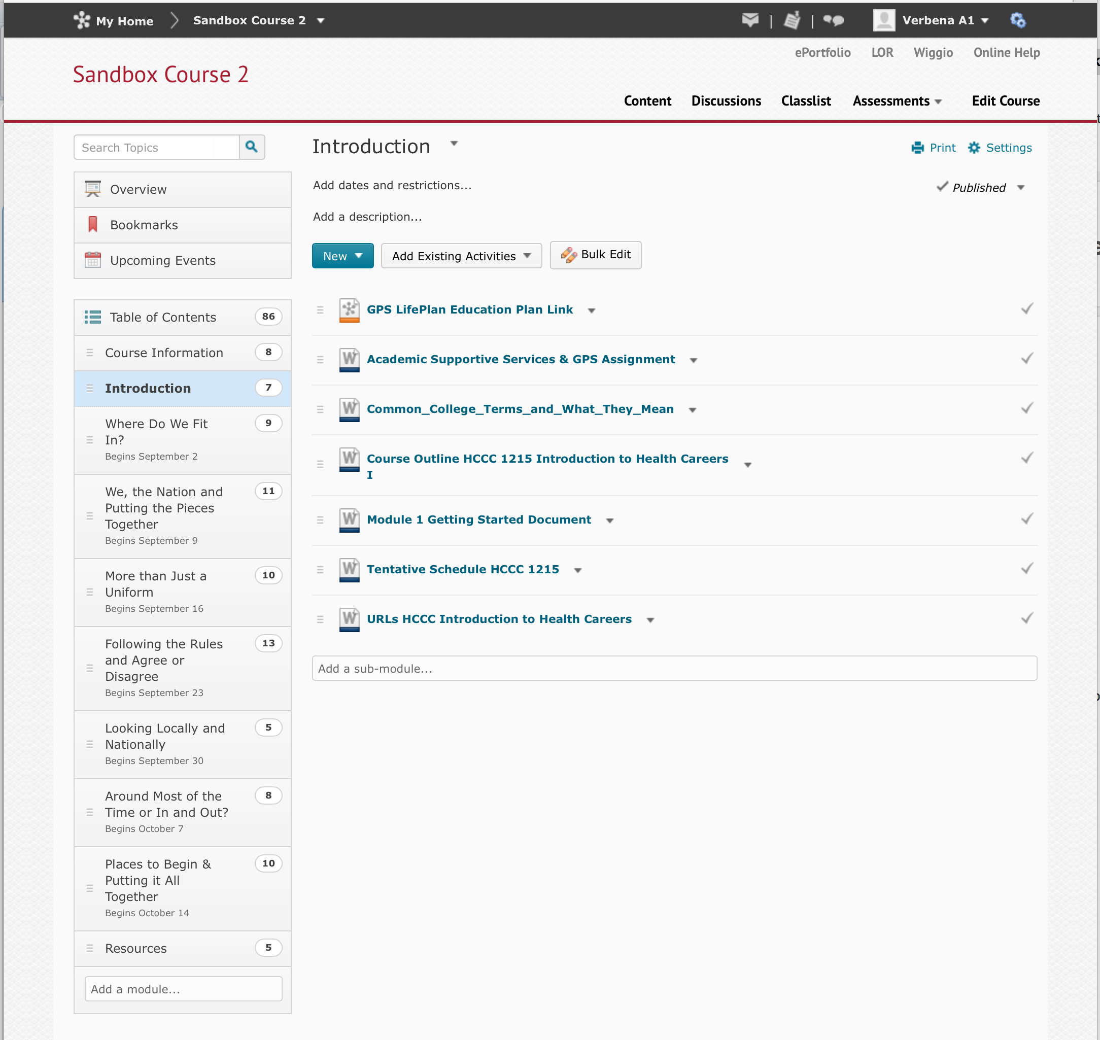

Import a Desire2Learn export into Canvas

D2L does not provide for exporting content in an interoperable format such as the IMS Common Cartridge. Some LMS platforms such as Canvas by Instructure support D2L import. Here is a link to detailed instructions:

http://guides.instructure.com/m/4152/l/82273-how-do-i-import-content-from-desire-2-learn-d2l-into-canvas

The process is to navigate to a new or existing course; select Settings from the navigation menu; select Import Content into this Course; select D2L export.zip format; and follow the prompts to completion.

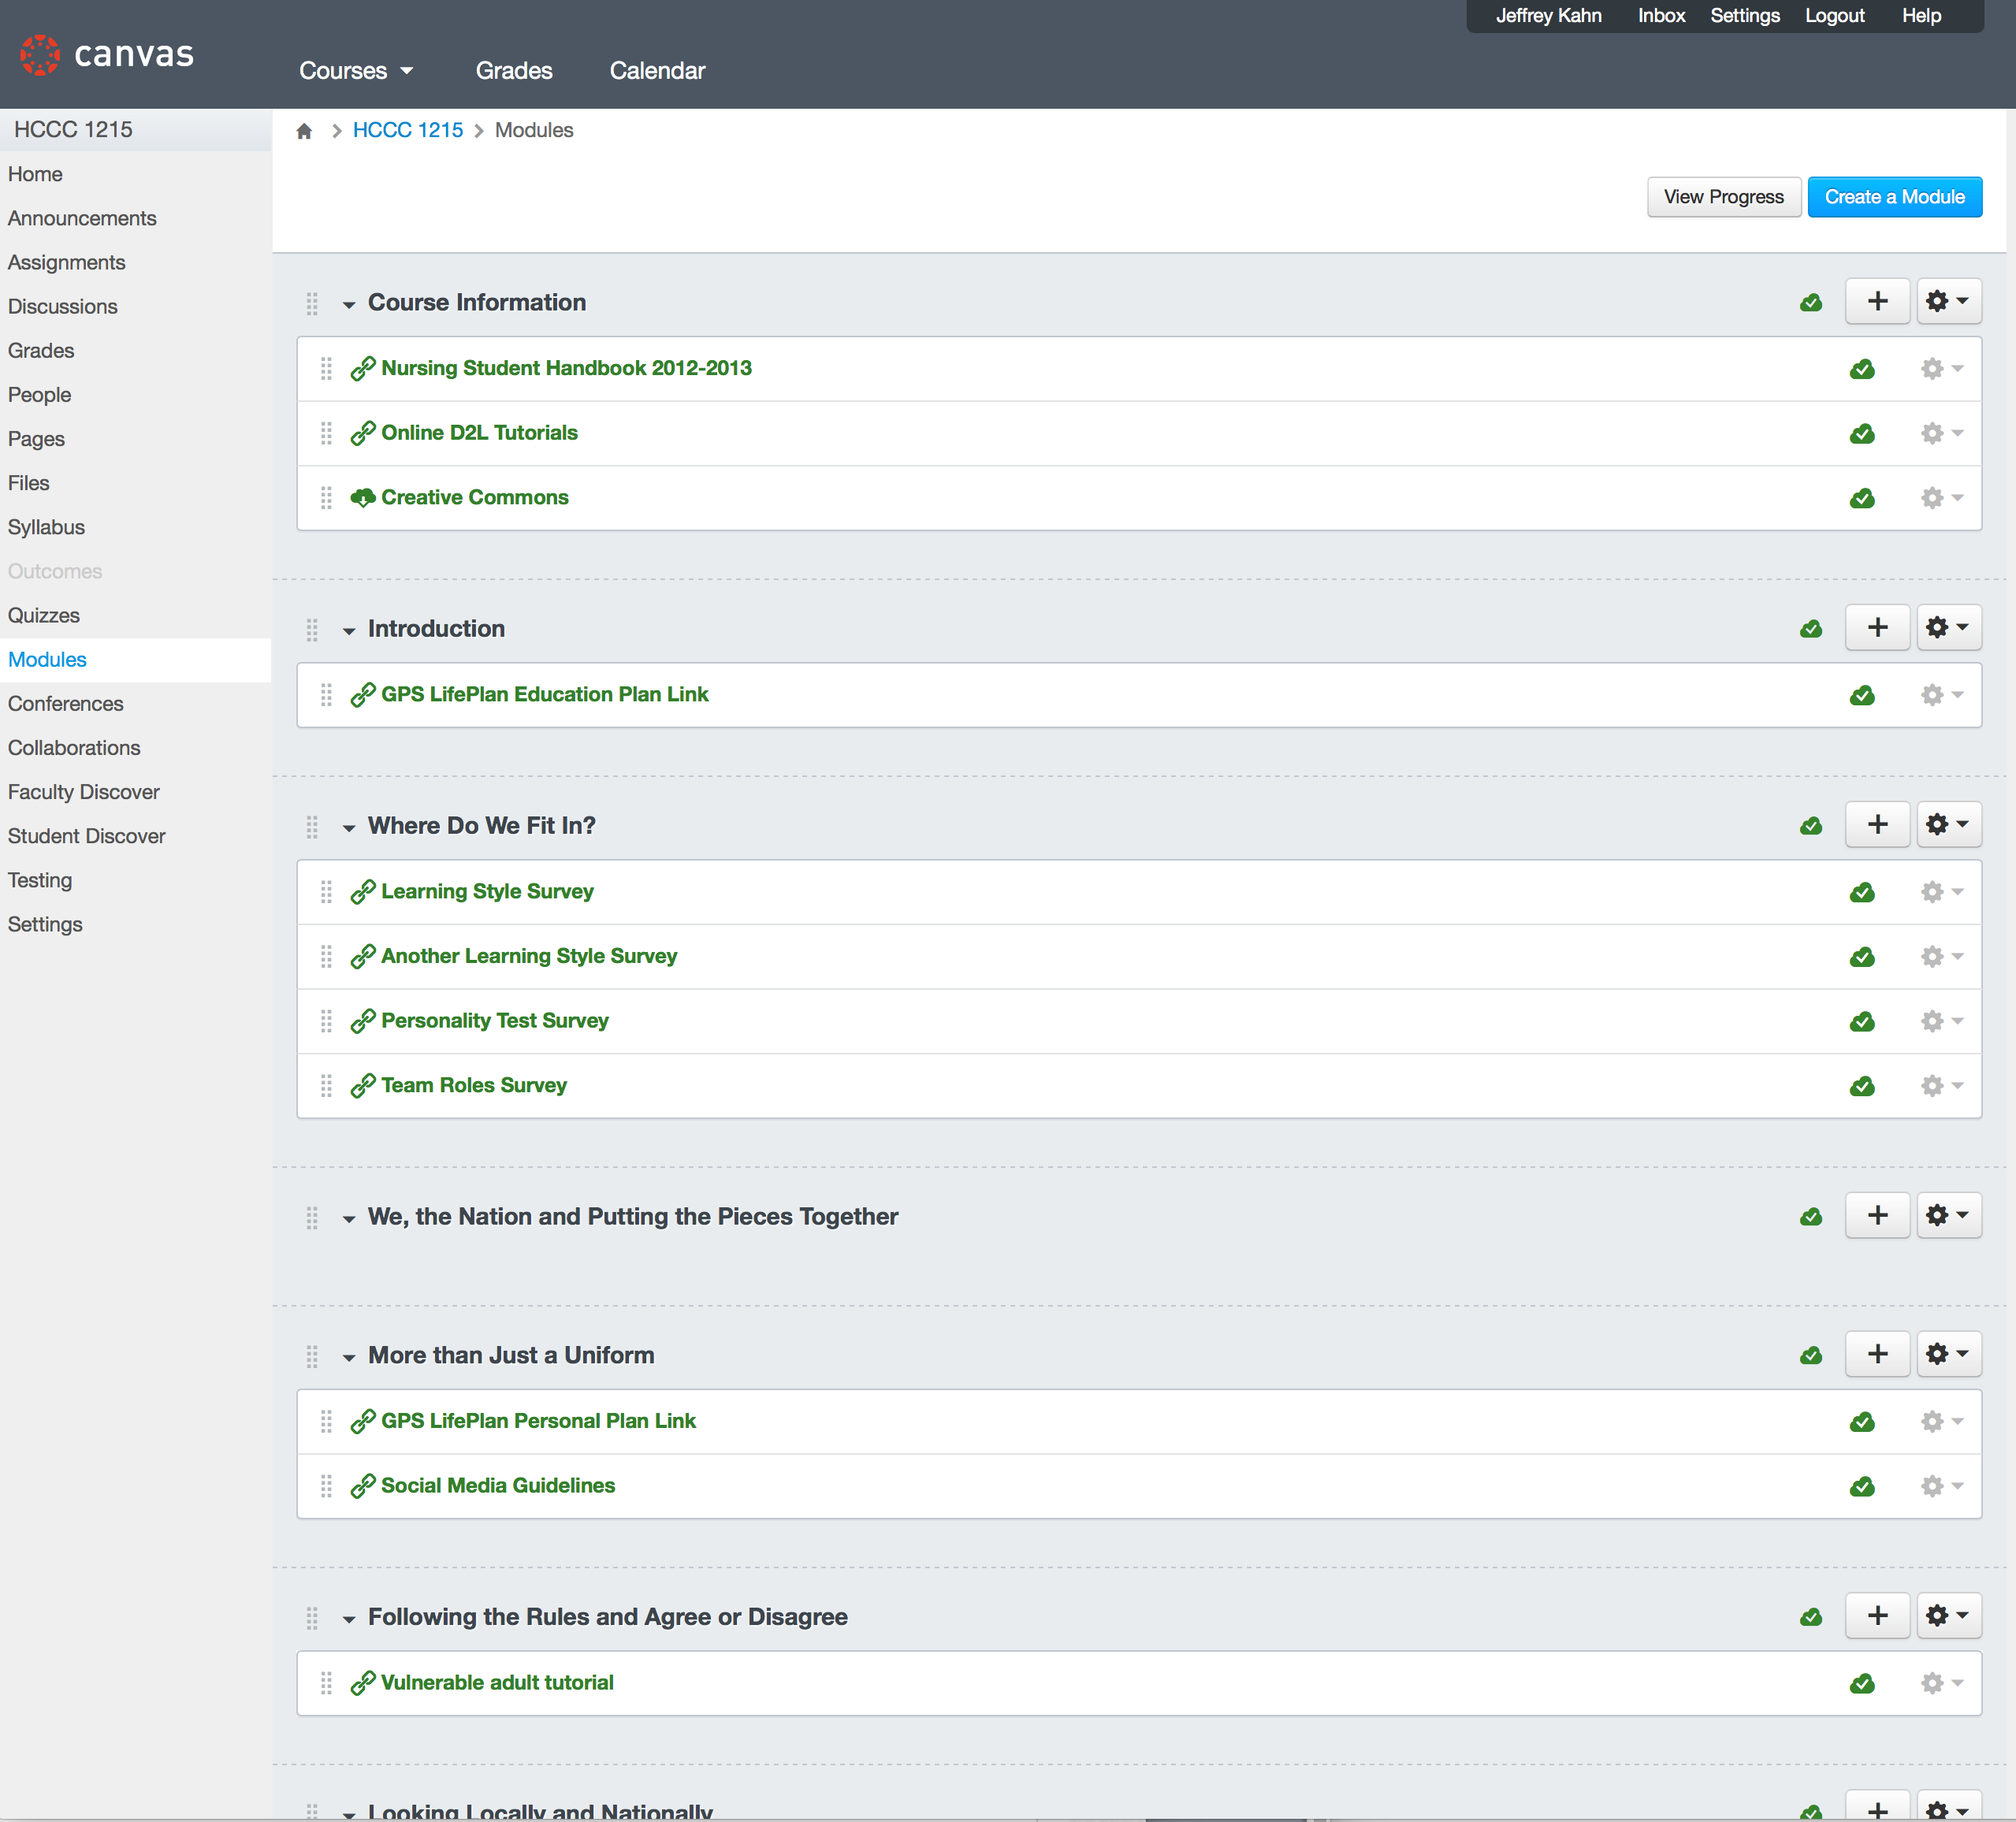

Import a Desire2Learn export into another LMS

The D2L export is a ZIP file, which can be unzipped using your computers file finder or other tools. Once unzipped, there will be folders (directories) and individual files that can be imported piecemeal.

Consult with your LMS vendor in case there are more options.

This work is licensed under a Creative Commons Attribution 4.0 International License.

This workforce solution was created through a cooperative agreement between the U.S. Department of Labor's Employment and Training Administration and the California State University-Multimedia Educational Resource for Learning and Online Teaching (MERLOT).

