Guidance for Grant Project Managers to Assess TAACCCT Grantee Contributions to SkillsCommons

This document provides guidance to support the Grant Project Managers assessment of TAACCCT Grantees progress toward completing all the SGA requirements related to contributing materials to the TAACCCT repository, [www.SkillsCommons.org](http://www.SkillsCommons.org).

* Highlight the SGA requirements for contribution of material to [www.SkillsCommons.org](http://www.SkillsCommons.org)
  + Creative Commons Licenses
  + Disclaimer of the DOL
  + Accessibility
  + Grant Deliverables and Subject Matter Expert Review
  + Industry Partner
  + Material Description
* Assessment rubric for monitoring progress
* Instructions on using the SkillsCommons repository to conduct the assessment.
* Sample summary table of the status of projects (Red,Yellow, Green)

**Section 1: SGA Requirements for Contribution of Material to** [www.SkillsCommons.org](http://www.SkillsCommons.org)

**1.1 Creative Commons License**

“In order to further the goal of career training and education and encourage innovation in the development of new learning materials, as a condition of the receipt of a Trade Adjustment Assistance Community College and Career Training Grant (“Grant”), the Grantee will be required to license to the public (not including the Federal Government) all work created with the support of the grant (“Work”) under a Creative Commons Attribution 3.0 License (“License”). This License allows subsequent users to copy, distribute, transmit and adapt the copyrighted work and requires such users to attribute the work in the manner specified by the Grantee. Notice of the License shall be affixed to the Work. For more information on this License, please visit http://creativecommons.org/licenses/by/3.0.”

Retrieved 12/5/2014 from: <http://doleta.gov/grants/pdf/SGA-DFA-PY-10-03.pdf>

pg. 21.

[Creative Commons Attribution 4.0](https://creativecommons.org/licenses/by/4.0/) is the next generation of CC licenses that have been released since the writing of the SGA. This updated version is a more user-friendly and internationally robust version of the version 3.0 requirement, though the versions are mutually compatible. More information about the versions can be found here: <http://creativecommons.org/version4> . Grantees are encouraged to choose to use the version that best meets their needs. For additional information, please contact [taa@creativecommons.org](mailto:taa@creativecommons.org).

**1.2 Disclaimer of the U.S. Department of Labor as the Funder of the Project**

If applicable, the following needs to be on all products developed in whole or in part with grant funds, “This workforce product was funded by a grant awarded by the U.S. Department of Labor’s Employment and Training Administration. The product was created by the grantee and does not necessarily reflect the official position of the U.S. Department of Labor. The U.S. Department of Labor makes no guarantees, warranties, or assurances of any kind, express or implied, with respect to such information, including any information on linked sites and including, but not limited to, accuracy of the information or its completeness, timeliness, usefulness, adequacy, continued availability, or ownership.”

Retrieved 12/5/2014 from: <http://doleta.gov/grants/pdf/SGA-DFA-PY-10-03.pdf>

pg. 15.

**1.3 Accessibility**

“All online and technology-enabled courses developed under this SGA must incorporate the principles of universal design in order to ensure that they are readily accessible to qualified individuals with disabilities in full compliance with the Americans with Disability Act and Sections 504 and 508 of the Federal Rehabilitation Act of 1973, as amended.”

Retrieved 12/5/2014 from: <http://doleta.gov/grants/pdf/SGA-DFA-PY-10-03.pdf>

pg. 8.

**1.4 Review of Grant Deliverables - SME Report**

“Successful applicants will be required to identify third-party subject matter experts to conduct reviews of the deliverables produced through the grant. Applicants should allot funds in their budget for the independent review of their deliverables by subject matter experts. Subject matter experts are individuals with demonstrated experience in developing and/or implementing similar deliverables. These experts could include applicants’ peers, such as representatives from neighboring education and training providers. The applicant must provide ETA with the results of the review and the qualifications of the reviewer(s) at the time the deliverable is provided to ETA.”

Retrieved 12/5/2014 from: <http://doleta.gov/grants/pdf/SGA-DFA-PY-10-03.pdf>.

pg. 15

**1.5 Industry Partners**

"Eligible institutions must involve at least one employer in the project that is actively engaged in the project in one or more of the following ways: defining the program strategy and goals, identifying necessary skills and competencies, providing resources to support education/training (such as equipment, instructors, funding, internships, or other work-based learning activities), providing assistance with program design, and where appropriate, hiring qualified participants who complete grant-funded education and training programs. While only one employer is required, the Department encourages applicants to collaborate with multiple employers within a sector, ensuring that program graduates will be prepared with the skills needed in the applicant’s region.”

Retrieved 12/5/2014 from <http://doleta.gov/grants/pdf/SGA-DFA-PY-10-03.pdf>.

pg. 14.

**Section 2: Suggested Rubric for Assessing Progress on Completing SGA requirements for Contributing Materials to the SkillsCommons Repository**

Grantees are required to contribute materials they created with funding from the TAACCCT program to the SkillsCommons repository. The RED-YELLOW-GREEN coding of projects enables the Grant Project Managers to categorize grantees in need of follow-up.

|  |  |
| --- | --- |
| TAACCCT Grantee Name: | Date of Assessment: |
| **Status of Contributions** | **Feedback for Grantees** |
| No Materials Contributed | NOTES |
| Some Materials Contributed but missing one or more of the SGA requirements   * Creative Commons License * DOL Disclaimer * Accessibility Statement and Features * Subject Matter Expert Review Statement | NOTES |
| **Materials Contributed with all SGA requirements completed** | **NOTES** |

**Section 3: How to Use SkillsCommons.org to Assess the Status of Contributions to the Repository.**

The SkillsCommons repository is easy to use and open for you to browse through the collection to assess the status of materials submitted to your Grant Project Collection. The following document provides you guided instructions to complete the assessment.

START AT [www.SkillsCommons.org](http://www.SkillsCommons.org)

1. Click the Browse drop down menu and select Grant project to find the grant project

you want to asses. (Logging into SkillsCommons is not required)

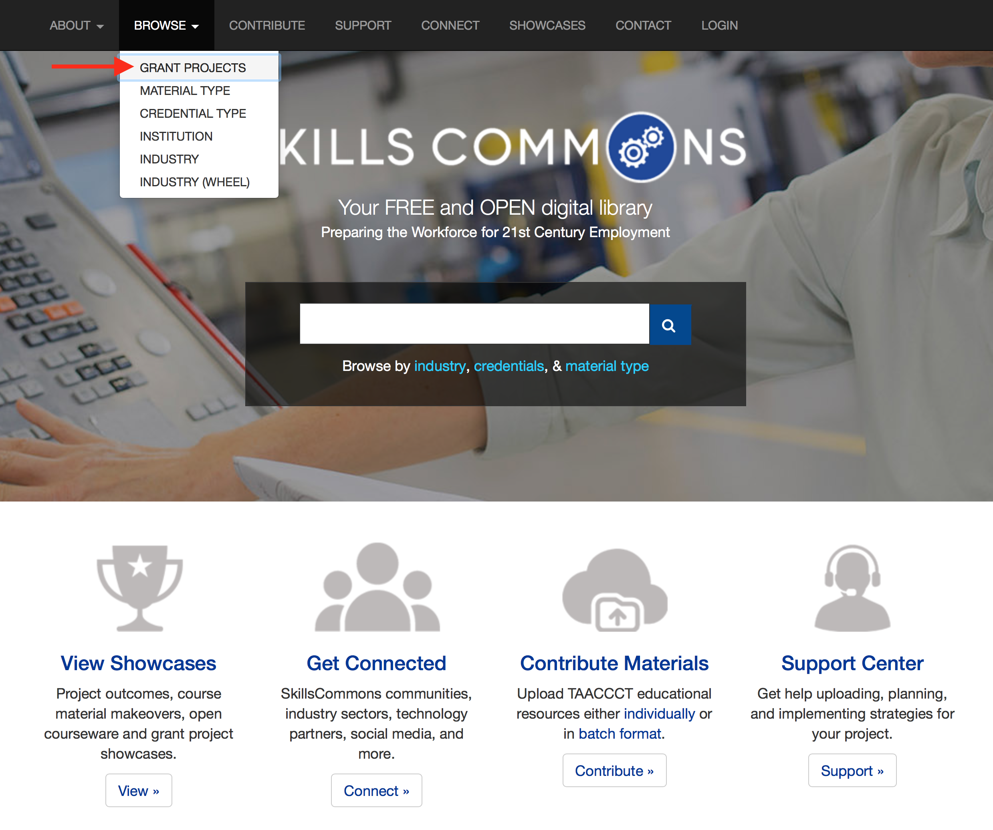

1. Scroll through the list to locate the Grant Project you want to assess - the list is in alphabetic order

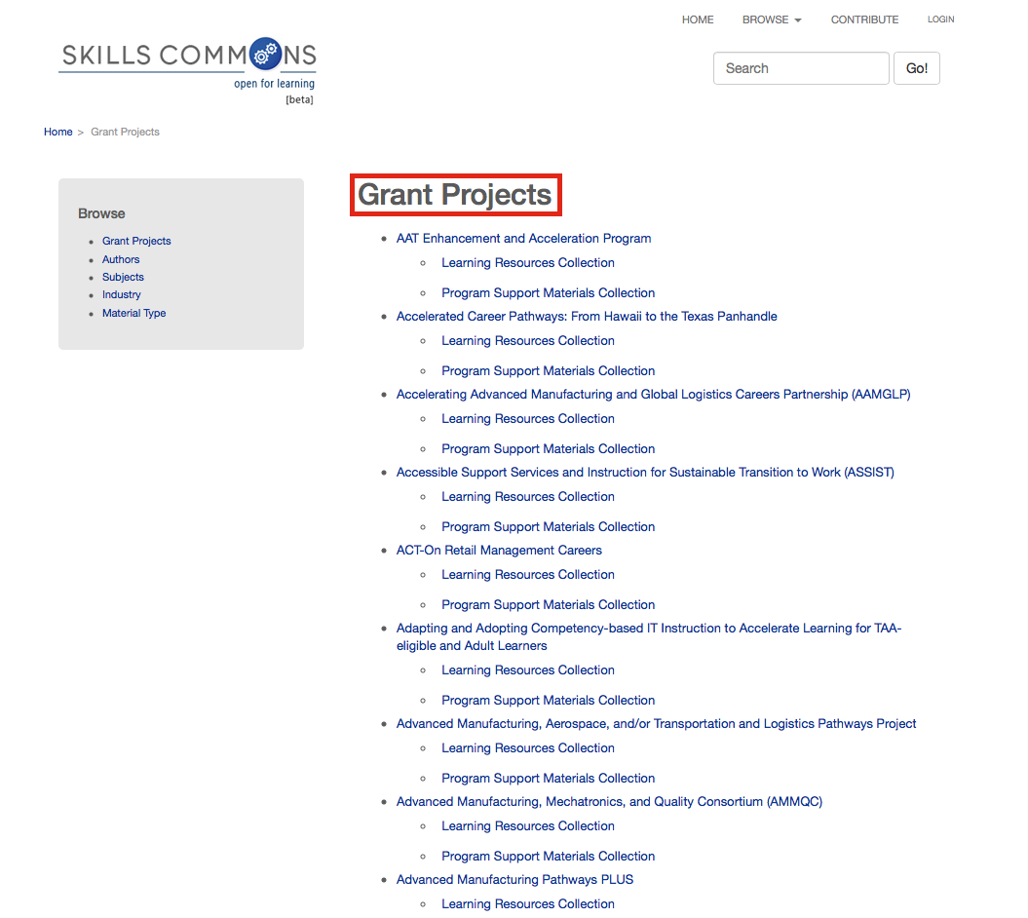

1. Select a Collection of material: Materials are submitted to the Learning Resources Collection and Program Support Materials Collection.

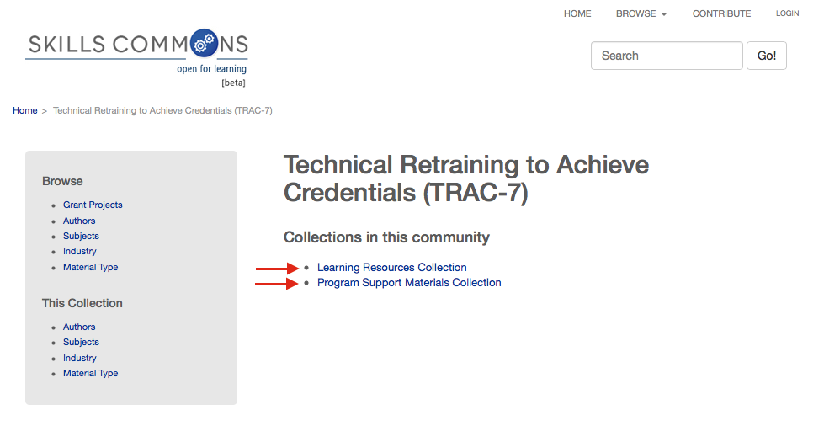

1. Review one of the submitted materials by clicking a selection from the list. You will need to review all materials in each of the items listed to assess if all SGA requirements have been satisfied

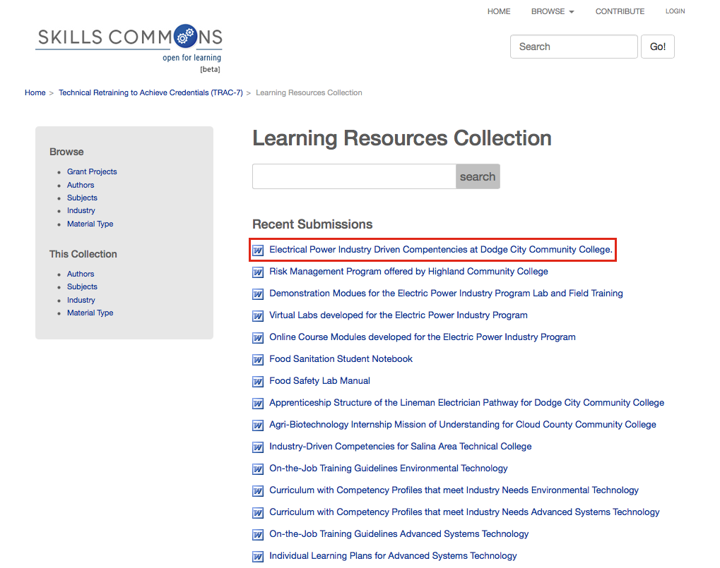

5. Review the submission and assess if the SGA requirements have been satisfied on the submission, i.e.; all material attached or both:

* **Creative Commons License**
  + Submission – The license should be visible on the submission in the Copyright/Licensing section (part of the submission metadata).
  + Material – The license should be visible within the item.
* **DOL Disclaimer Statement**
  + Material – The disclaimer should be visible within the item.
* **Accessibility Statement and Features**
  + Submission – The link to the Accessibility Statement and a list of Accessibility Features should be visible on the submission in the Accessibility section (part of the submission metadata).
* **Subject Matter Expert Review** **Statement**
  + Submission – A statement should be visible on the submission as a Quality Note under the Education/Instructional Information section (part of the submission metadata).
* **Material Description**
* **Industry Partner**

Simply scroll through the page to check for each requirement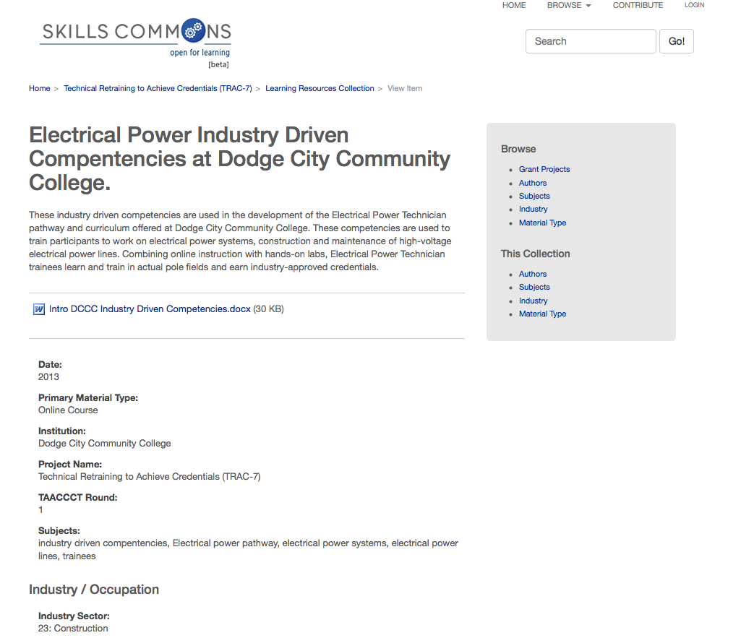

6. Ensure Creative Commons Licensing requirements are met on the information page; CC-BY license for materials created with the funding from TAACCCT. Other materials can have other licenses.

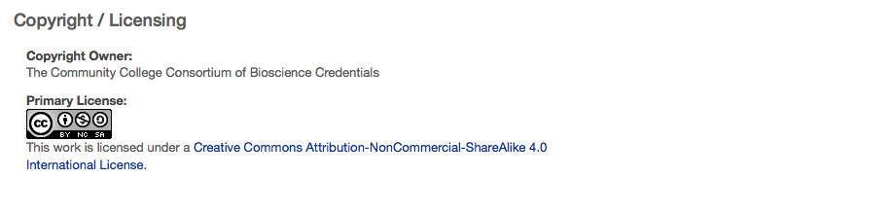

7. Ensure all the SGA requirements are met on the individual materials submitted by clicking on the file and viewing the document.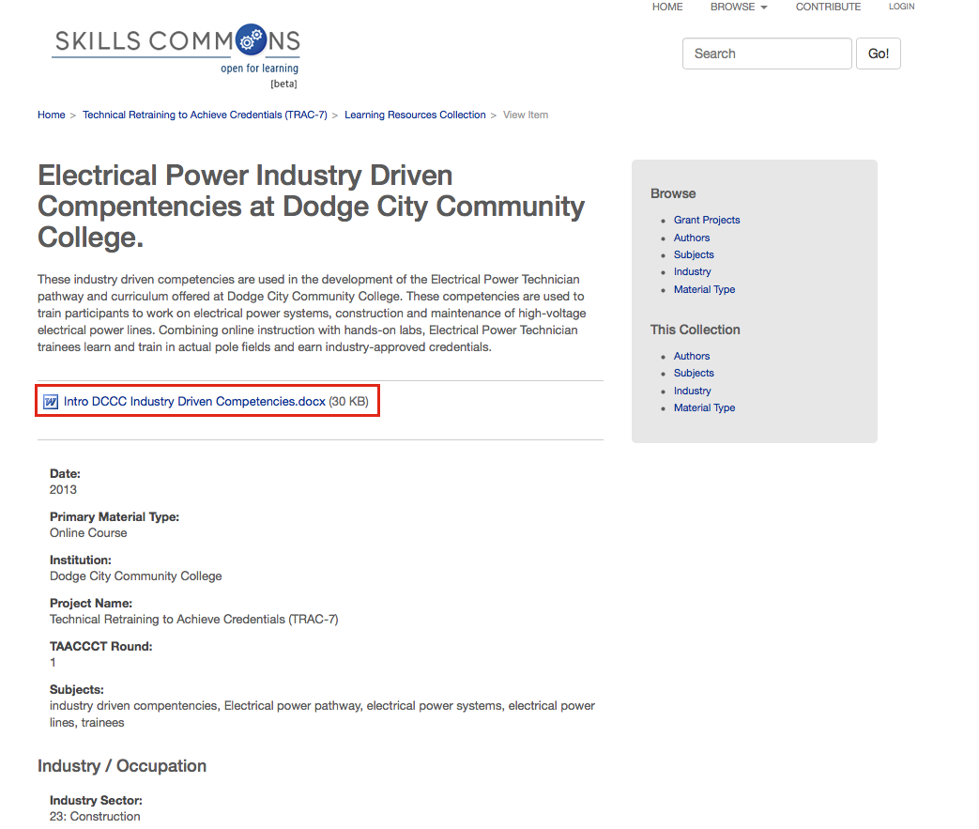

* Verify that a CC BY license and the Required Disclaimer of the U.S. Department of Labor as the Funder of the Project is included on each material

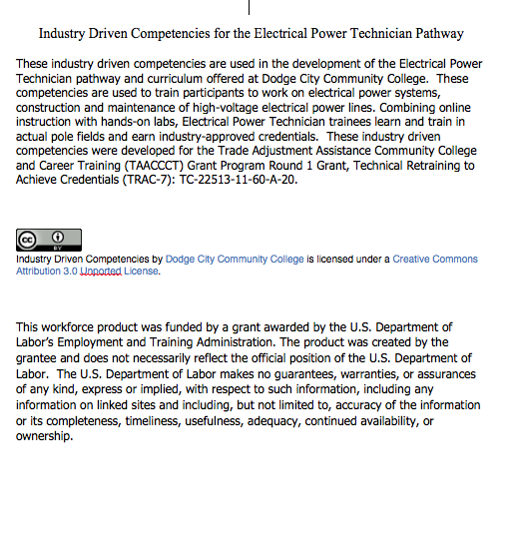

8. SkillsCommons provides you a list of checkpoints to document your satisfaction of the accessibility requirements. Choose the accessibility features that are appropriate for your materials. (For example, you materials may not have any tables so you would not need to complete the “Table Markup” checkpoint). SkillsCommons provides you guidance and background information about each checkpoint (See below for additional support).

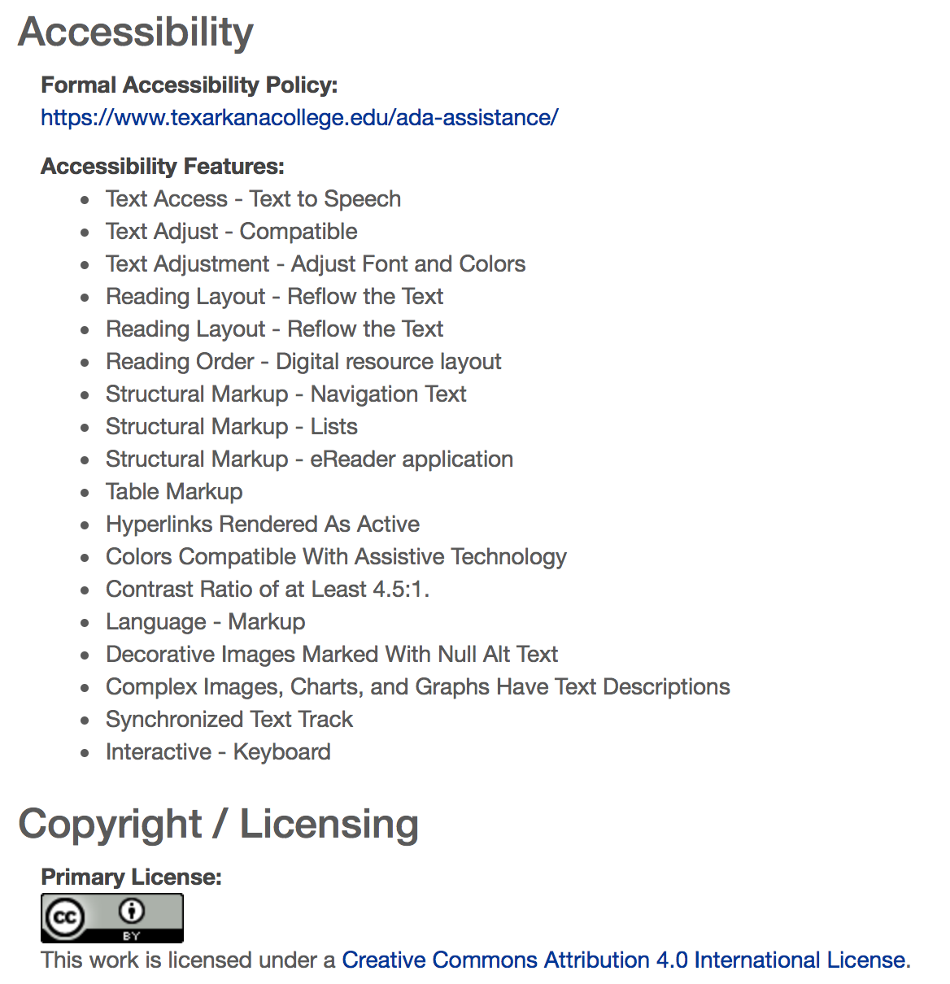

Visit the SkillsCommons Support Services Center for additional guidance to ensure your Grant Project meets the requirement: <http://support.taaccct.org/home/accessibility/>

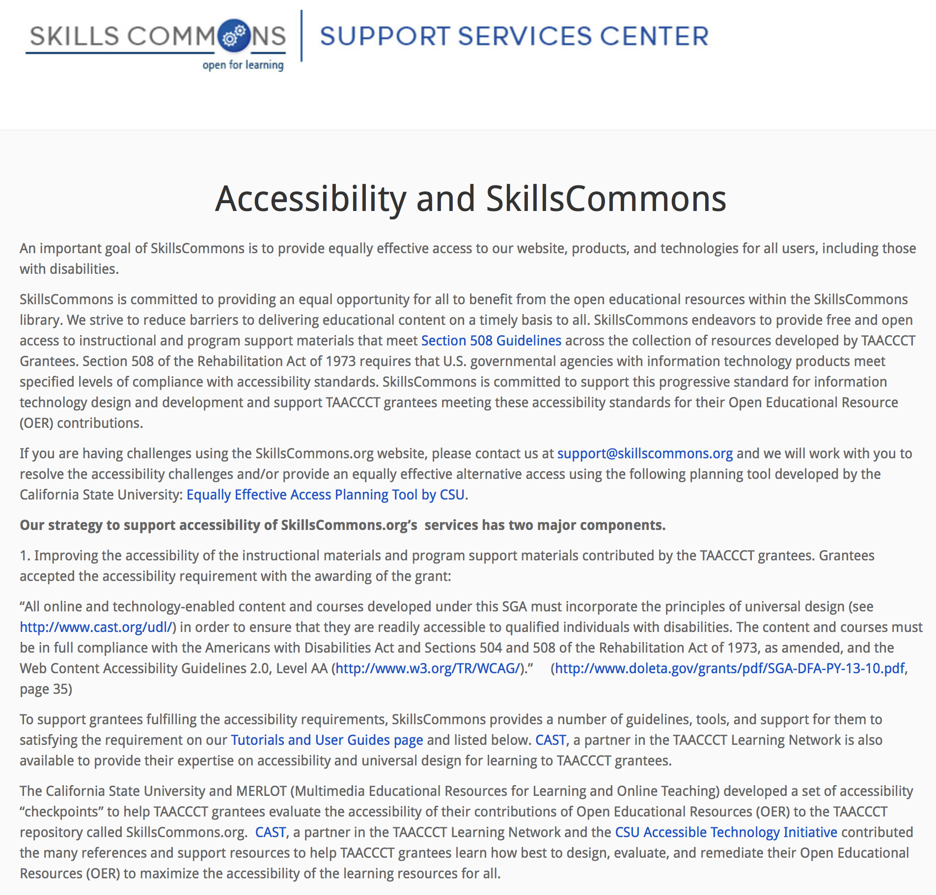

An Accessibility Checkpoints guide along with instructions for completing the Accessibility Checkpoints is available to assist in ensuring the accessibility of materials contributed to SkillsCommons

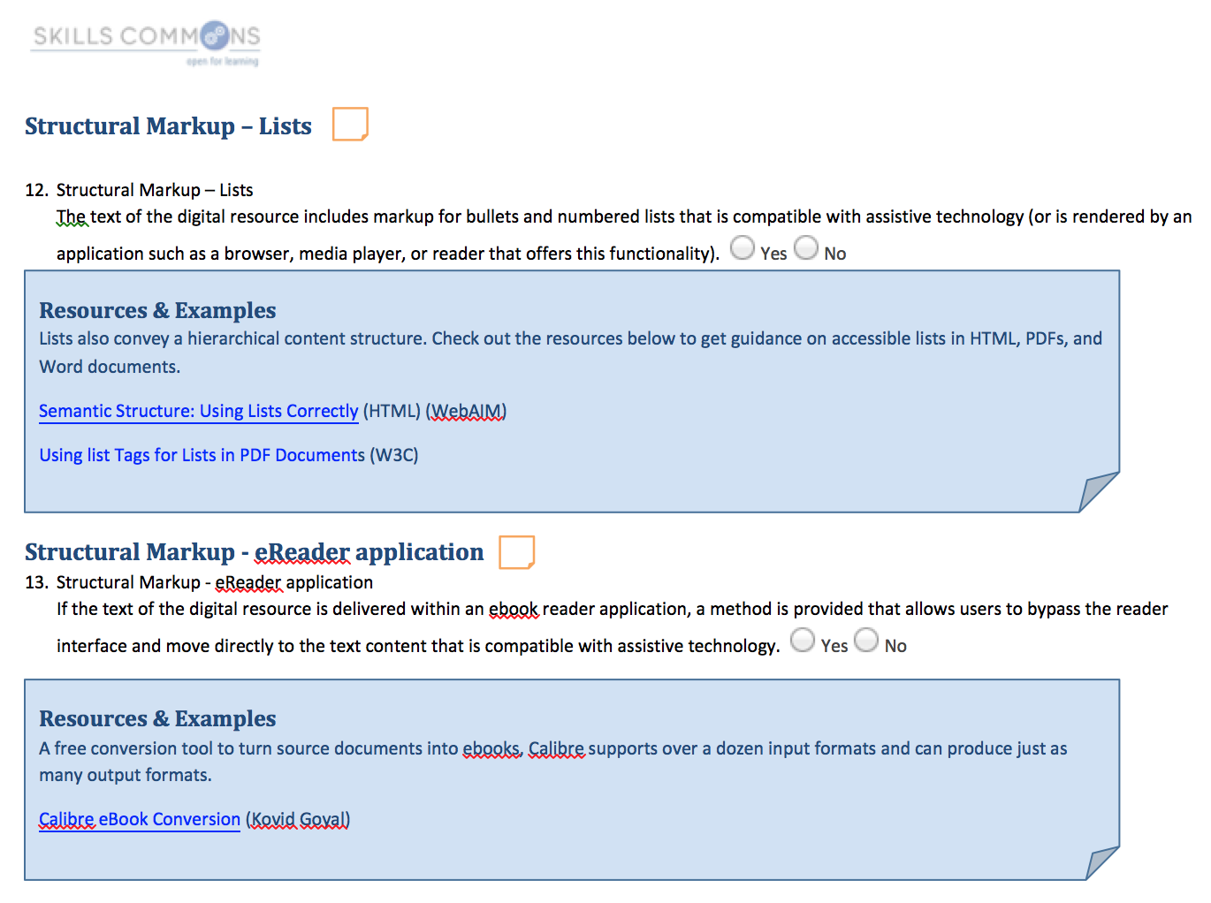

9. There are multiple ways to document the Subject Matter Expert Review. You can check one or more of the boxes:   
Consultations during development of instructional materials

Participation as an ongoing member of team developing the instructional materials

Conducting an evaluation of the instructional materials and providing a report

Using an approved rubric to conduct the evaluation of the instructional materials and providing a report

SME Quality Report is posted in Skills Commons

Other

And you can provide a narrative within the open text field “Quality Note” and upload a report with the related learning materials.

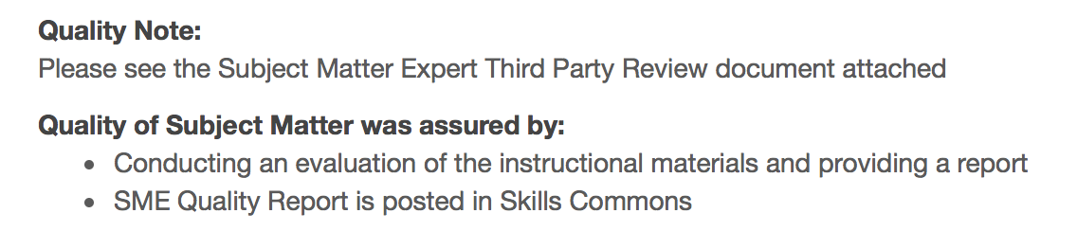

10. Review the Description field of the submission and ensure it provides information that would enable other faculty, instructional designer, employee in the industry, or prospective learner understand the contents of your submission. Your description should include:

* The discipline or subject area covered by the materials (e.g. welding safety)
* The course in which the materials could be used (e.g. 1st year introduction to welding)
* The scope and type of the materials (e.g. this is a one to two-week learning module where students get to watch a video demonstrating safe welding practices for the novice welder)
* An inventory of the types of materials packaged in the submission ( The collection of materials includes a course syllabus, 5 videos, and 5 self-assessments of welding safety practices)
* Other information that is unique about the materials being submitted

The example below only lists the title of the document. More detail needs to be added so users have enough information to decide if this material is appropriate for their use.

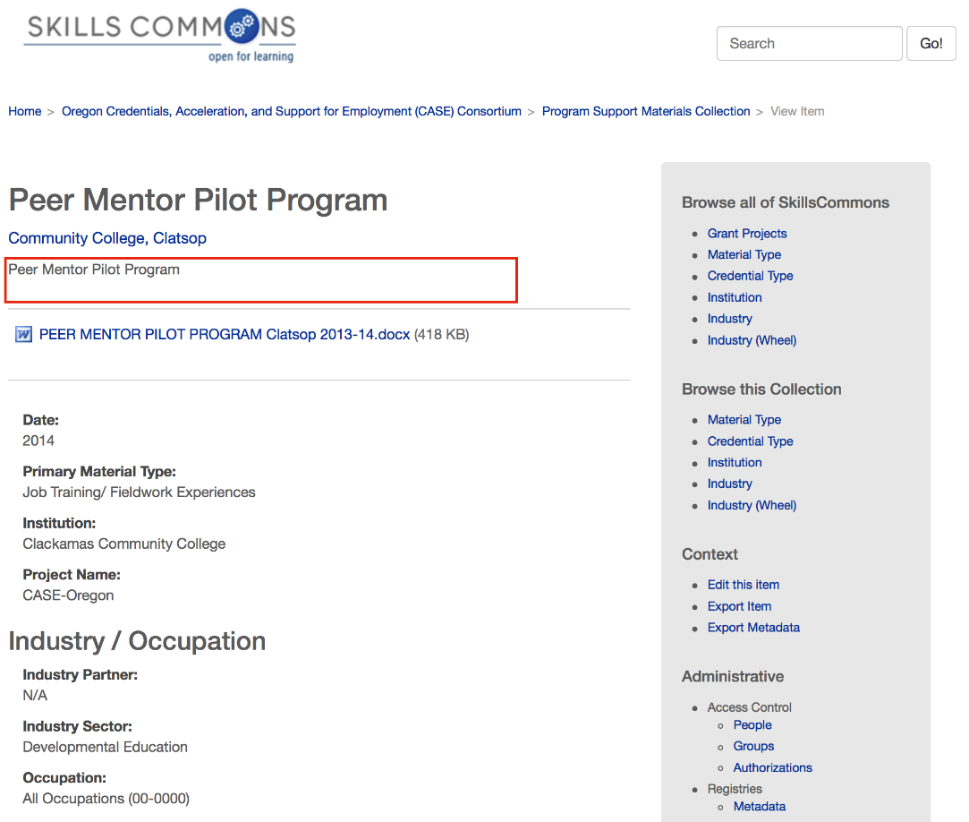

This is a good example and provides a detailed description about the material.

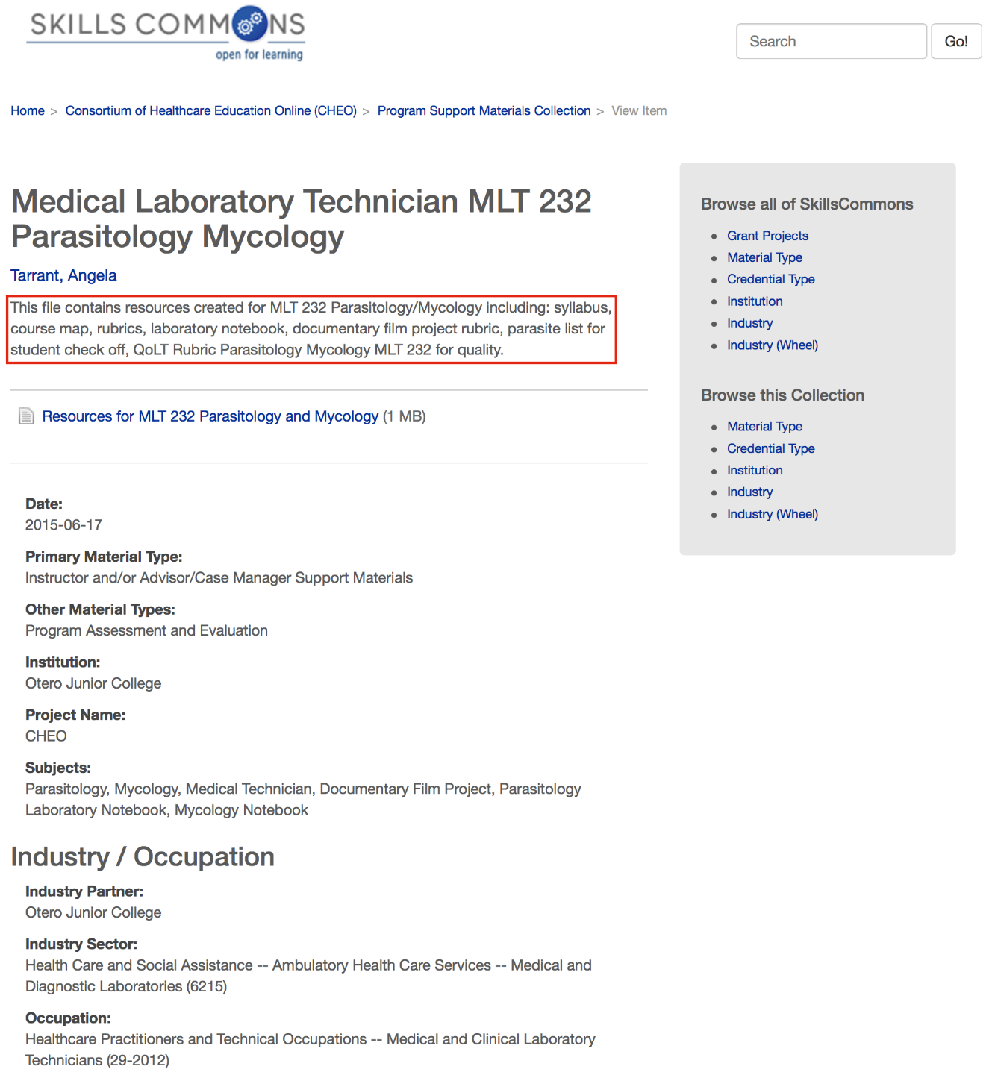

11. Review the Industry Partner field of the submission and ensure it provides the name of your employer partner and/or industry partner, see the examples below:

This example, “Healthcare” needs to be more specific. A specific employer partner and/or industry partner needs to be named.

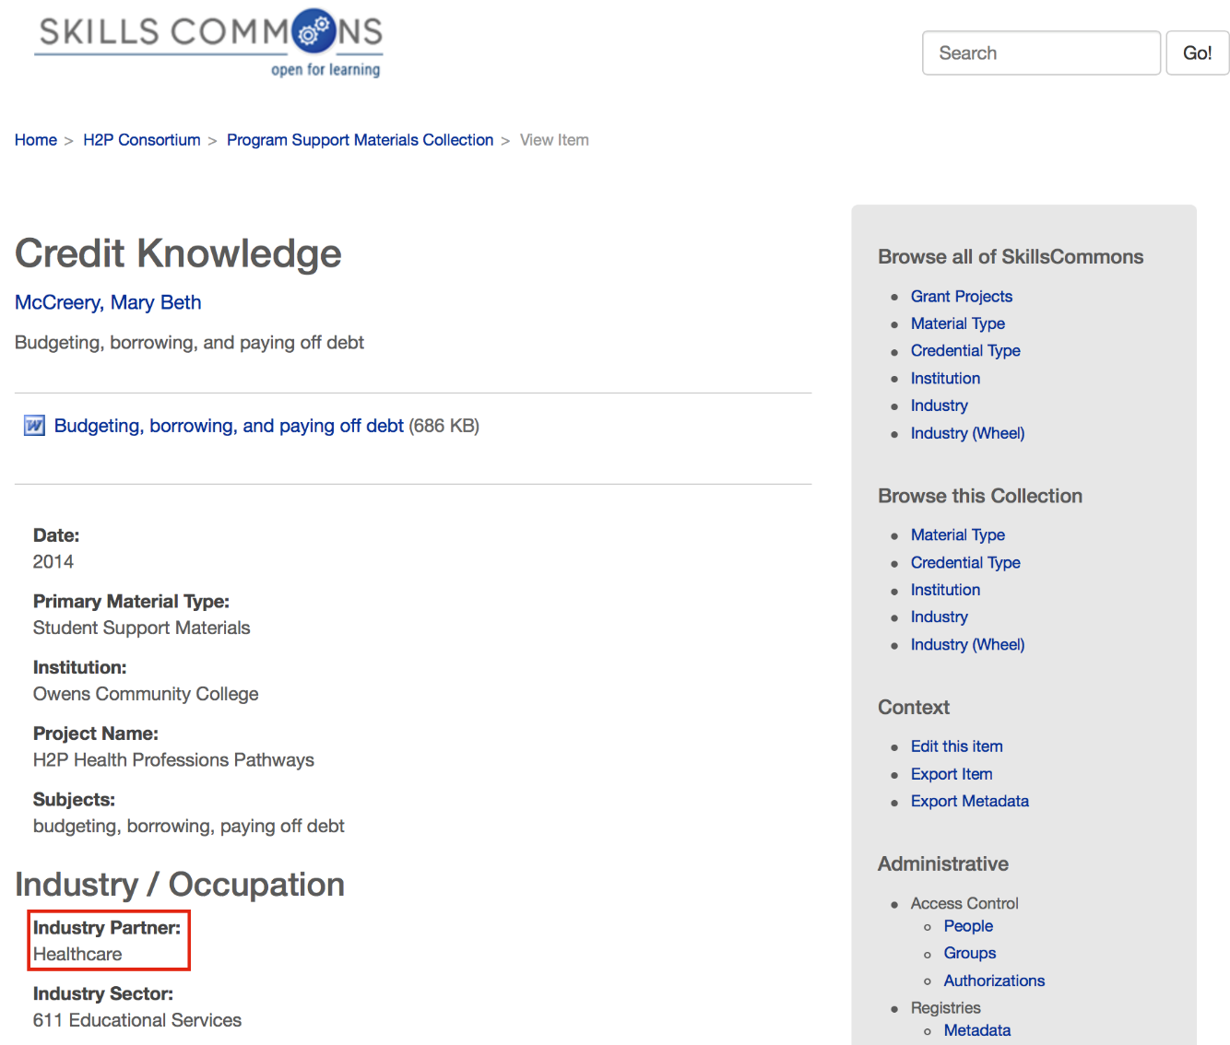

This is a good example, “Samuel U. Rodgers Health Center” is specific. The name of the employer partner and/or industry partner is identified.

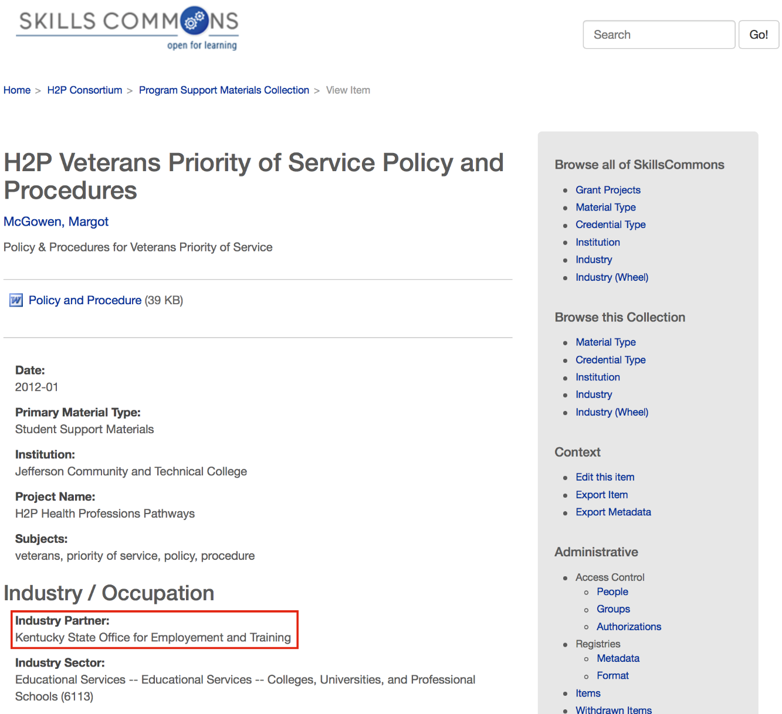

12. Program Support Materials Collection: Review the submissions by clicking on each of the items listed. You will need to review all materials in each of the items to assess if all SGA requirements have been satisfied.

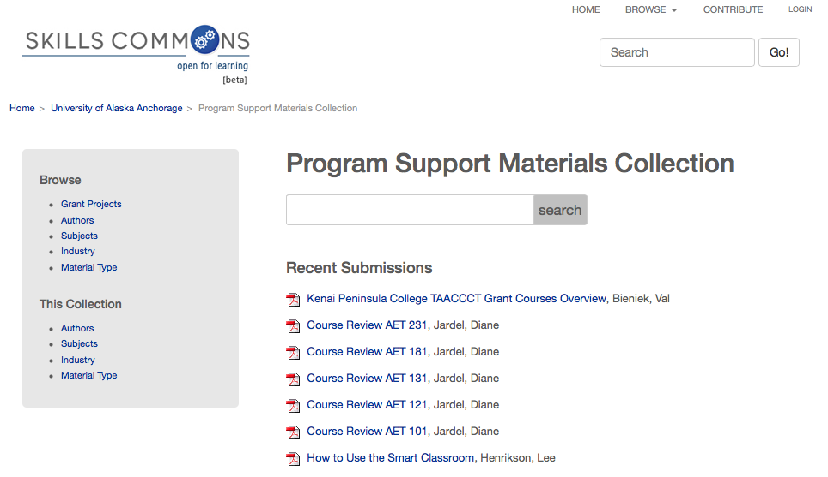

13. Review the submission and assess if the SGA requirements have been satisfied on the submission, all material attached or both:

* **Creative Commons License**
  + Submission – The license should be visible on the submission in the Copyright/Licensing section (part of the submission metadata).
  + Material – The license should be visible within the item.
* **DOL Disclaimer Statement**
  + Material – The disclaimer should be visible within the item.
* **Accessibility Statement and Features**
  + Submission – The link to the Accessibility Statement and a list of Accessibility Features should be visible on the submission in the Accessibility section (part of the submission metadata).
* **Subject Matter Expert Review Statement**
  + Submission – A statement should be visible on the submission as a Quality Note under the Education/Instructional Information section (part of the submission metadata).
* **Material Description**
* **Industry Partner**

**Section 4: Recording Project Assessment**

The following table is provided as an example of a worksheet that can be used to record the findings of a TAACCCT grantee SGA compliance review.

**TAACCCT Grant OER Repository**

**SGA Requirement Checklist**

|  |  |  |
| --- | --- | --- |
| TAACCCT Grant Project Name: | | |
| TAACCCT Grantee: | | |
| Date Assessed: | | |
| Program(s) of Study: | Status | Comments: |
| Program #1 |  |  |
| Learning Resources Collection |  | All submissions and materials are SGA compliant |
| Program Support Materials Collection |  | Missing DOL Disclaimer on several documents |
| Program #2 |  |  |
| Learning Resources Collection |  | No materials have been contributed for this program |
| Program Support Materials Collection |  | Creative Commons Licensing needed on all documents |
| Program #3 |  |  |
| Learning Resources Collection |  | All submissions and materials are SGA compliant |
| Program Support Materials Collection |  | All submissions and materials are SGA compliant |
| Etc…. |  |  |
|  |  |  |
|  |  |  |
|  |  |  |
|  |  |  |
|  |  |  |

[CC BY graphic](http://creativecommons.org/licenses/by/4.0/)

This work is licensed under a Creative Commons Attribution 4.0 International License.

This workforce solution was created through a cooperative agreement between the U.S. Department of Labor's Employment and Training Administration and the California State University-Multimedia Educational Resource for Learning and Online Teaching (MERLOT).