SkillsCommons Repository User Guide

Editing Your CC BY License Entry
This document was created to assist you with updating/editing the Creative Commons CC BY License field after you have completed your submission and uploaded your materials into SkillsCommons.
For more information about Creative Commons and how to choose the right license for your material please visit the following links:
- Creative Commons http://www.creativecommons.com/
- Choose a CC License http://creativecommons.org/choose/

How to Edit Your CC BY License
If, after submitting your repository item, you need to edit or update your CC BY entry you can do so by following the steps outlined below.
- Type http://skillscommons.org/ into your browser address bar.
- Click on “CONTRIBUTE” located in the main menu of the SkillsCommons Repository website.

- Sign in using your e-mail address and password.
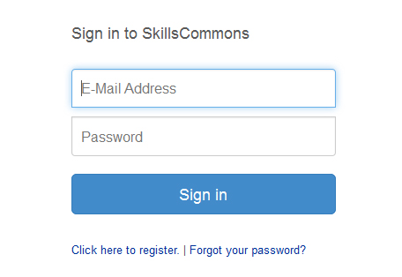
- Once you have signed in, click on the submission you wish to edit. For our purposes we will edit the “Solar Power Quiz #1” submission.
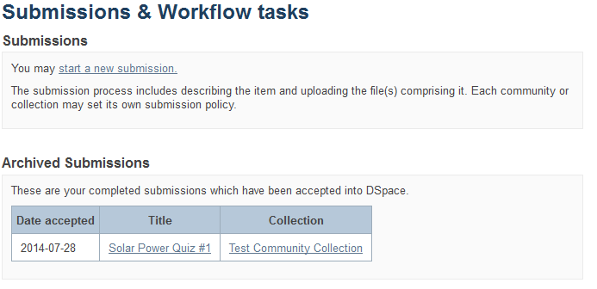
- You are now on the item page. To edit this item click on “Edit this item” under the “Context” heading.
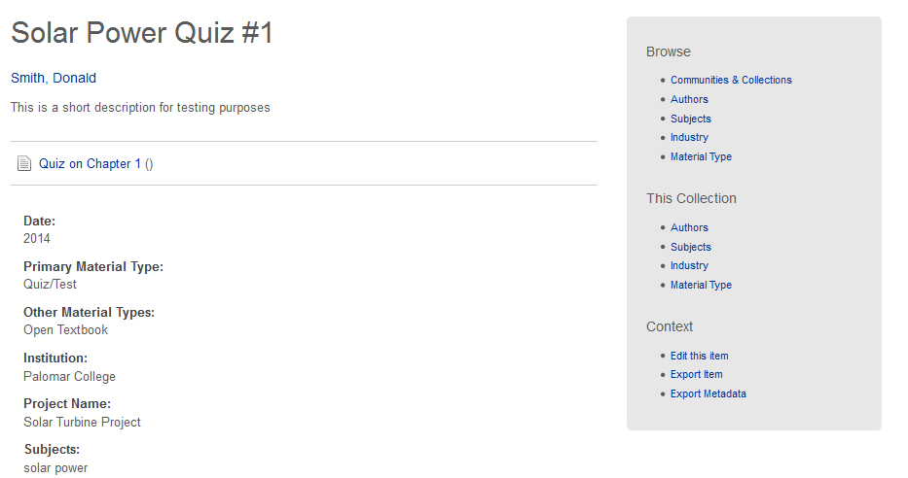
Click on “Edit this item” under the “Context” heading
- After clicking on “Edit this item” you will be presented with the screen below. Click on the “Item Metadata” tab to edit the fields in this item.
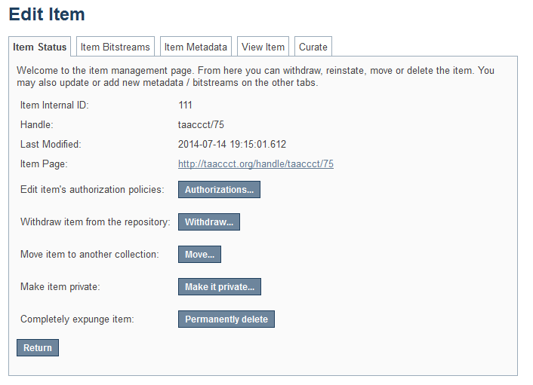
Click on “Item Metadata” to edit the fields in this item.

- After clicking the “Item Metadata” tab you will be presented with the full metadata record. This record will show you the fields that you entered when you first submitted the item.

Update the “Primary License” Field
To update the Primary License Field scroll down to “dcterms.license” and delete the old entry. After you delete the old entry, enter ONE of the following license options exactly as shown below:
CC BY
CC BY-SA
CC BY-ND
CC BY-NC
CC BY-NC-SA
CC BY-NC-ND
Public Domain
CC0
Other
After editing your entry, scroll to the bottom and click the “Update” button.

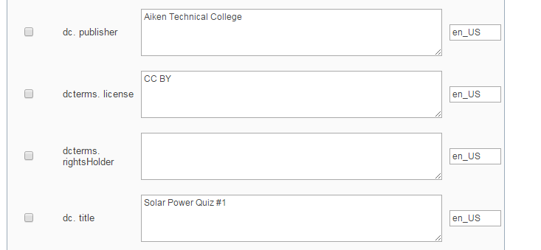

After clicking the “Update” button you will see the following screen notifying you that the metadata has been updated. You can now go back to the item record and see your updates.
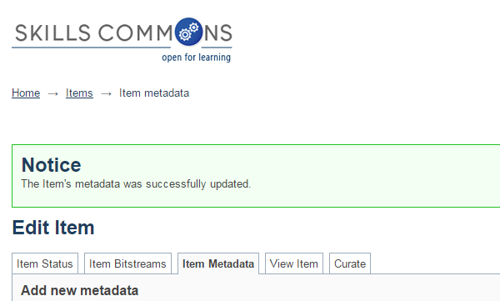

Update the “Additional License” Field
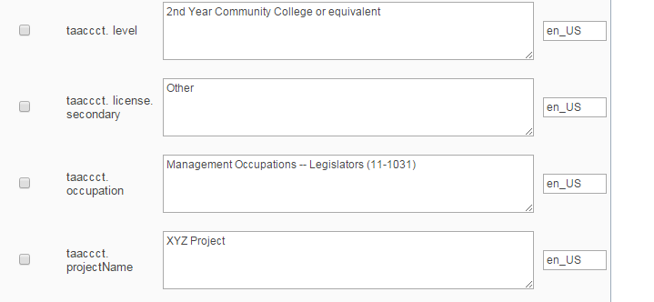
To update the Additional License Field find “taaccct.license.secondary” and enter ONE of the following license options exactly as shown below:
CC BY
CC BY-SA
CC BY-ND
CC BY-NC
CC BY-NC-SA
CC BY-NC-ND
Public Domain
CC0
Other
After editing your entry, scroll to the bottom and click the “Update” button.

After clicking the “Update” button you will see the following screen notifying you that the metadata has been updated. You can now go back to the item record and see your updates.

Adding more than one “Additional License”
The Additional License field can have more than one value. If you have more than one CC BY license that applies to the Additional License field you can add it by selecting “taaccct.license.secondary” from the drop down menu at the top of the Item Metadata page.

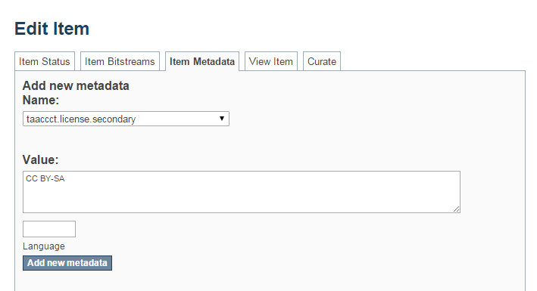
To ADD an Additional License Field choose the “taaccct.license.secondary” field from the dropdown menu
After editing your entry, scroll to the bottom and click the “Update” button.
Enter ONE of the following license options exactly as shown below in the “Value” box.
CC BY
CC BY-SA
CC BY-ND
CC BY-NC
CC BY-NC-SA
CC BY-NC-ND
Public Domain
CC0
Other

Click “Add new metadata” and then click the “Update” button to save your changes.

This work is licensed under a Creative Commons Attribution 4.0 International License.
This workforce solution was created through a cooperative agreement between the U.S. Department of Labor's Employment and Training Administration and the California State University-Multimedia Educational Resource for Learning and Online Teaching (MERLOT).

