Skills Commons Repository User Guide

Documenting Description and Industry Partner for Program Support Materials Collection
This document was created to assist with the specific Description and Industry Partner fields submission process for your “Program Support Materials” collection. This document will cover the steps of adding submissions up to the Industry Partner fields and provide specific examples of what is required for this field. Instructions for editing completed submissions in the Description and Industry Partner fields are also included.

ADDING (SUBMITTING) MATERIALS

- Type http://skillscommons.org/ into your browser address bar.
- Click “CONTRIBUTE” located in the top menu of the SkillsCommons Repository website.
- Sign in to the SkillsCommons Repository using your e-mail address and password.
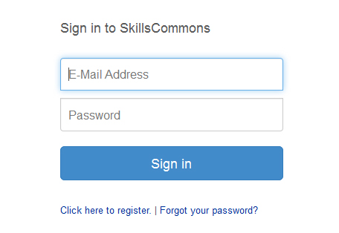
- Once you have signed in, click on the “start a new submission” link.
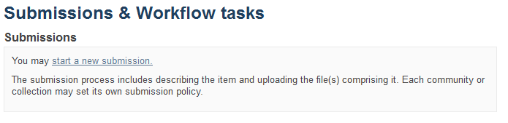
- Select your Program Support Materials collection from the dropdown menu and click “Next” to start your submission.
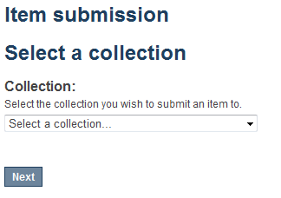
- Entering your Item Description – PAGE 1
The single item submission process allows you to enter all the metadata about your material, upload the associated files, review your submission, and finally submit them item to the repository. Enter as much information about the item as you can in order to help others find it in the repository. Each field has a brief description of the data you should enter into the field. The following pages provide some additional information about each field.
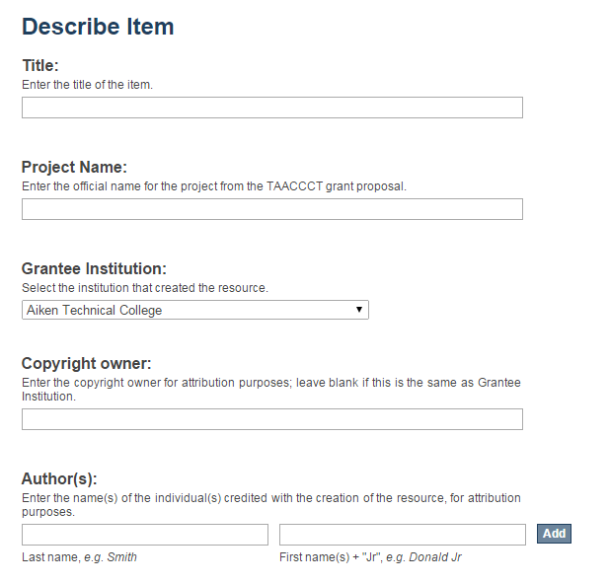
Enter the official name of your grant project if it is different than the name on your TAACCCT grant proposal.
REQUIRED FIELD: This is for attribution purposes. You can leave it blank if this is the same as Grantee Institution.
REQUIRED FIELD: To add multiple authors click the “Add” button.
REQUIRED FIELD: Select the name of the institution responsible for creating this item.
REQUIRED FIELD: Enter the title of the item.
(continued on next page)
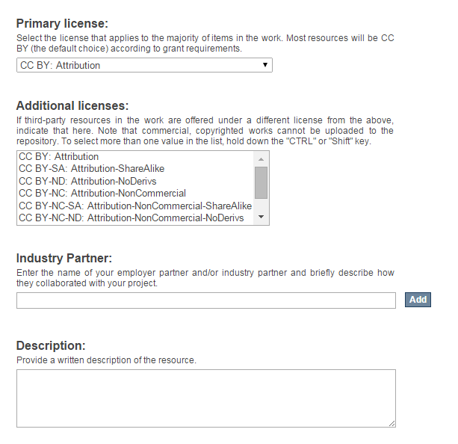
Enter the name of your employer partner and/or industry partner and briefly describe how they collaborated with your project. Please see below for specific examples.

REQUIRED FIELD: Select the license that applies to the majority of items in the work. Most resources will be CC BY (the default choice) according to the grant requirements.
REQUIRED FIELD: Use this field to describe the material in as much detail as possible so others can find it when searching the repository. A detailed description also helps users decide if it is an appropriate material for their use. Be as specific as possible so others can understand what the material is about. Please see below for specific examples.

If third-party resources in the work are offered under a different license from the above, indicate that here. Note that commercial, copyrighted works cannot be uploaded to the repository. To select more than one value in the list, hold down the "CTRL" or "Shift" key.
(continued on next page)

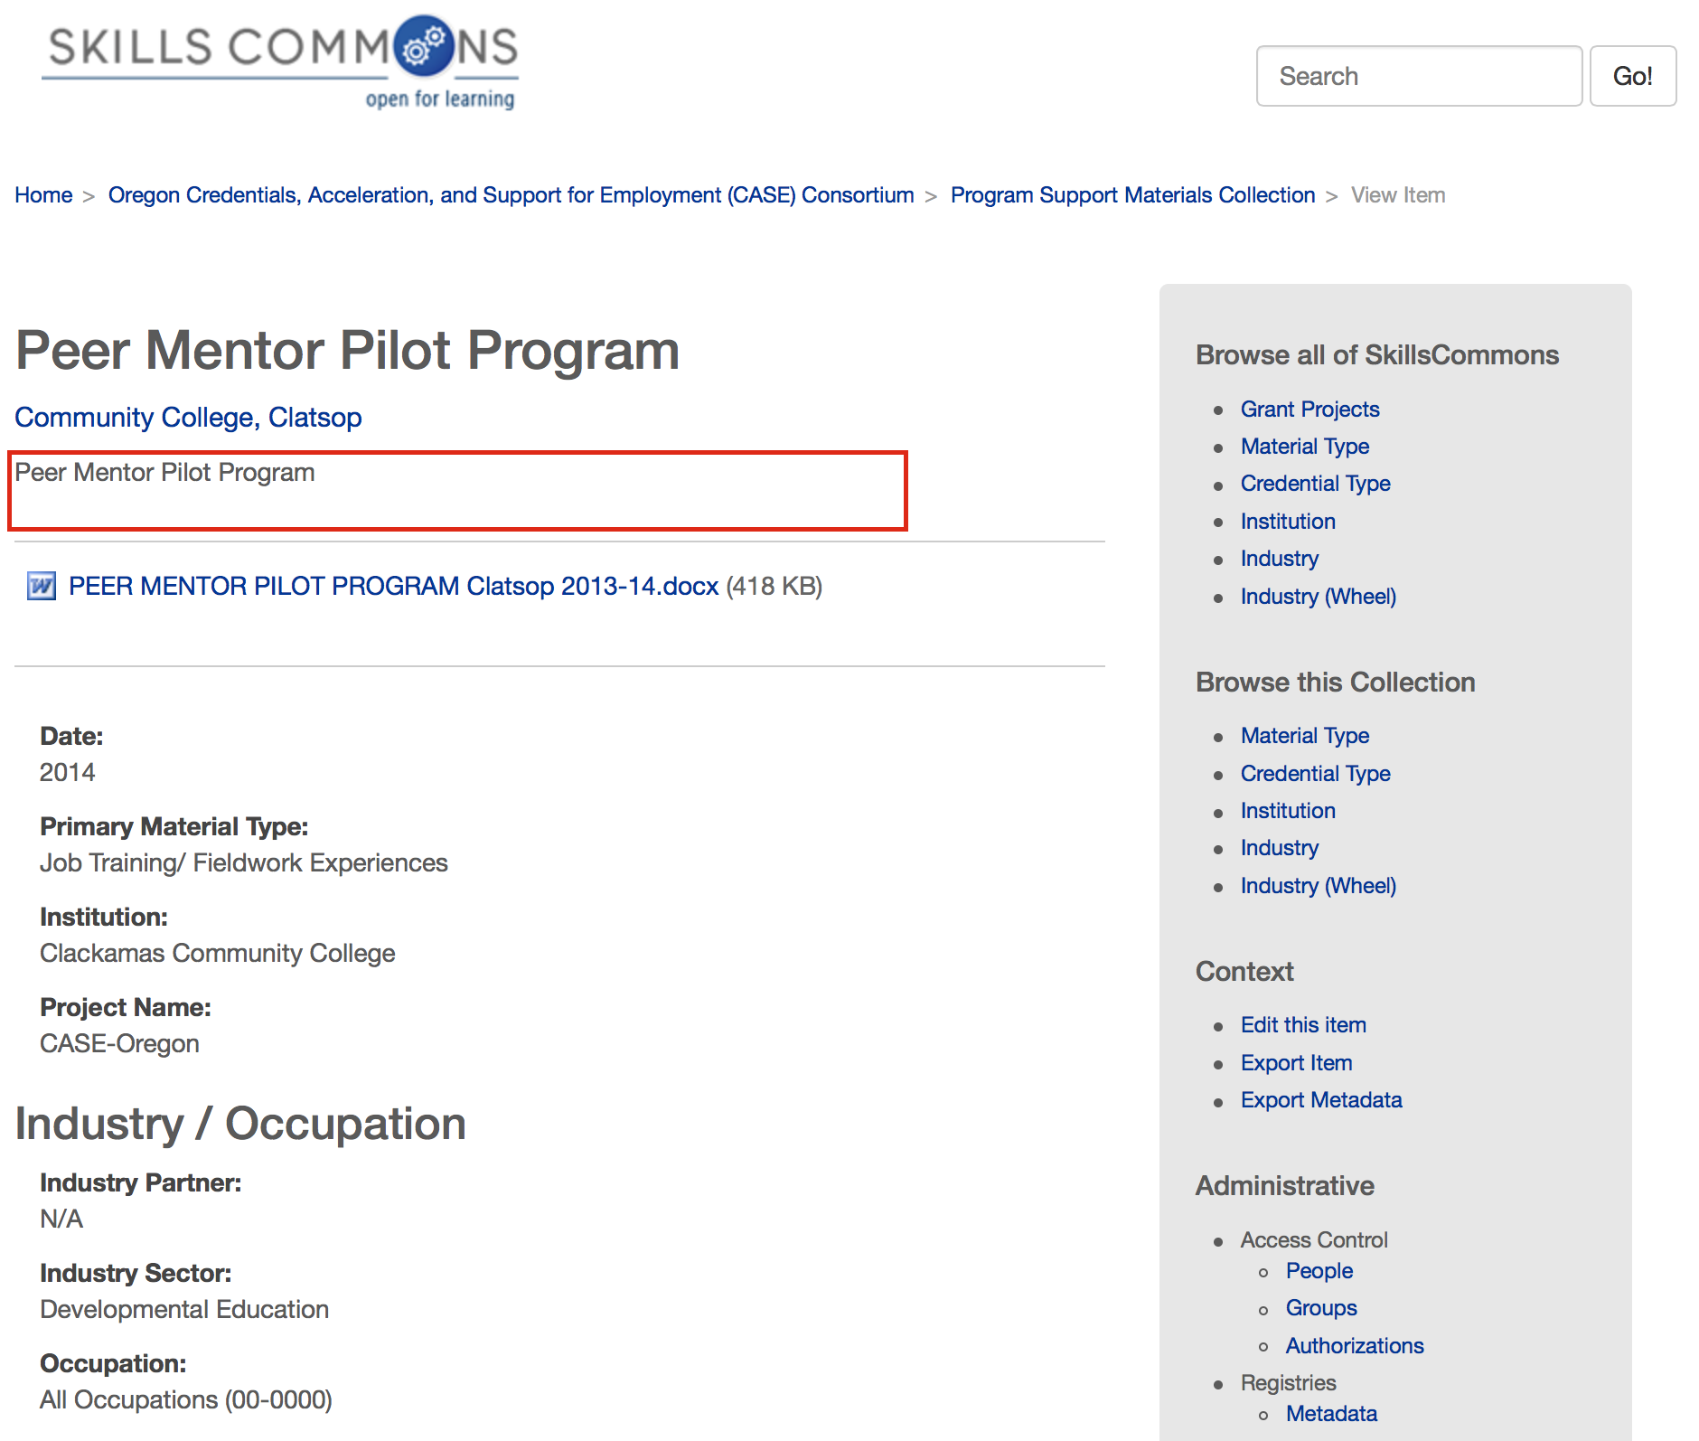
This example, “Peer Mentor Pilot Program” needs to provide more detail about the material than just the title of the document. For example, “This document contains a job description for the peer mentor program at Clatsop Community College along with an application form. This document also contains the evaluation and assessments for the peer mentoring program. A student peer mentor manual is also included.”

(continued on next page)

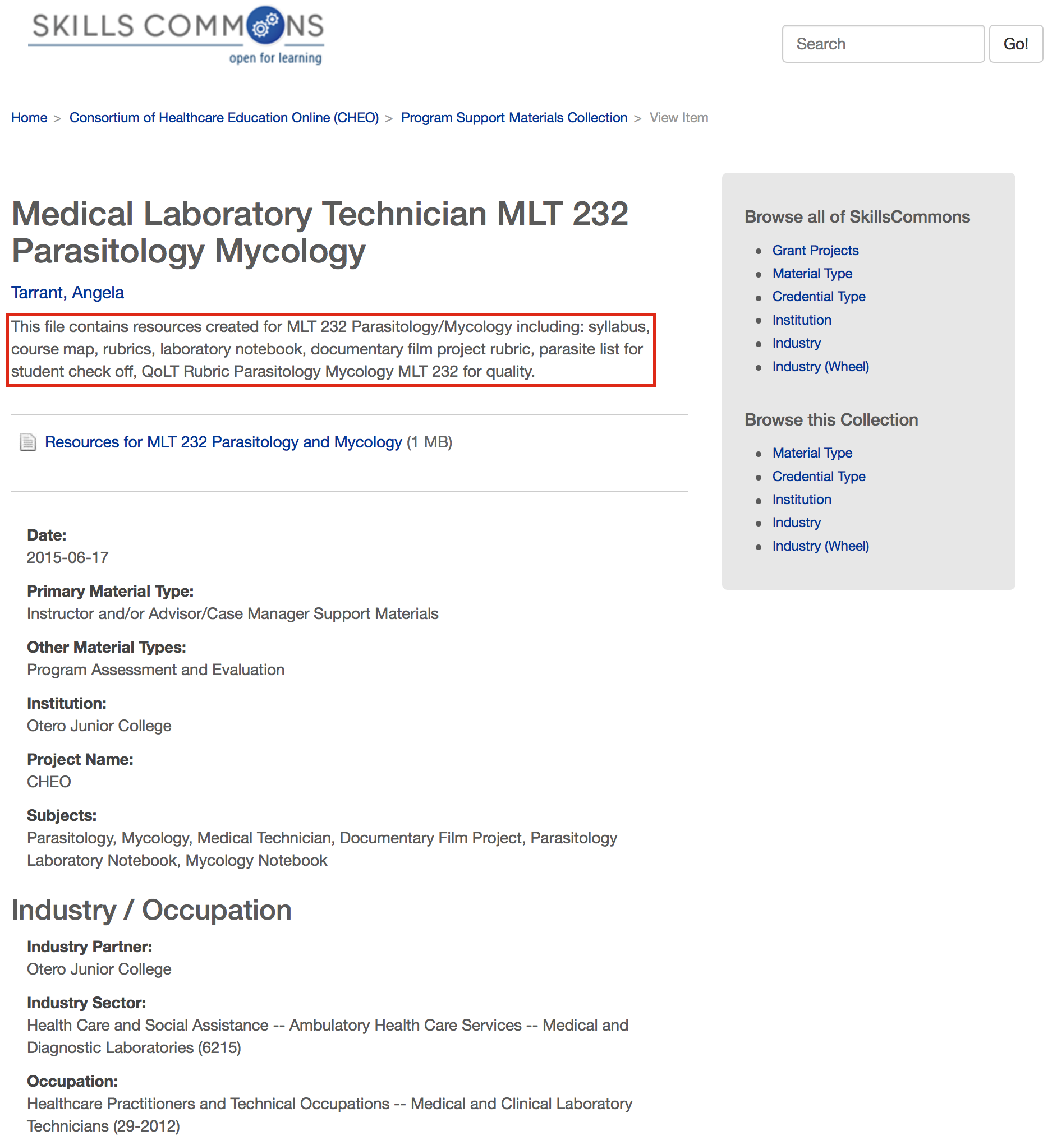
This example, “This file contains resources created for MLT 232 Parasitology/Mycology including: syllabus, course map, rubrics, laboratory notebook, documentary film project rubric, parasite list for student check off, QoLT Rubric Parasitology Mycology MLT 232 for quality.” provides a detailed description about the material. Users are given enough information to decide if this material is appropriate for their use.
objectives, student learning outcomes, list of assignments and names of the course textbooks.”

(continued on next page)

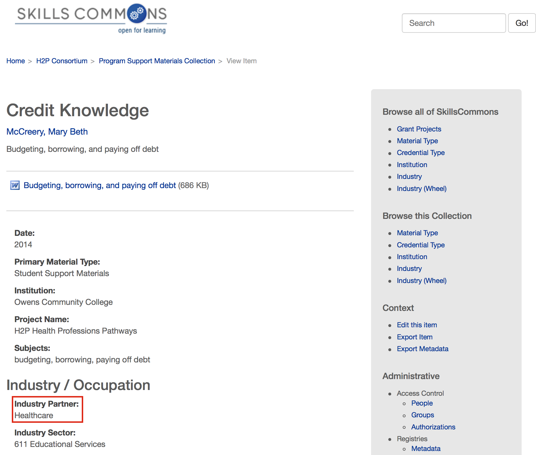
This example, “Healthcare” needs to be more specific. A specific employer partner and/or industry partner needs to be named.
(continued on next page)

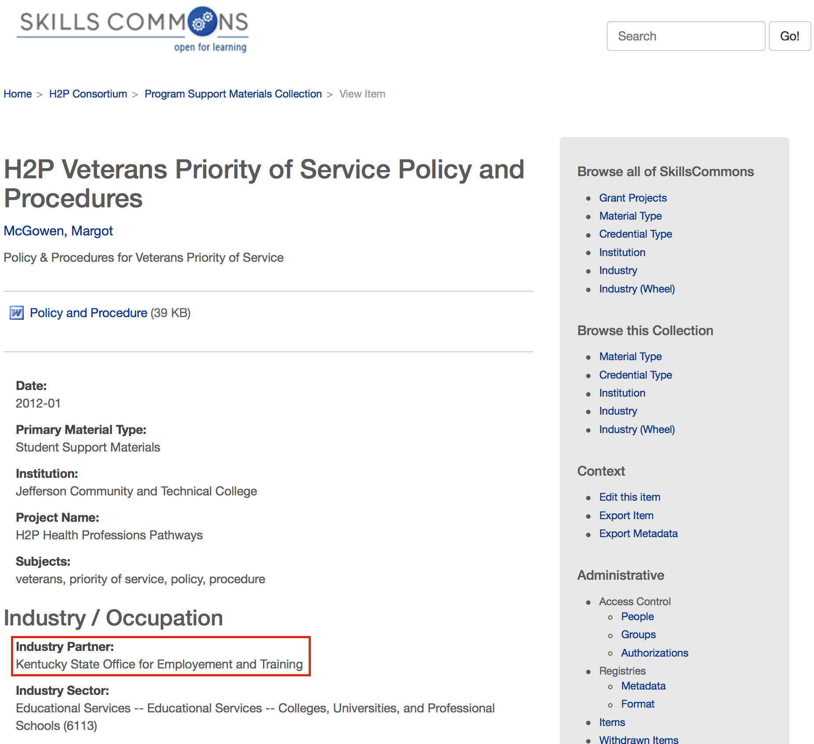
This example, “Kentucky State Office for Employment and Training” is specific. The name of the employer partner and/or industry partner is identified. If you did not use an employer partner and/or industry partner to develop your program support material, please add “U.S. Department of Labor”

EDITING AN ITEM IN THE REPOSITORY

- Type http://skillscommons.org/ into your browser address bar.
- Click “CONTRIBUTE” located in the top menu of the SkillsCommons Repository website.
- Sign in to the SkillsCommons Repository using your e-mail address and password.
- Once you have signed in click on the submission you wish to edit. For our purposes we will edit the “Solar Power Quiz #1” item.
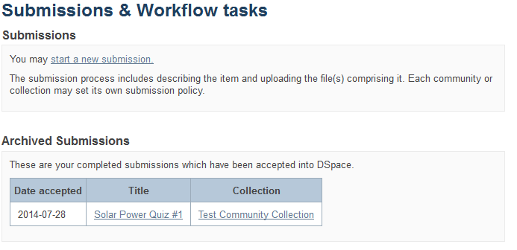
- You are now on the item page. To edit this item click on “Edit this item” under the “Context” heading.
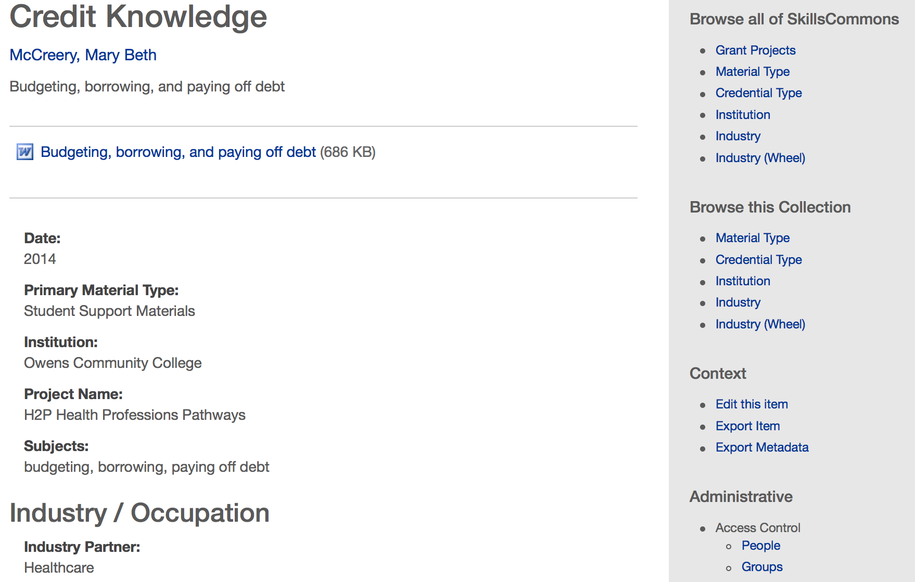
Click on “Edit this item” under the “Context” heading
- After clicking on “Edit this item” you will be presented with the screen below. Click on “Item Metadata” to edit the fields in this item.
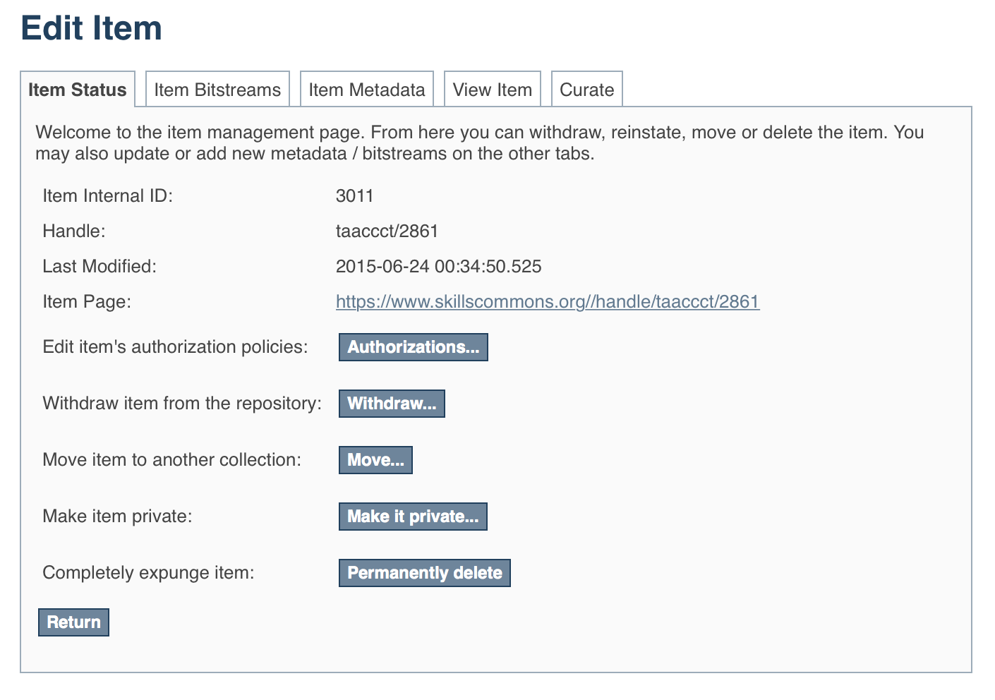
Click on “Item Metadata” to edit the fields in this item.

- After clicking “Item Metadata” you will be presented with the full Metadata record. This record will show you the fields that you initially entered when you first submitted the item.
PLEASE NOTE: These changes are not validated in any way. You are responsible for entering the data in the correct format. If you are not sure what the format is, please do NOT make changes. If you need assistance making edits please contact our support staff at support@skillscommons.org.
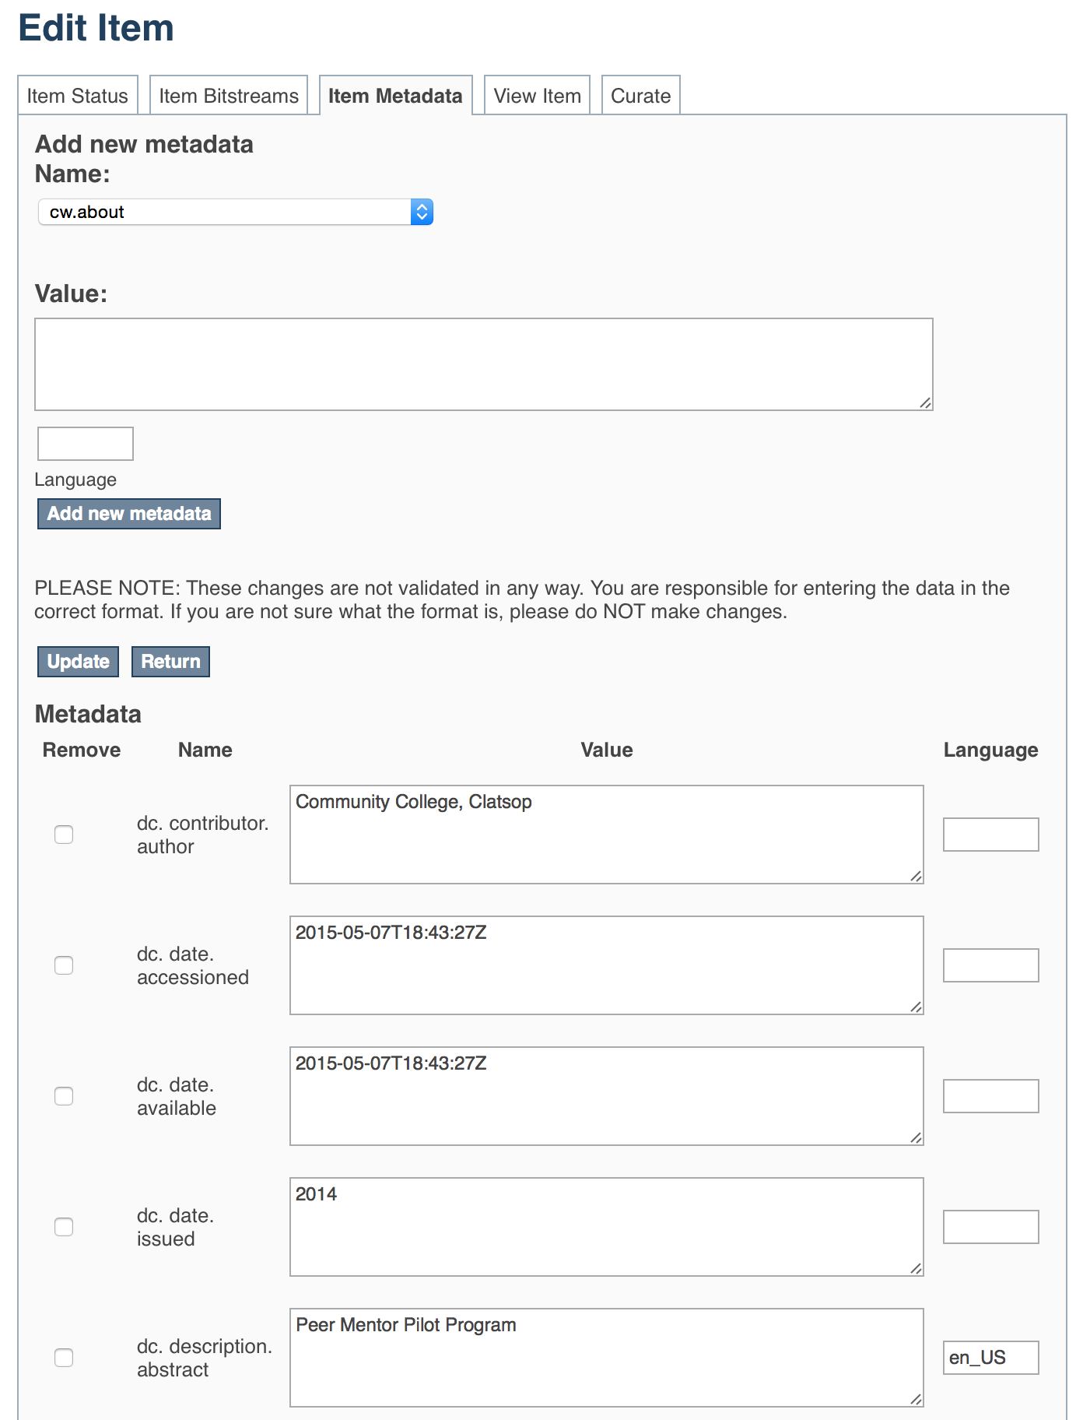
To update the Description Field that you already entered, scroll down and find the “dc. description. abstract” field you wish to update and type the new information.
Be sure to click on the “Update” button found at the top or bottom of the page.

To update the Industry Field that you already entered, scroll down and find the “dc. description. sponsorship” field you wish to update and type the new information.
Be sure to click on the “Update” button found at the top or bottom of the page.

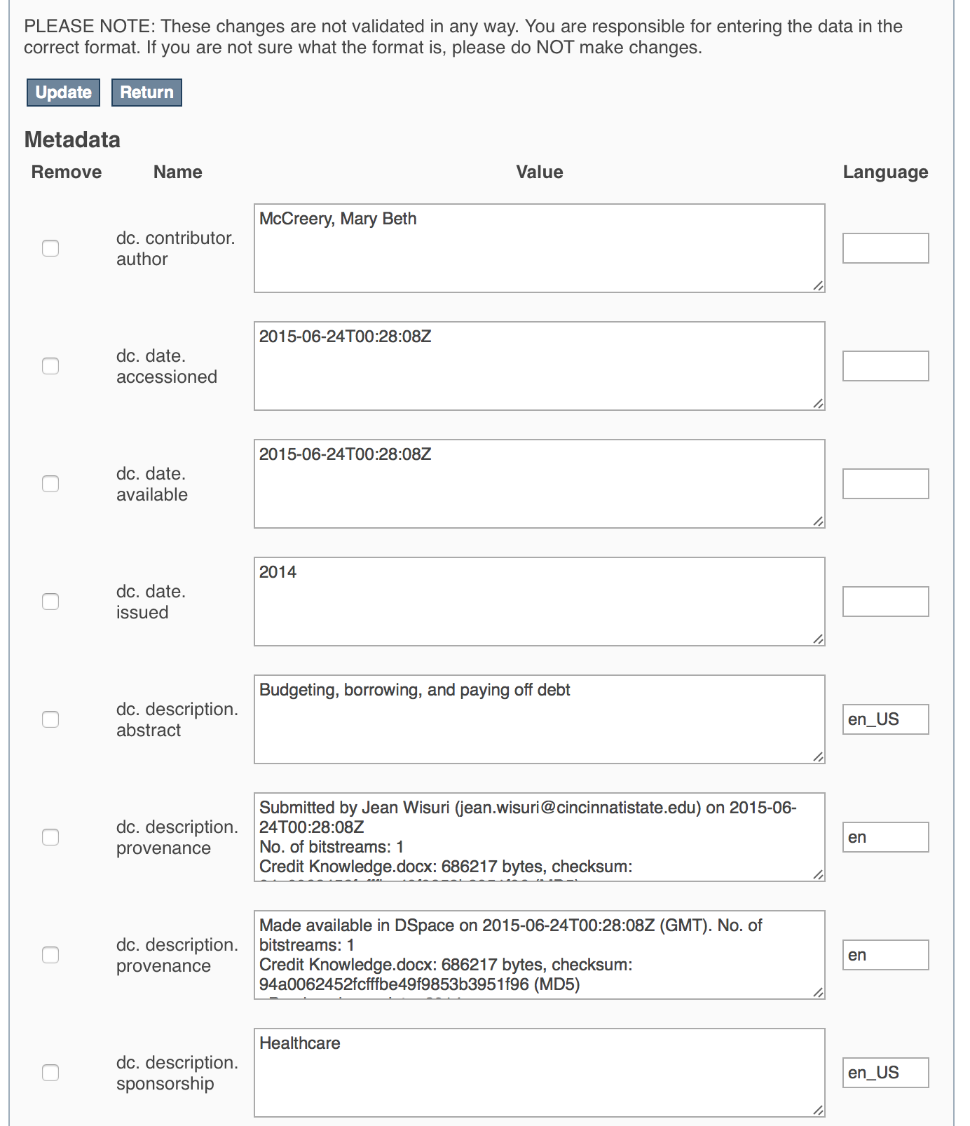
To update the Industry Field that you already entered, scroll down and find the “dc. description. sponsorship” field you wish to update and type the new information.
Be sure to click on the “Update” button found at the top or bottom of the page.

This work is licensed under a Creative Commons Attribution 4.0 International License.
This workforce solution was created through a cooperative agreement between the U.S. Department of Labor's Employment and Training Administration and the California State University-Multimedia Educational Resource for Learning and Online Teaching (MERLOT).

