Free Hosting of Online Courses
Teaching a course online involves delivering digital content to students, typically through a Learning Management System (LMS). An LMS provides a place to store and display digital content, organize users into courses and give the users roles such teachers, students, etc, deliver messages to users through email and announcements, deliver tests and manage a grade book, and so on.
There are several LMS products with significant market shares, including Blackboard (www.blackboard.com), Canvas (www.canvaslms.com), Desire2Learn/Brightspace (www.brightspace.com), etc.
If an instructor does not have access to an LMS through their school, there are free-to-use options. This document describes how to use CourseSites by Blackboard (www.CourseSites.com) to host a course submitted to SkillsCommons. Through CourseSites, an instructor can teach up to 5 courses at no charge and invite students to enroll.
The CourseSites website provides plenty of help materials, but here is an overview of the process:

Signing Up
While CourseSites is free, you do need an account. Visit the website and sign up as either an instructor or student:
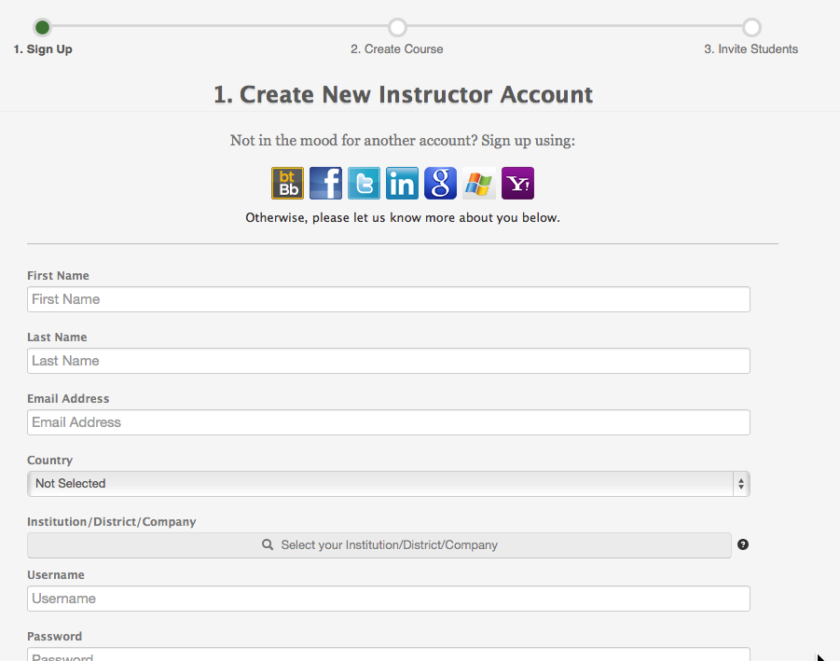
CourseSites Create New Instructor Account Form

Creating a Course by Importing a Blackboard Course Export
Once you have an account, you have the option to create a course. You can build a course from scratch, uploading materials as appropriate. You can also use materials that you have downloaded from SkillsCommons. Note that materials in SkillsCommons carry the Creative Commons attribution license, which allows you to reuse the materials. In some cases, the SkillsCommons submission includes either a Blackboard course export file or an IMS Common Cartridge file. Either of these files will contain material you can import into your CourseSites course as a head start.
Let’s say you want to teach a course on Audiometry. There is such a course in SkillsCommons you can use as a base.
https://www.skillscommons.org/handle/taaccct/1888

SkillsCommons Submission Page for Audiometry Materials

This course has both a Blackboard export format and an IMS Common Cartrige format available. Since CourseSites is based on Blackboard, the preferred format is the export

In CourseSites, choose to create a course from your Home Page.

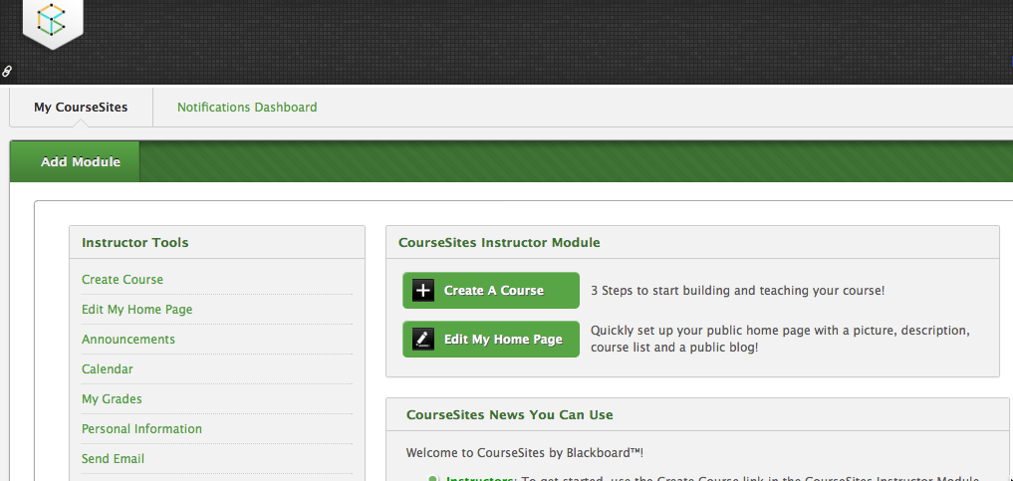

CourseSites Home Page with Create A Course Button

Clicking on the Create A Course Button gives you a wizard to guide you through the process.

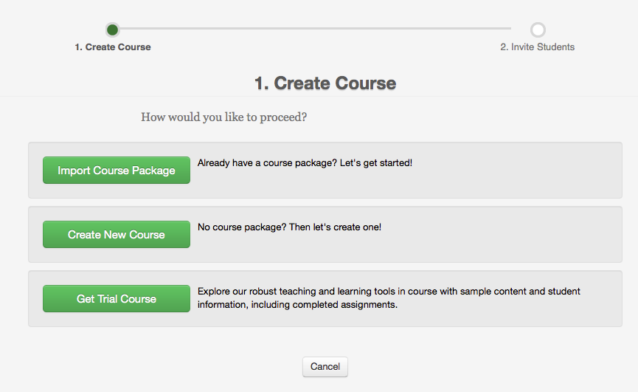
Create Course Form
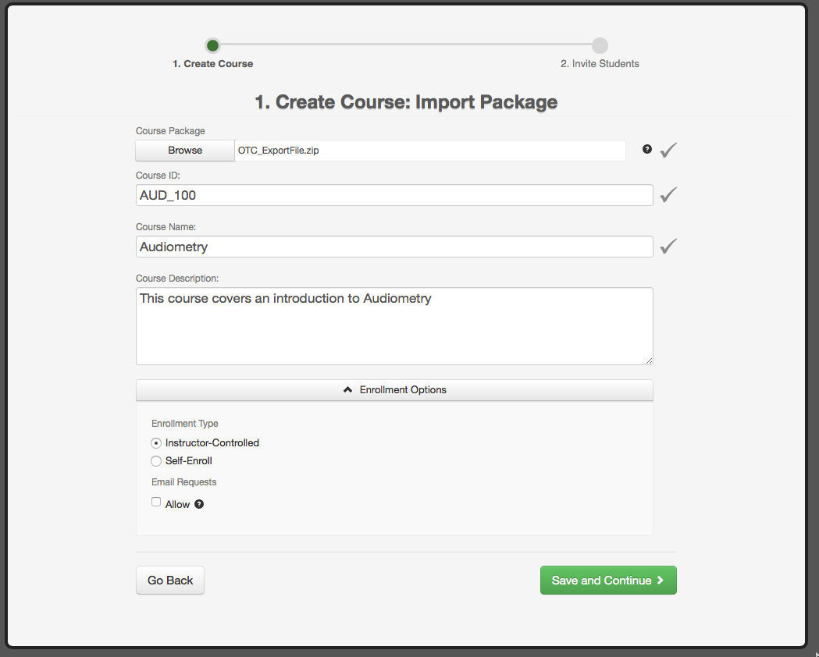
Import Package Form
You will want to use the Blackboard export file and then any course ID, name, and description. Note that when you download the export file from SkillsCommons, your browser may unzip the file. The file needs to be in zipped format before it can be imported into CourseSites. If you only see the unzipped form, zip all of the contents into a file for import.
After import, you are prompted to invite students, which you can do right away or later.
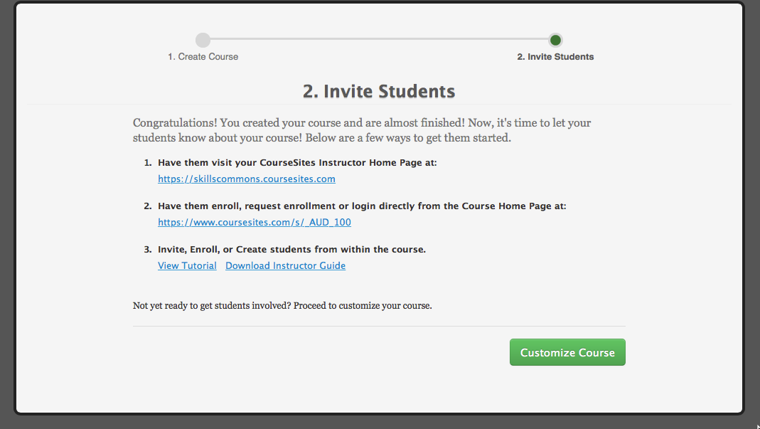
Invite Students Step
The imported course contains the content in the SkillsCommons submission. You can control the styling, colors, layout, etc. using Blackboard menus.
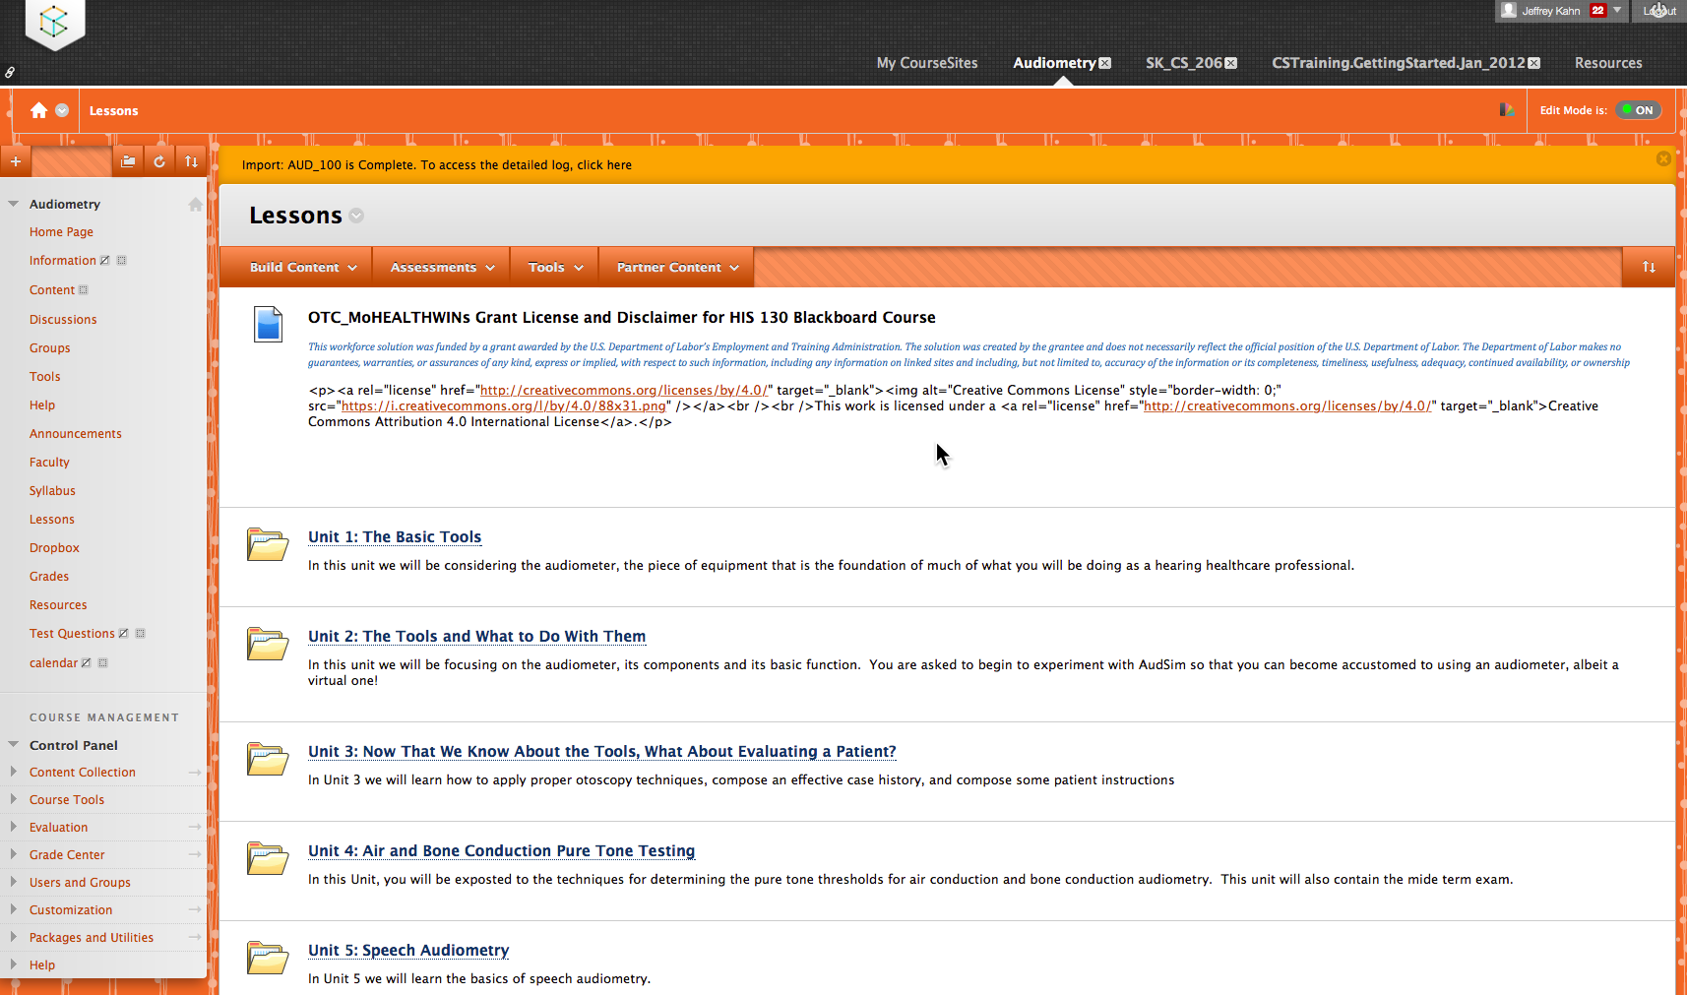
Imported Course Content

Creating a Course by Importing an IMS Common Cartridge
The process for creating a course given an IMS Common Cartridge is the same, just upload the imscc file in place of the zip. An export file from Blackboard will provide a better experience since nothing is stripped out in making the export. In making the cartridge, some content such as announcements are stripped out and there are some other concessions to a common format. Still, the content will import and this is a much better start than a blank course.

Create a Course from Scratch
If there is no SkillsCommons export file, create a new CourseSites course and use the Blackboard menus and features to assemble your materials. No matter the method by which the material is placed into the course, the benefit of a free LMS remains.
This work is licensed under a Creative Commons Attribution 4.0 International License.
This workforce solution was created through a cooperative agreement between the U.S. Department of Labor's Employment and Training Administration and the California State University-Multimedia Educational Resource for Learning and Online Teaching (MERLOT).

