Assess the Accessibility
Of

PowerPoint Documents

Table of Contents

Introduction 3
Text Access 4
Reading Order 7
Structural Markup and Navigation 9
Tables 11
Hyperlinks 12
Color as Information 14
Color Contrast 16
Images 20

Introduction
This tutorial provides step-by-step instructions on how to determine the accessibility of PowerPoint Presentations.

Tools
The list below contains links to the applications used in this tutorial to assess PowerPoints:
- Colour Contrast Analyser (CCA)
- Microsoft PowerPoint

Further Assistance
If the PowerPoint Presentation being assessed does not meet one or more of the accessibility criteria described below, please consult with the campus office serving students with disabilities for assistance in obtaining an accessible version. Providing this access in a timely manner is critical for student success.

Text Access
Allows users to enable text-to-speech functionality so that the text may be read aloud.

What to do
Listen to the text

Tool(s) to use
Microsoft PowerPoint for PowerPoint presentations (.ppt, .pptx) and compatible formats (.rtf)

How to use
- Open the document in Microsoft PowerPoint.
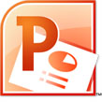
- Select More Commands… from the Custom Quick Access Toolbar.
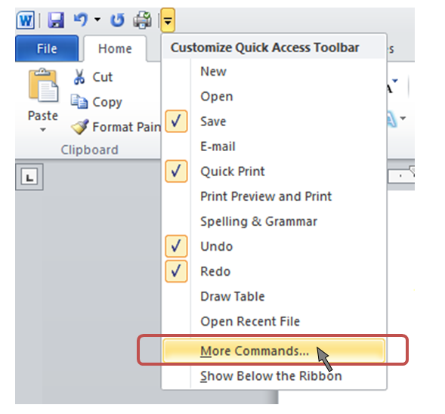

- Select All Commands from the Choose commands from: dropdown menu. 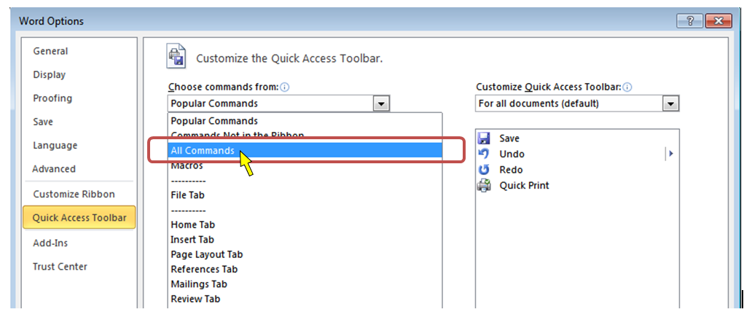
- Select Speak from the list of commands on the left
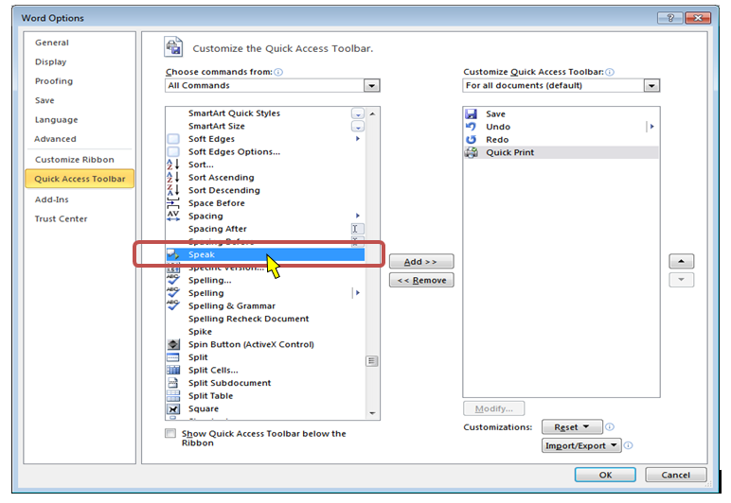
- Select the Add > > button
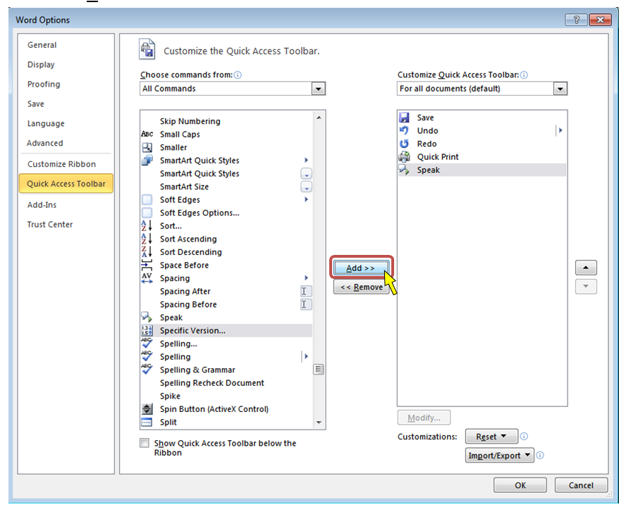
- Select the OK button
- Select the text in the slide to be read aloud
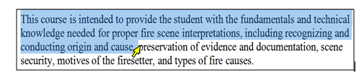
Note: If the text is selectable letter by letter, then this is a good indication that the text is digital.
- If needed, enable the computer’s sound and adjust it to a safe volume level to listen to Word speak the text aloud.
- On the Custom Quick Access Toolbar, select the Speak selected text icon to hear the text read aloud.
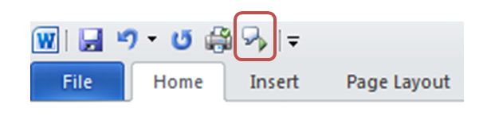

What is the Result?
If the text can be heard using the Speak function in Microsoft PowerPoint, then it is digital text that assistive technology may be able to access for the reader.
If the text is not selectable or cannot be read aloud by a text to speak application, such as the Speak function in PowerPoint, then the text in the material is not digital and assistive technologies may not be able to access information in the document.

Reading Order
Reading order corresponds to visual layout.

What to do
Check the reading order

Tool(s) to use
Microsoft PowerPoint for PowerPoint presentations (.ppt, .pptx) and compatible formats (.rtf)

How to use
- Open the presentation in Microsoft PowerPoint
- In the Drawing group on the Home ribbon, select the Arrange dropdown menu
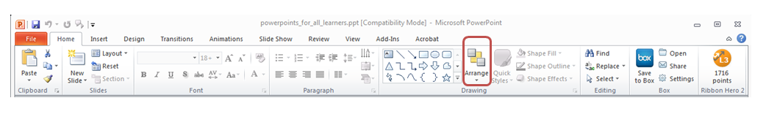
- Choose Selection Pane…
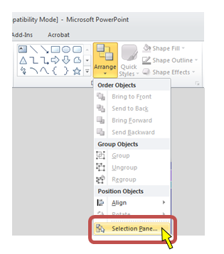

- Select each item in the Shapes and Visibility pane.
Note: The item in the bottom of the list should correspond with the first group of content on the slide. The item in the top of the list should correspond with the last group of content. This may seem counterintuitive but it is the way the reading order is organized.
Note: The circled numbers are not part of Microsoft PowerPoint; they are placed on the screenshot to illustrate the order of content on the slide. The number depicts that the Title area is read first, and the column on the right is then read, followed by the second column read third.
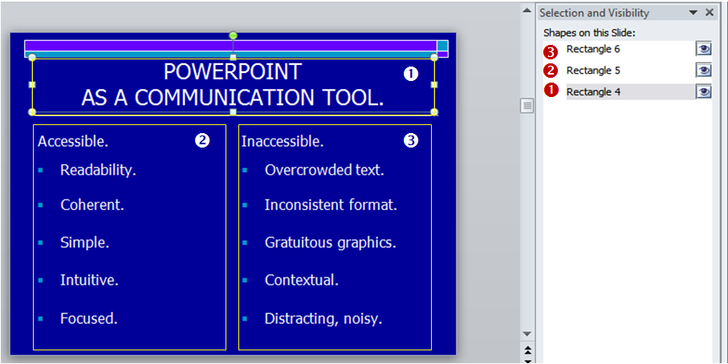

What is the Result?
The PowerPoint presentation has proper reading order if the content of the slides are in the logical order intended by the author. The visual order should generally start at the top left of the slide and end at the bottom, right.
The PowerPoint presentation does not have proper reading order if the content of the slides are not in logical order.

Structural Markup and Navigation

The document includes structural markup such as headings and lists that can be used for navigation by assistive technology.

What to do
Assess the structure of the document by looking for headings, lists and tables.

Tool(s) to use
Microsoft PowerPoint for PowerPoint presentations (.ppt, .pptx) and compatible formats (.rtf)

How to use
- Open the presentation in Microsoft PowerPoint
- In the pane on the left, select the Outline tab.
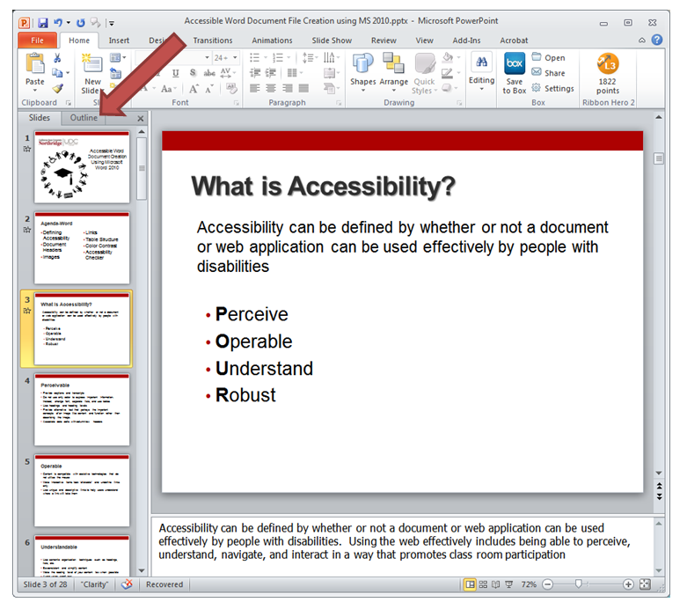

- Verify that the text in each slide is also in the Outline pane
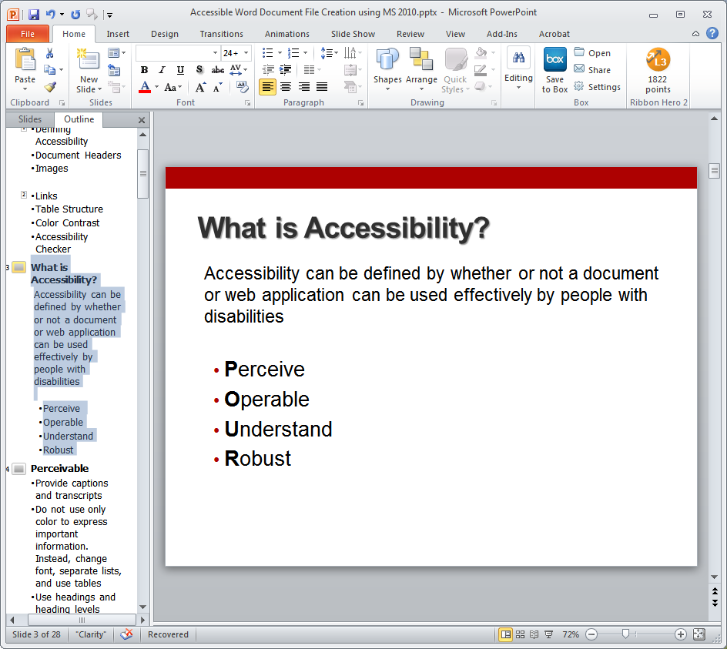

What is the Result?
The document has structural markup that can be used for navigation if the heading levels and list styles are used throughout the document.
- Each slide has a title that displays in the outline.
- The text of each slide displays in the outline.
- Lists are structured using the bullet and/or number list function(s)
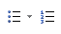
The document does not have a proper structural markup if:
  - The document contains what looks like titles and lists, but the corresponding structure is not used.
  - The text in the slide does not appear in the outline

Tables

Data tables include markup that identifies row and column headers.

What to do
If the Power Point being assessed does not meet one or more of the accessibility criteria described below, please consult with the campus office serving students with disabilities for assistance in obtaining an accessible version. Providing this access in a timely manner is critical for student success.

Hyperlinks

Allows users to understand a link’s destination and what the name of the resource is that they are linking to.

What to do
Verify that links have a recognizable meaning and are functional.

Tool to use
Microsoft PowerPoint for PowerPoint presentations (.ppt, .pptx) and compatible formats (.rtf)

How to use
- Open the PowerPoint document
- Browse through the document and look for links.
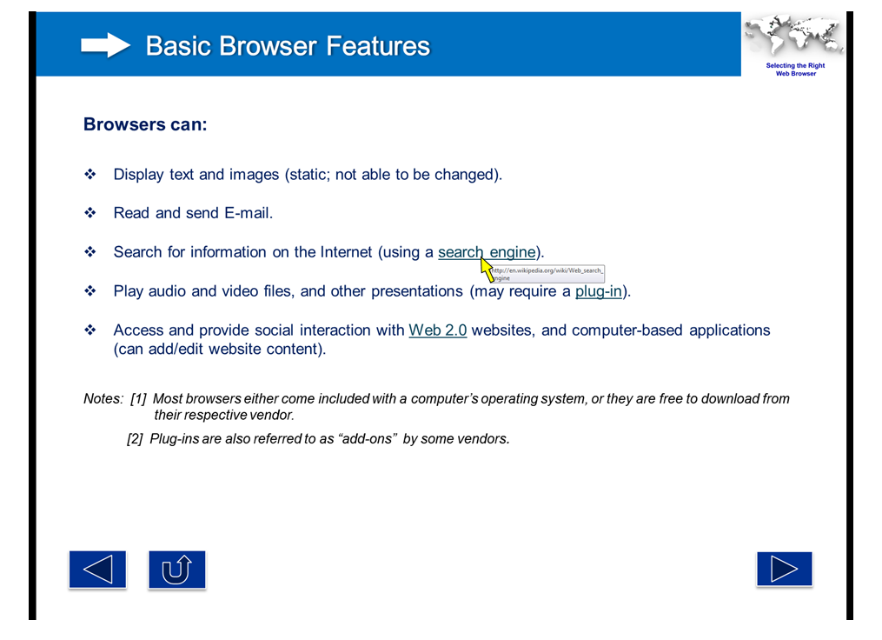
- Manually check the links by selecting them.
- Verify that the link goes to the expected destination.

What is the Result?
All users may be able to use the links included in a document if they are understandable and work properly. The hyperlinks in a document are operable and understandable if:
  - The links go to their appropriate destination.
  - The link text for the link clearly states where it will lead. A link labeled “Word doc” does not tell a person where it is linking to, especially when taken out of context of the text around it.
Below is a list of links that do not have meaningful names:
“Click here”
“Next document”
“New document”
“here”
“Link”
  - Links are well labeled if the link text is understandable when extracted from the surrounding text.
  - Many users navigate a page by listing the links without the surrounding text.

Users may not be able to use the links included in a document if they are not understandable or do not work as expected. Hyperlinks are not useful to users if:
  - Links are broken
  - Links do not have meaningful text
  - Link text is “Click here”, “About”, “More Info”, “More”, etc.
  - Links do not look different from its surrounding text

Color as Information

When information is conveyed using color, a second technique is necessary for users that cannot perceive colors.

What to do
Look for content that conveys meaning through the use of only color.

Tool to use
Microsoft PowerPoint for PowerPoint presentations (.ppt, .pptx) and compatible formats (.rtf)

How to use
- Open the PowerPoint document
- Read through the content and look for instructions or descriptions that require readers to interpret colors. In the screenshot below, the Intraembryotic mesoderm section with the paraxial, intermediate and lateral plate portions being differentiated with color only. Paraxial is yellow, intermediate is green, and laterial plate is red.
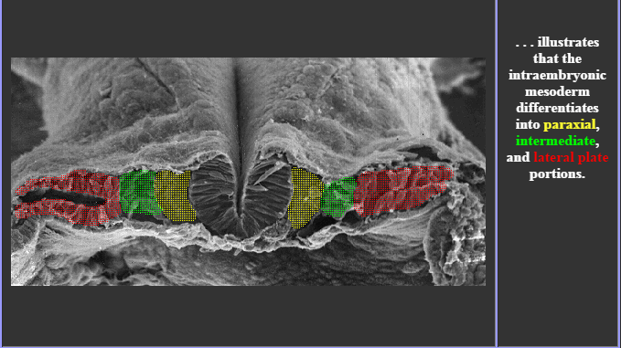

What is the Result?
Users may visibly perceive information and instruction when alternative distinguishing features are used such as:
- The use of Strong, larger, or italic font is used in combination or instead of color
- The use of symbols, such as asterisk (*) or pound (#), is used in combination or instead of color.
- The use of an underline or pattern is used in combination or instead of color.
Using any of these alternatives may be beneficial to users who are colorblind.

Users may not be able to visibly perceive information and instruction if they are color dependent. Users with colorblindness may not be able to use the document because there are no alternatives to color available.

Color Contrast
High contrast helps users distinguish between text and the background on which the text appears. Tools can test for the proper contrast ratio of 4.5:1 provided between the text (foreground) and its background.

What to do
Analyze the color contrast between text and its background.

Tool(s) to use
Colour Contrast Analyser (CCA)

How to use
- Open the PowerPoint document.

- Open the Colour Contrast Analyser.
- Scan the page for text with color combinations other than black text with white backgrounds (and vice versa)

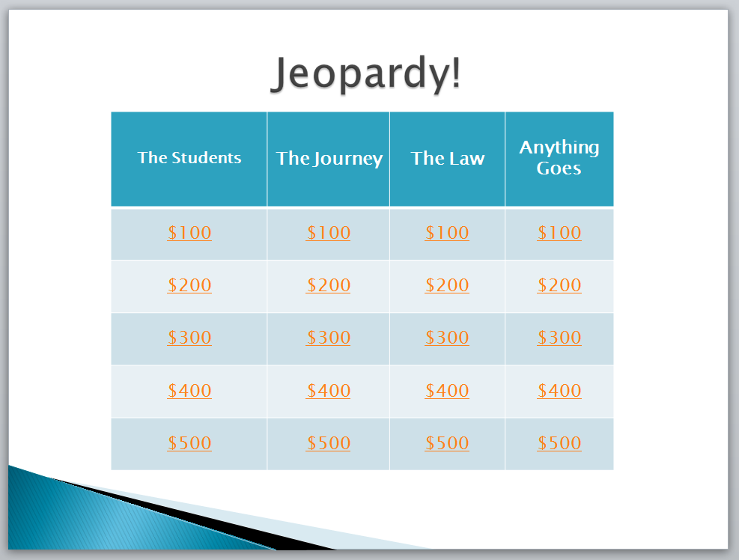
http://www.merlot.org/merlot/downloadFile.htm?fileName=Nanabek%2fIntroductory+Inclusion+jea.gm.pptx

- Using the CCA’s Foreground Colour Sampler, select the color of the text by placing the cross hair in the center of the letter.

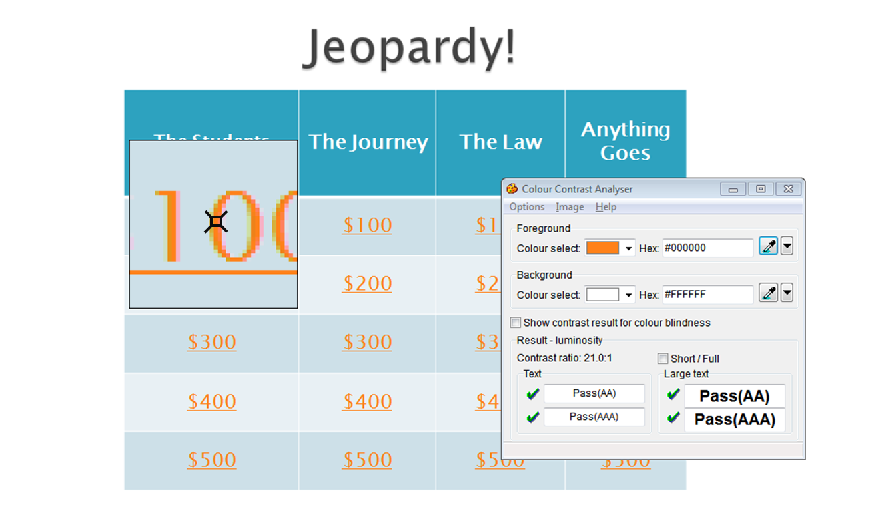

- To analyze the contrast, use the Background Colour Sampler and place the crosshair just outside of the letter previously selected.
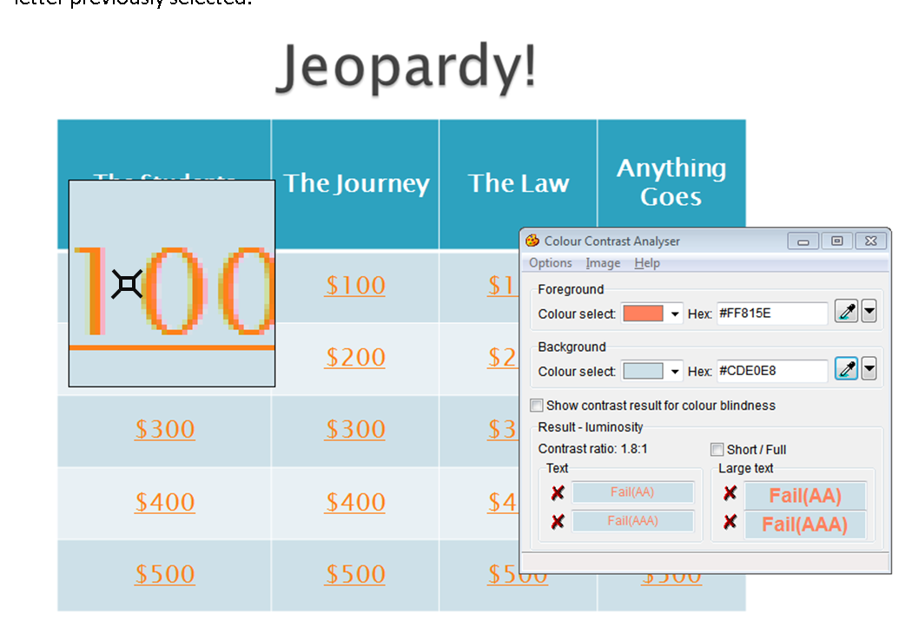
Note: Use the Colour Contrast Analyser. Do not assume that the contrast is accessible without using a color contrast analyzing tool. Sometimes, the contrast between text and background may appear like it should pass a color contrast test, but when tested, failed due to low contrast.
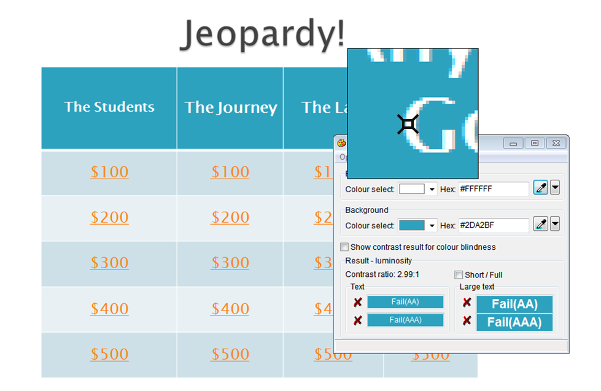
- Review the results of at the bottom of the CCA.

What is the Result?
If there is a green check mark next to the word Pass (AA), then the text and foreground color combination has a high enough contrast that is suitable for most people.
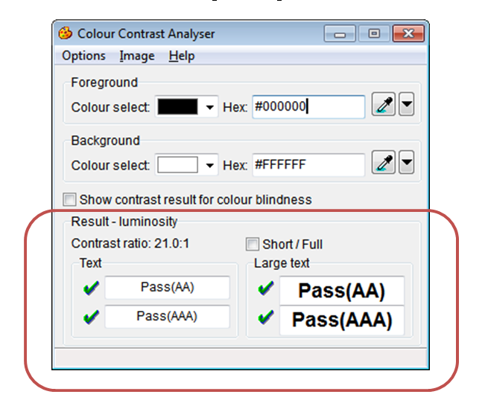

If there is a red x next to the word Fail (AA), then the text and foreground color combination does not have a high enough contrast and people with color blindness may not be able to read the text.
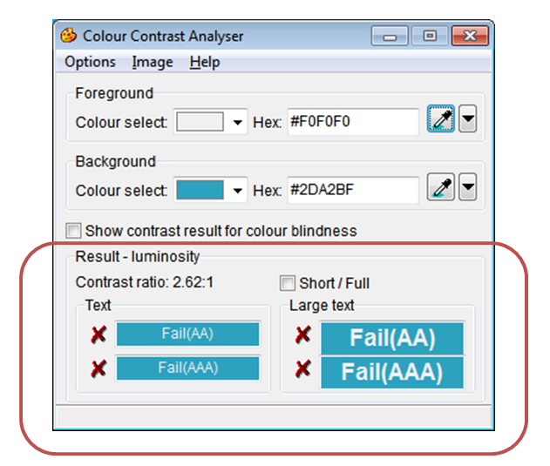

http://www.merlot.org/merlot/downloadFile.htm?fileName=Nanabek%2fIntroductory+Inclusion+jea.gm.pptx

Images
Meaningful images should be described for all users. As authors, consider what message the image is meant to provide. If it is meaningful, a brief description of the intended information should be provided.

What to do
Check the images in the document for alterative text or a description of the image in the surrounding text.

Tool(s) to use
Microsoft Word for Word documents (.doc, .docx) and compatible formats (.txt, .rtf, .wps, .wpd)

How to use
- Open the PowerPoint document
- Right click on the image and select Format Picture…, Format Object… or Format Shape… at the bottom of the shortcut menu.
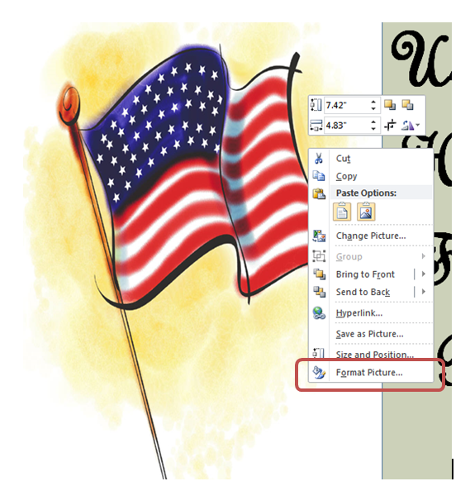

- Select Alt Text in the menu to the left to displays the alternative text for this image.
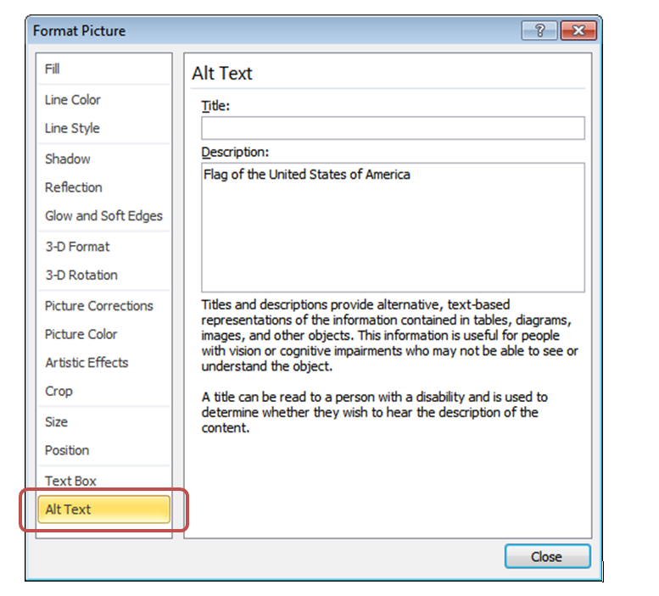
- Read the alternative text in the Description: field
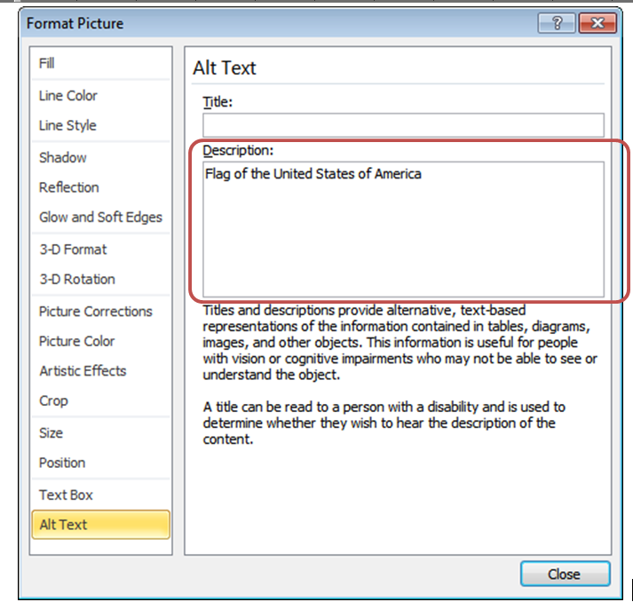

What is the Result?
If the Description: section of Alt Text contains a short description of the image’s function, meaning or content, then the document has appropriate alterative text. The image has proper descriptions if:
- The alternative text description is short and meaningful. The image may be described to assistive technology users.
- Complex images, charts, and graphs are described in surrounding text for all users to read. Complex images may also be supplemented with a link to additional information.
- Decorative images do not have alternative text descriptions. These images may be ignored by assistive technology which decreases the amount of non-important information the user of assistive technology will hear.
Note: The following images do not need to have alternative text descriptions:
- decorative images
- unimportant images
- important images that are described in a paragraph above or below

The document does not have proper alternative text if:
  - The Description: field is blank.
  - The Description: field does not have a short description of the image’s function, meaning or content.
  - The Description: field contains a web address (unless the image is of a simple, high level web address)
