SkillsCommons Repository User Guide

Learning Resources Collection
Welcome to the SkillsCommons Repository. This document was created to assist with the single item submission process for the “Learning Resources Collection” within your Community. This document will cover adding submissions, editing completed submissions and deleting completed submissions.

ADDING (SUBMITTING) MATERIALS

- Type http://skillscommons.org/ into your browser address bar.
- Click “CONTRIBUTE” located in top menu navigation of the SkillsCommons Repository website.

- Sign in to the SkillsCommons Repository using the e-mail address and password you were provided.
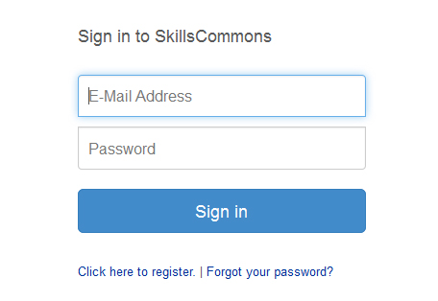
- Once you have signed in click on the “start a new submission” link.
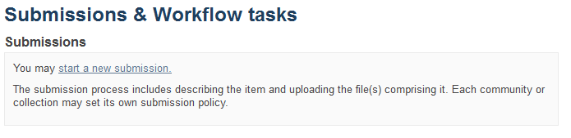
- Select the “Learning Resources Collection” from the “Collection” dropdown menu and click “Next” to start your submission.
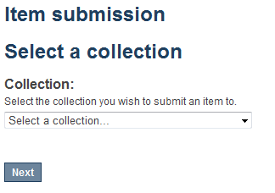
- Entering your Item Description – PAGE 1
The single item submission process is a six step process that allows you to enter all the metadata about your material, upload the associated files, review your submission, and finally submit the item to the repository. Enter as much information about the item as you can in order to help others find it in the repository. Each field has a brief description of the data you should enter into the field. The following pages provide some additional information about each field.
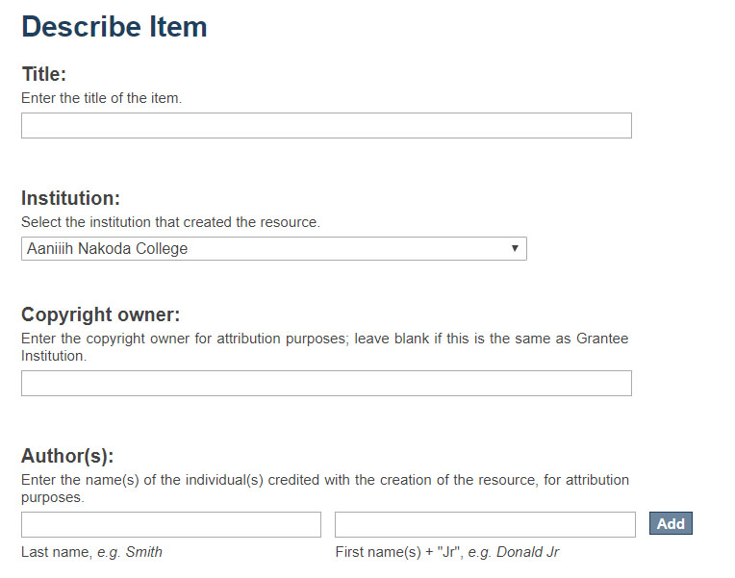
Author(s): To add multiple authors click the “Add” button.
Copyright owner: Enter the copyright owner for attribution purposes; leave blank if this is the same as Institution.
Institution: (REQUIRED FIELD) Select the name of the institution that created the resource.
Title: (REQUIRED FIELD) Enter the title of the item.
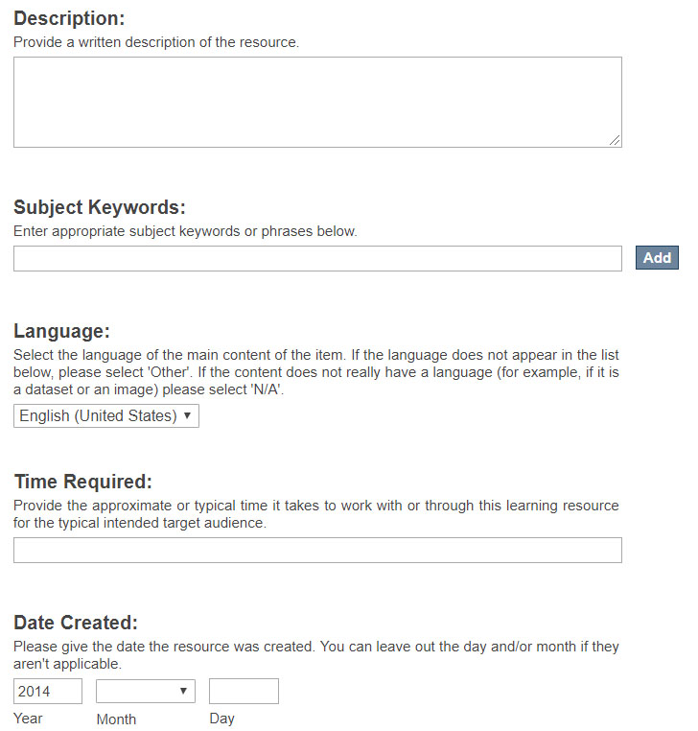
Date Created: (REQUIRED FIELD) The “Year” field is required.
Time Required: Provide the approximate or typical time it takes to work with or through this learning resource for the typical intended target audience.
Language: Select the language of the main content of the item.
Subject Keywords: Keywords allow users to find materials in the repository. Enter multiple keywords by clicking the “Add” button after each keyword.
Description: (REQUIRED FIELD) Use this field to describe the material in as much detail as possible so others can find it when searching the repository. A detailed description also helps users decide if it is an appropriate material for their use. Be as specific as possible so others can understand what the material is about.
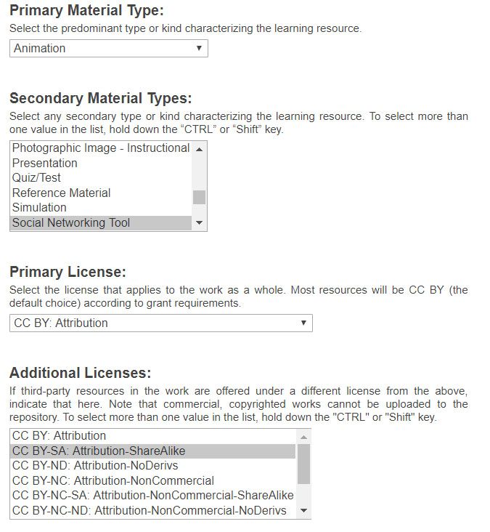
Additional Licenses: If third-party resources in the work are offered under a different license from the above, indicate that here. Note that commercial, copyrighted works cannot be uploaded to the repository. To select more than one value in the list, hold down the "CTRL" or "Shift" key.
Primary License: (REQUIRED FIELD) Select the license that applies to the majority of items in the work. Most resources will be CC BY (the default choice) according to the grant requirements.
Secondary Material Types: Select any secondary type or kind characterizing the learning resource you are uploading. To select more than one value in the list, hold down the “CTRL” or “Shift” key.
Primary Material Type: (REQUIRED FIELD) Select the predominant type or kind of material characterizing the learning resource you are uploading.

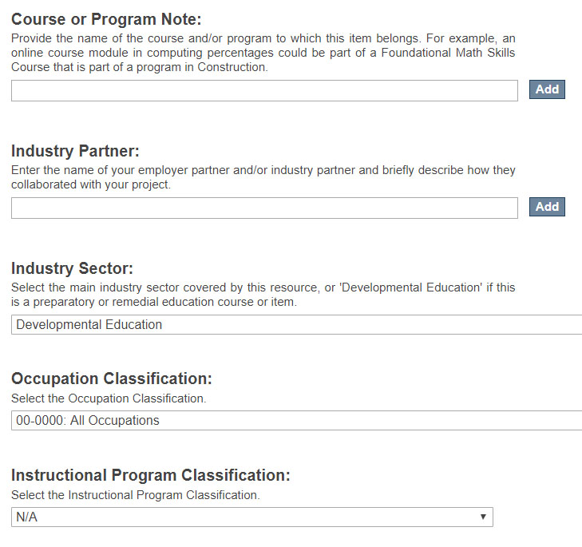
Instructional Program Classification: (REQUIRED FIELD) Select the relevant CIP code to classify the instructional program that the item or course originally belonged to.
Occupation Classification: (REQUIRED FIELD) Select the relevant SOC code for this course or item.
Industry Sector: (REQUIRED FIELD) Select the main industry sector (NAICS code) covered by this resource. If this is a preparatory or remedial education course/item select “Developmental Education”.
Course or Program Note: Provide the name of the course and/or program to which this item belongs. For example, an online course module in computing percentages could be part of a Foundational Math Skills Course that is part of a program in Construction. Click the “Add” button to add more than one.
Industry Partner: Enter the name of your employer partner and/or industry partner and briefly describe how they collaborated with your project.

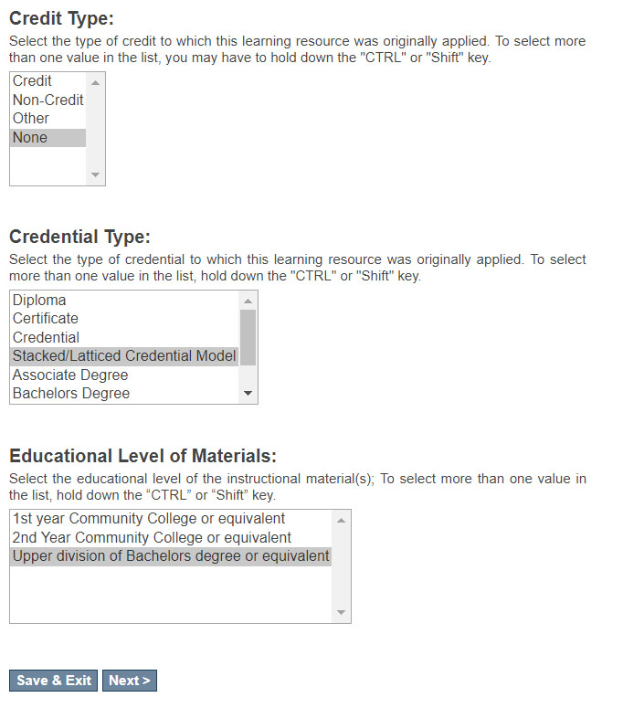
Click “Save & Exit” if you would like to return later to complete the submission. Click “Next” to continue on to PAGE 2 of the material description process.

Educational Level of Material: (REQUIRED FIELD) Select the educational level of the instructional material(s); To select more than one value in the list, hold down the “CTRL” or “Shift” key.
Credential Type: (REQUIRED FIELD) Select the type of credential to which this learning resource was originally applied. To select more than one value in the list, hold down the "CTRL" or "Shift" key.
Credit Type: (REQUIRED FIELD) Select the type of credit to which this learning resource was originally applied. To select more than one value in the list, hold down the "CTRL" or "Shift" key.
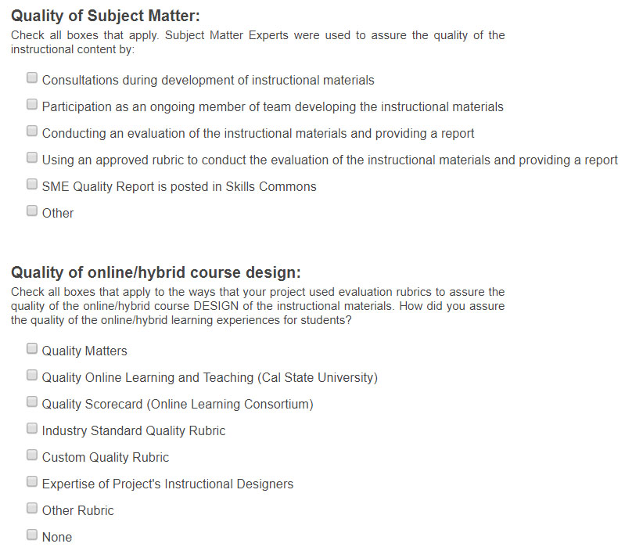
Quality of Subject Matter: (REQUIRED FIELD) Check all boxes that apply.
Quality of online/hybrid course design: (REQUIRED FIELD) Check all boxes that apply.

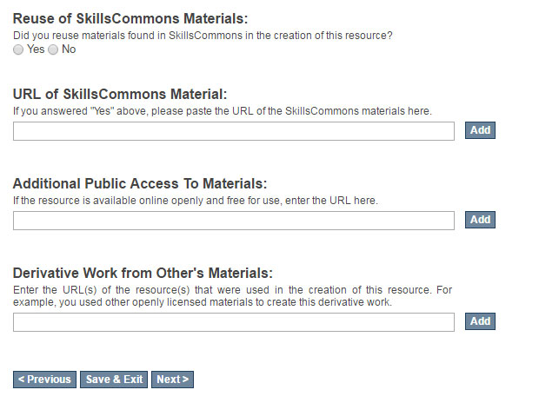
Derivative Work from Other’s Materials: Enter the URL(s) of the resource(s) that were used in the creation of this resource. For example, you used other openly licensed materials to create this derivative work. Click the “Add” button to add more than one URL.
Additional Public Access To Materials: If the resource is available online openly and free for use, enter the URL here. Click the “Add” button to add more than one URL.
URL of SkillsCommons Material: If you answered “yes” to the question above, please paste the URL of the SkillsCommons materials here. Click the “Add” button to add more than one URL.
Reuse of SkillsCommons Materials: Did you reuse materials found in SkillsCommons in the creation of this resource? Click “Yes” or “No”

Click “Previous” to go back to PAGE 1. Click “Save & Exit” to return later to complete the submission. Click “Next” to continue on to PAGE 3.

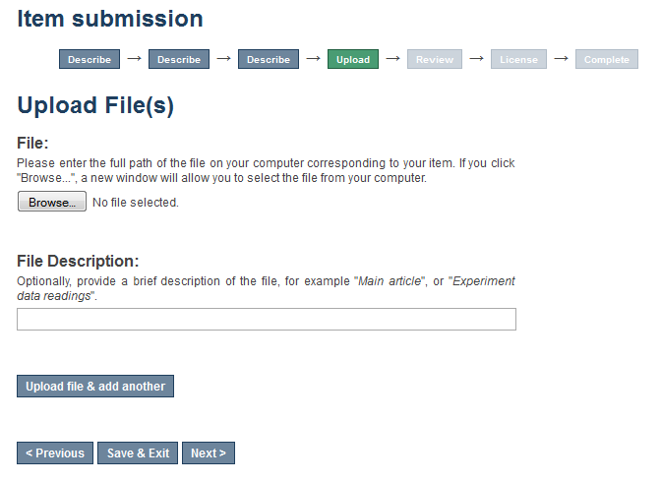
If you would like to upload multiple files click “Upload file & add another”
Reminder – don’t forget to upload your Quality Assurance Report and your Accessibility Checkpoint Form if applicable.
Provide a brief description of the file. The description you provide should be helpful to someone considering whether to download the material. As an example, "Workshop Announcement Flyer" is more helpful than "Workshop Document."
Click “Previous” to go back a page. Click “Save & Exit” if you would like to come back later and finish. Click “Next” to continue entering data.
Browse for and select the file you would like to upload.

- If you are uploading multiple files and you click on “Upload file & add another” you will be presented with the following screen. Here you will be able to “Browse” for and upload additional files, edit a previously uploaded file, as well as remove a previously uploaded file.
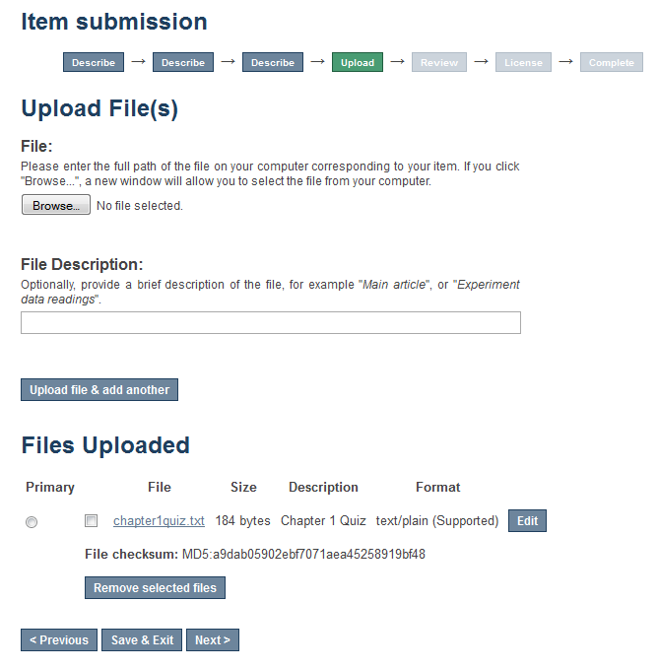
If you have multiple files you can use the radio button to indicate which of the files is the primary file for this submission.
Click “Edit” to edit an existing uploaded file.
To remove a previously uploaded file click the check box located to the left of the file name and then click “Remove selected file”
Click “Upload file & add another”
Add a brief description of the file.
Click “Browse” to upload another file.
- After you click “Next” you will have a chance to review your work and make changes on the Review Submission page.
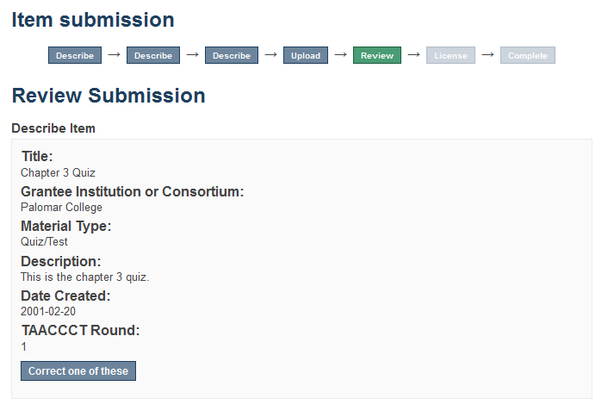
Click the “Correct one of these” buttons located at the end of each section.
- Once you are satisfied with your submission, click on the “Complete Submission” button at the bottom of the page.
- Your submission is complete. You will receive an e-mail notification when your submission has been added to the collection.
Submit another item.
View your recently submitted items.

EDITING AN ITEM IN THE REPOSITORY

- Type http://skillscommons.org/ into your browser address bar.
- Click “CONTRIBUTE” located in the top menu of the SkillsCommons Repository website.

- Sign in to the SkillsCommons Repository using your e-mail address and password.
- Once you have signed in click on the submission you wish to edit. For our purposes we will edit the “Solar Power Quiz #1” item.
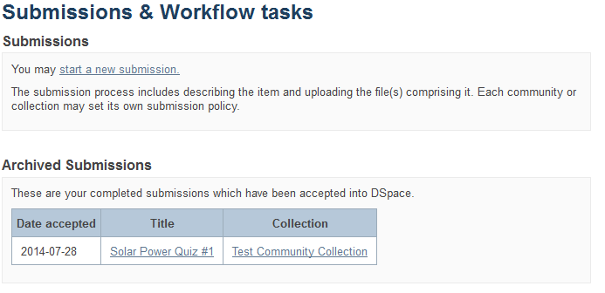
PLEASE NOTE: if there is an item you wish to edit but you are not the original creator of the item it will not show up in your Archived Submissions. To access this item for editing find the item in the repository and then follow the instructions beginning at step number 5 below.
- You are now on the item page. To edit this item click on “Edit this item” under the “Context” heading.
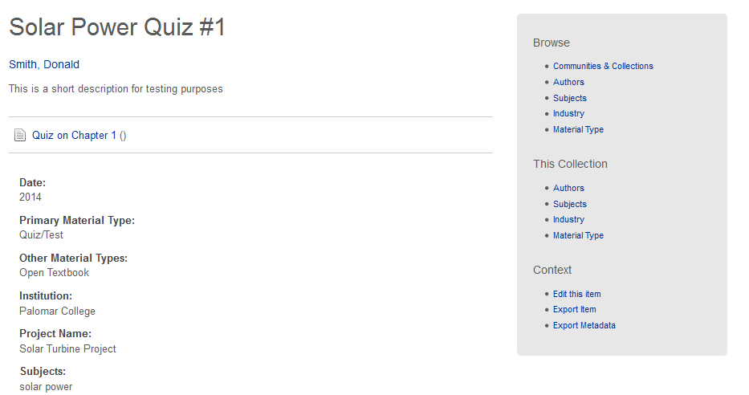
Click on “Edit this item” under the “Context” heading
- After clicking on “Edit this item” you will be presented with the screen below. Click on the “Item Metadata” tab to edit the fields in this item.
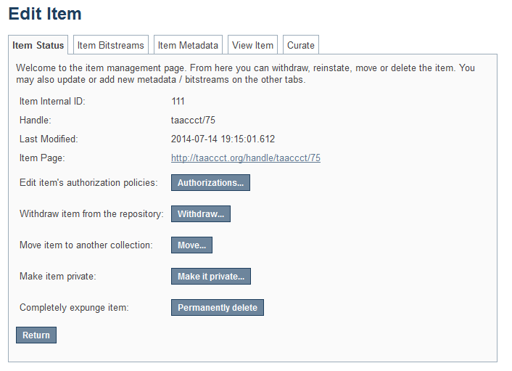
Click on “Item Metadata” to edit the fields in this item.

- After clicking “Item Metadata” you will be presented with the full Metadata record. This record will show you the fields that you initially entered when you first submitted the item.
TO ADD A NEW FIELD - find the field metadata name in the “Name” dropdown menu. Please see Appendix A for full list of fields and associated metadata names.
PLEASE NOTE: These changes are not validated in any way. You are responsible for entering the data in the correct format. If you are not sure what the format is, please do NOT make changes. If you need assistance making edits please contact our support staff at support@skillscommons.com .
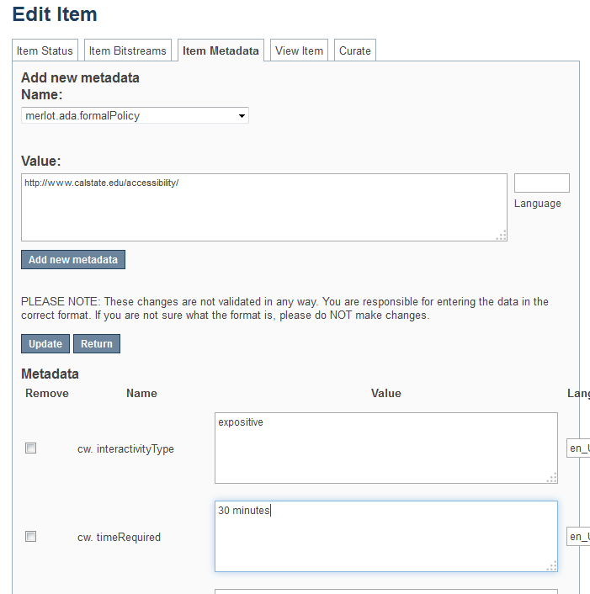
Add the information to the “Value” field.
In our example we are going to add a link to the California State University Formal Accessibility Policy.
To update a field that you already entered, scroll down and find the field you wish to update and type the new information.
Be sure to click on the “Update” button found at the top or bottom of the page.

Click “Add new metadata” and your field will be added.
To add a field that you missed or skipped when you first submitted your item, find it in the “Name” dropdown menu.
See Appendix A for full list of fields and associated metadata names.
In our example we are going to add a URL to the “URL to Formal Accessibility Policy” field.
TO ADD ANOTHER VALUE TO A REPEATABLE FIELD
See Appendix A to see which fields are repeatable. The field “Author(s)” is a repeatable field. For this next example we will add another author to our item.
Please see Appendix A and make sure that the field you are about to add is a repeatable. If it is not repeatable please do not add another field.
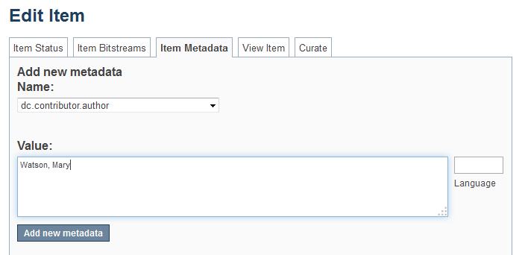
To add another entry to a repeatable field, find it in the “Name” dropdown menu.
See Appendix A for full list of fields and associated metadata names.
In our example we are going to add another author to the “Author(s)” field which corresponds to the “dc.contributor.author” metadata name.
Add the information to the “Value” field.
You must type the value in the appropriate format. If you are unsure of the format check Appendix A at the end of this document.
In this case, the format is [Last Name, First Name].
Click “Add new metadata”
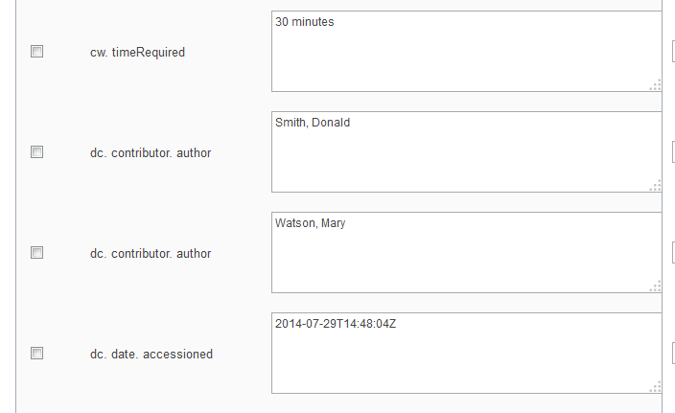
After you clicked “Add new metadata” scroll down to see that you now have another author assigned to the “dc.contributor.author” field.

TO ADD/UPLOAD MORE FILE(S) – Click on the “Item Bitstream” tab. You will be presented with a list of the file(s) that you initially uploaded.
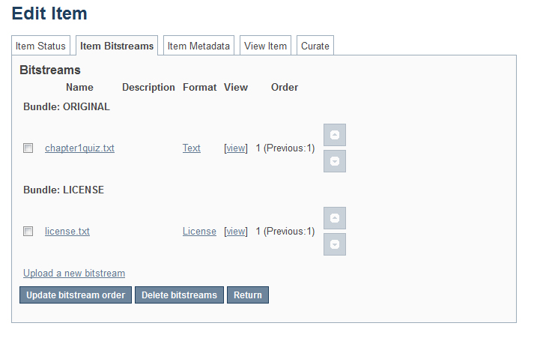
NOTE: The “license.txt” is added when you agree to the terms of service. Please do not edit or delete this item.
This “txt” file does not contain any metadata about your chosen CC BY license.

To upload a new file click on “Upload a new bitstream” link and follow directions to upload your new file(s).

Click on the “Item Bitstreams” tab.

TO DELETE UPLOADED FILE(S) – Click on the “Item Bitstream” tab. You will be presented with a list of the file(s) that you initially uploaded.
NOTE: The “license.txt” is added when you agree to the terms of service. Please do not edit or delete this item.
This “txt” file does not contain any metadata about your chosen CC BY license.

Click “Delete bitstreams”
Select the file(s) you want to delete using the check box.
Click on the “Item Bitstream” tab.
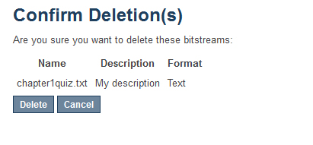
Confirm the deletion(s) by clicking “Delete”
TO EDIT UPLOADED FILE(S) – Click on the “Item Bitstream” tab. You will be presented with your list of uploaded file(s).
NOTE: The “license.txt” is added when you agree to the terms of service. Please do not edit or delete this item.
This “txt” file does not contain any metadata about your chosen CC BY license.
Click on the name of the item you would like to edit. Make your edits and click “Save”
Click on the “Item Bitstream” tab.

DELETING AN ITEM IN THE REPOSITORY

- Type http://skillscommons.org/ into your browser address bar.
- Click “CONTRIBUTE” located in the top menu of the SkillsCommons Repository website.

- Sign in to the SkillsCommons (TAACCCT) Repository using your e-mail address and password.

- Once you have signed in you will see your previous submissions in the “Archived Submissions” area. Click on the submission you wish to delete. For our purposes we will delete the “Solar Power Quiz #1” item.
PLEASE NOTE: if there is an item you wish to delete but you are not the original creator of the item it will not show up in your Archived Submissions. To access this item please find the item in the repository and then follow the instructions beginning at step number 5 below.
- You are now on the item page. To delete this item click on “Edit this item” under the “Context” heading.
Click on “Edit this item” under the “Context” heading.
- After clicking on “Edit this item” you will be presented with the screen below. To delete this item click the “Permanently delete” button.
Click “Permanently delete” to remove this item from the repository.
- After clicking “Permanently delete” you will be presented with the full item record. Scroll to the bottom of the page and click “Delete” to permanently delete the item.
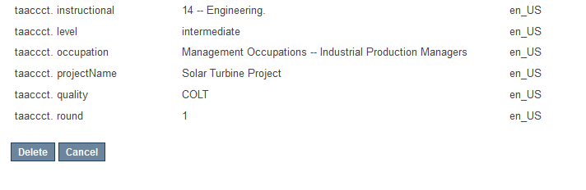
Click “Delete” to permanently delete the item. If you do not want to delete it at this time, click “Cancel”

Appendix A
Learning Resources Collection
Field Names, Metadata Names and Descriptions
http://support.skillscommons.org/home/contribute-manage/metadata-and-apprendices/appendix-a/

Appendix B
Program Support Materials Collection
Field Names, Metadata Names and Descriptions
http://support.skillscommons.org/home/contribute-manage/metadata-and-apprendices/appendix-b/

Appendix C
List of NAICS Codes
http://support.skillscommons.org/home/contribute-manage/metadata-and-apprendices/appendix-c/

Appendix D
List of SOC Codes
http://support.skillscommons.org/home/contribute-manage/metadata-and-apprendices/appendix-d/

Appendix E
List of CIP Codes
http://support.skillscommons.org/home/contribute-manage/metadata-and-apprendices/appendix-e/
This work is licensed under a Creative Commons Attribution 4.0 International License.This workforce solution was created through a cooperative agreement between the U.S. Department of Labor's Employment and Training Administration and the California State University-Multimedia Educational Resource for Learning and Online Teaching (MERLOT).

