CSU-MERLOT Use Case:

Reuse OER for Rapid Program Development
Summary: Community college program manager uses SkillsCommons.org library to find and reuse instructional and program support materials to design and deliver a foundational math course within a construction certificate program in 4 weeks.
The Challenge: The Virginia Community College System (VCCS) is asked by a local major construction company to develop a new construction certificate program to prepare their workforce with new employees and advance the skills of their current workforce. The construction company wants the training to be mostly online so the participants can start getting training while they are still doing most of their current jobs if need be. One of the requirements for this program is that students need to complete a foundational math course and the VCCS program manager is asked to deliver the course in 4 weeks to meet the company’s schedule for the workforce. Quickly finding high quality curriculum that is targeted to the construction companies required skills is critical for the success of the partnership.
The program manager has heard about the Department of Labor’s SkillsCommons.org free and open library of workforce development curriculum and she visits the website to see what she can find.
First Steps: Getting online and going to www.SkillsCommons.org , she sees the easy to use website where she is able to browse the collection by the topics areas and occupation codes. She decides to use the search tool, like she does with Google, and types “foundational math” in the search field on the home page of the website.

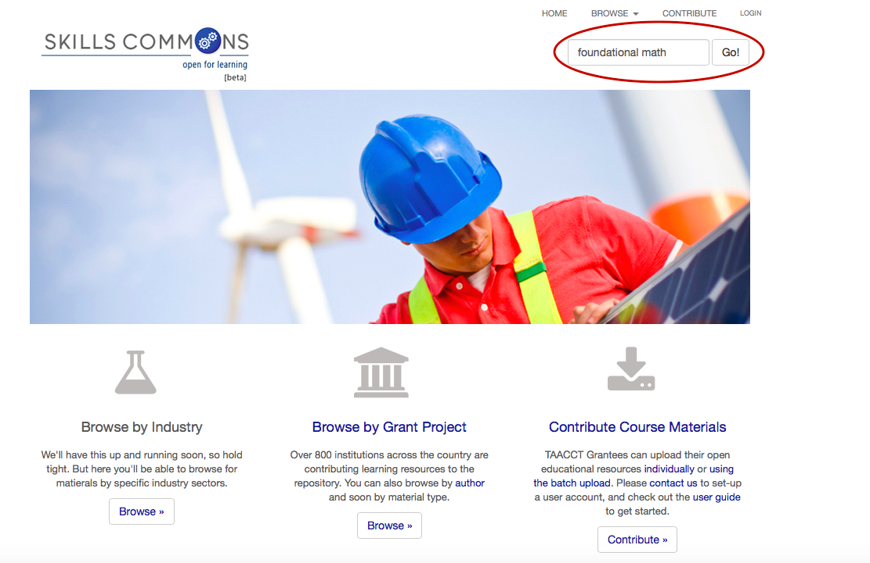

She gets 52 items on the hit list and now she has to decide if any of these materials might be useful for her project.
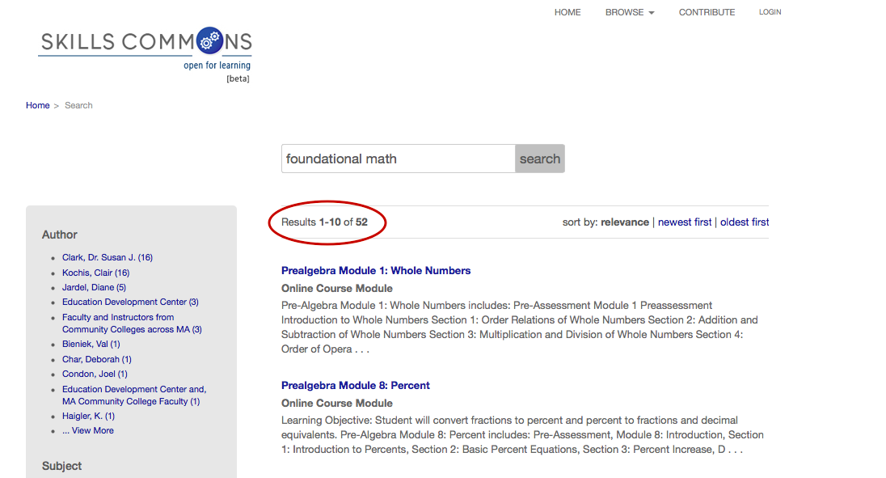

The first result in the list is Prealgebra Module 1: Whole Numbers: https://www.skillscommons.org/handle/taaccct/552. Prealgebra would be part of the foundational math skills for the construction certificate. The descriptions of the materials are important for her to decide which materials she should spend her time evaluating and downloading.
She would also like to get a “preview” on what the instructional materials look like from a faculty and/or student’s perspective. Seeing how others are teaching the curriculum would be very helpful in her plans for designing her course – no need to reinvent the wheel if the wheel is really good already. She decides to get more details about the materials. There are a number of requirements for instructional materials at VCCS and being able to see if the materials in SkillsCommons.org meet these requirements from the get-go would save her lots of time. In order to know if they are meeting the requirements she must answer the following questions:
- Are there instructional materials about the accessibility (508 compliance) so she can prepare for accommodations and alternative media if necessary?
- Are the learning objectives in the course aligned with the learning objectives the contractor requires?
- Is the design of the instructional process right for students’ successfully learning online? Does the course have a Quality Matters score and certification?
- Are all of the copyrights cleared so they can legally reuse the content?
It would be good to know who authored the materials and if there was good quality control of the content as well.
She clicks on the title of the resource and is provided some of the information she is looking for.

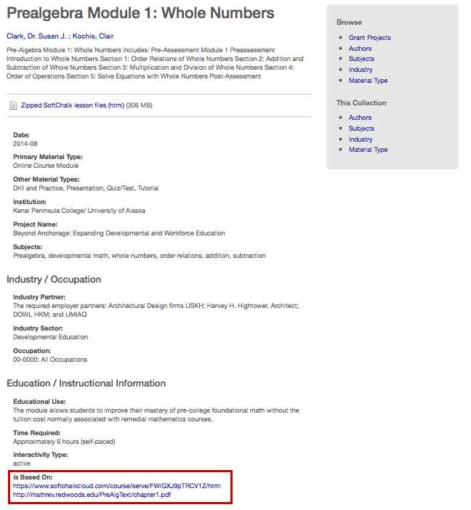
From the information provided, she quickly sees:
- The module contains videos (with transcripts) practice exercises, handouts, and review exercises and an open textbook. The transcripts are important for improved accessibility
- the topic areas – which are aligned with she course requirements
- it’s an online module – which is what she needs
- The subsequent SkillsCommons pages show that the materials have a CC BY Creative Commons license which lets her know that she can use the materials with attribution to the original author.
- it takes about 6 hrs. (self-paced) – which is a reasonable amount of time
- it was created in partnership with an architecture firm – so it might have relevant examples of practice problems for construction

The SkillsCommons catalog record also has a “preview” of the module (click on link below), as well as the link to the open textbook. She sees that the module was built with SoftChalk and SoftChalk has a Voluntary Product Accessibility Template (VPAT) which provides her some good information about the accessibility of the resource. https://www.softchalkcloud.com/course/serve/FWIGXJ9pTRCV1Z/html
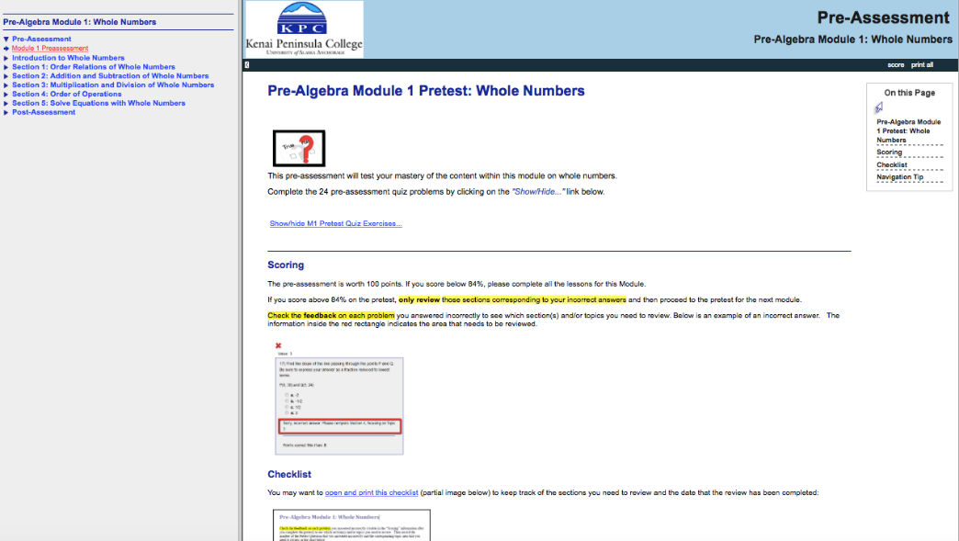
The program manager can add this SkillsCommons resource to “My SkillsCommons Collection” which enables her to save and organize her discoveries for easy access later (the program manager would need to have an account on SkillsCommons.org in order to do this).
The program manager next reviews the open textbooks that can be used to connect the different online modules she has found. http://mathrev.redwoods.edu/PreAlgText/chapter1.pdf
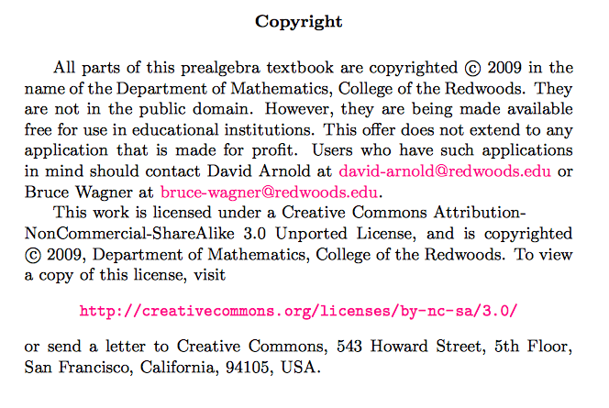
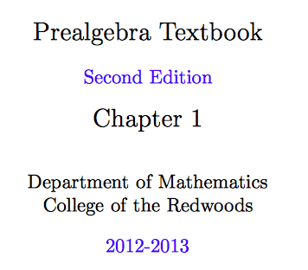

Quality Assurance: After reviewing a number of other instructional resources in SkillsCommons and saving them to “My SkillsCommons Collection”, the program manager explores the “program support materials” collection in SkillsCommons.org. There she finds evaluations of the instructional materials by subject matter experts and information about how the learning outcomes for the courses align with the skills and knowledge needed for the jobs currently in demand. The evaluations and industry alignment information provides the quality assurance the program manager needs to have confidence that the reuse of these instructional resources will help their institution achieve their goals.

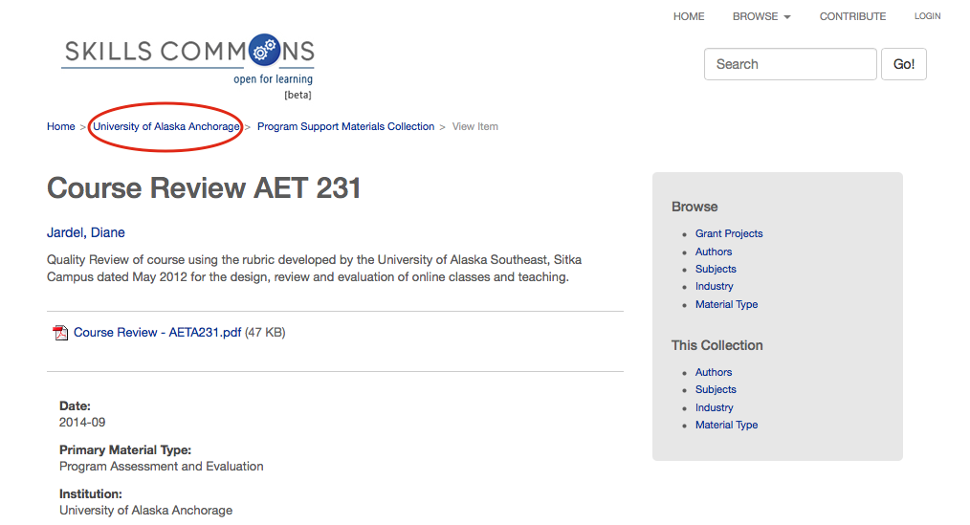

Resources for Outreach and Marketing: Once she creates the mostly online course, she will need some marketing information that the major construction company can distribute to their existing and potential employees. She will also have to plan on providing guidelines for admission into the program, the level of student support services (e.g. tutoring, coaching, mentoring) that will help prevent the students from dropping out of the program. Once again, she explores the Program Support Materials collection in SkillsCommons.org (which requires her to go back to the college home page – University of Alaska Anchorage in this example). She will then click on the Program Support Materials Collect link, and find a variety of examples of marketing materials and some good admissions guidelines from other community colleges, which she saves with her “My Skills Commons Collection”.
Three days later, the program manager presents the resources she has found to her boss, the Dean of Extended Education, her 2 instructional designers, and a representative of the major construction company. She reviews the materials and gets feedback from the Company on the topics and branding of the materials. With this feedback for customizing the resources to fit the needs of their project, they download the resources from SkillsCommons.org, and begin to edit the resources.
Two weeks later, VCCS has the foundational math course customized and ready for final review before delivery. All the stakeholders reconvene and provide the final review of the curriculum. The next day, the instructional designers start uploading the customized curriculum into their campus’ Learning Management System and prepare to enroll students in the certificate program.

Access and Customizing Delivery: This same content can be found in SoftChalkCloud. We could do this for all Skills Commons content that is converted to SoftChalk Lesson format. Further, we could use either a private SoftChalkCloud or a public one.
The content can be placed as a link in Blackboard by copying the link from SoftChalkCloud into a web link in Blackboard. Note that it is also possible to have lesson content that is scored, with grades flowing to the Blackboard grade book.
SoftChalk lessons can also be saved as EPubs, here shown in iBooks on a Mac.

The same ePub can be viewed on the iPad.

The lesson can be downloaded to the SoftChalk editor to all for modification. Note that derivative works can be published back to the cloud with a click.

In Conclusion:
As a result of using SkillsCommons.org to locate, view, download, and customize material for a foundational math course for the new construction certificate program, the program developer at the Virginia Community College would spend a fraction of the time it would have normally taken to develop and deliver a quality, strategically aligned course.
This work is licensed under a Creative Commons Attribution 4.0 International License.
This workforce solution was created through a cooperative agreement between the U.S. Department of Labor's Employment and Training Administration and the California State University-Multimedia Educational Resource for Learning and Online Teaching (MERLOT).

