SkillsCommons Batch Import - Program Support Collection
This document was created to assist you with the batch import feature available in SkillsCommons.

What Is the Batch Import?
The Batch Import feature will allow you to make multiple submissions to the SkillsCommons repository at one time. Please note that this guide should be used for the “Program Support Collection” within SkillsCommons.

Why use the Batch Import?
If you have multiple submissions you may find it faster and more useful to use the Batch Import feature.

Choosing to use the Batch Import Feature
Before using the Batch Import feature we strongly encourage you to complete at least one submission using the Single Submission process. This will familiarize you with the fields, how your submission will be displayed and give you a greater understanding of the repository and the submission process itself.
If you choose to use the Batch Import feature you will need to take the time to read and understand each of the fields, their metadata names and their specific requirements. Each of the fields and their requirements are outlined in this user guide.
BEFORE You Begin:
- Before using the BATCH Import feature we strongly suggest that you upload at least one submission via the Single Item Submission process.
- Read through this full guide before you start your batch submission.
- Don’t’ forget: Your first entry MUST start on Row 4
- The file names you list at the end of each row must match exactly with the files in the zip file. The field is case sensitive.

Let’s begin!

- Type http://skillscommons.org/ into your browser address bar.
- Click “batch upload” located under the “Contribute Course Materials” section on the homepage.

- Sign in using your SkillsCommons E-mail Address and Password.
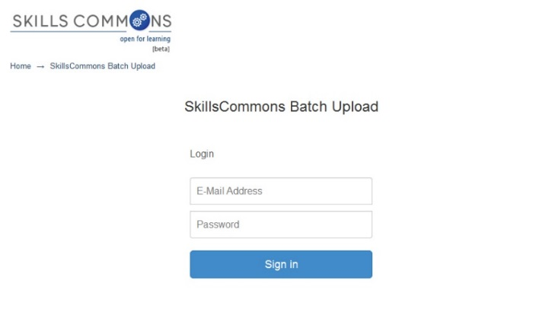
- Download the batch upload excel spreadsheet named “metadata-ps.xlsx” and save it on your computer.
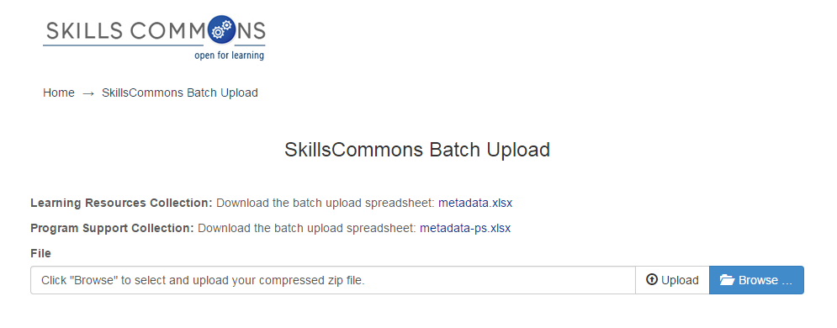
- Open the spreadsheet and fill in each cell with the appropriate data. Each submission item will have its own row. The first submission must start on Row 4. The last submission cannot exceed row 23. Rows 4 through 23 will allow for 20 batch submissions at a time. If you have more than 20 submissions please start a new batch process following these same steps.
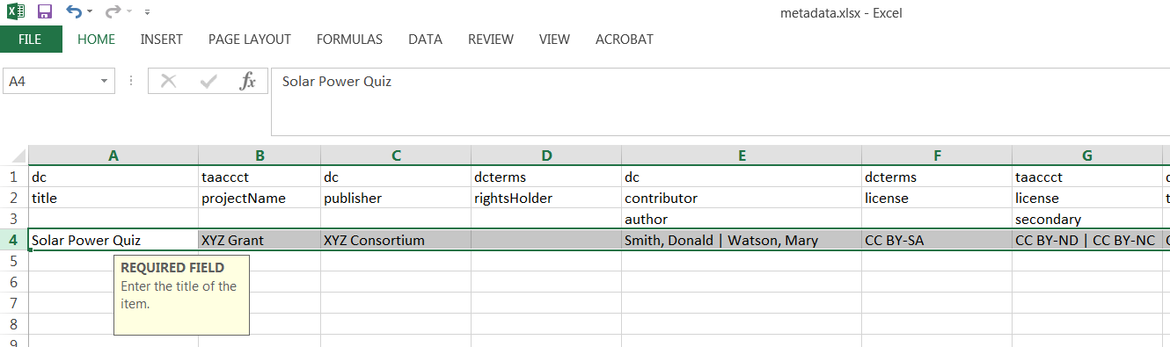
Note that when you click in each cell you will see directions specific to that cell.
Your first submission MUST start on row 4

PLEASE NOTE: The data you enter is not validated in any way. You are responsible for entering the data in the correct format.
If after reviewing this user guide you are still not sure of the correct format(s), please do NOT make changes. Contact support services at support@skillscommons.org for assistance.

REMINDERS:

- Before using the BATCH option we strongly suggest that you upload at least one submission via the Single Item Submission process
- Read through this full guide before you start your batch submission.
- Don’t’ forget: Your first entry MUST start on Row 4
- The file names you list at the end of each row must match exactly with the files in the zip file. The field is case sensitive.

Entering Your Data

Please follow the specific instructions below when entering information in each cell of the spreadsheet. Remember that your first submission must start on Row 4 and your last submission cannot go beyond Row 23.
Example | Description
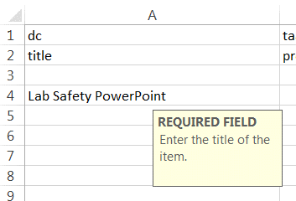 | Field Name: Title  Internal Metadata Name: dc.title  Instructions: Enter the title of the item  Required: Yes  Repeatable: No  Controlled Vocabulary: None
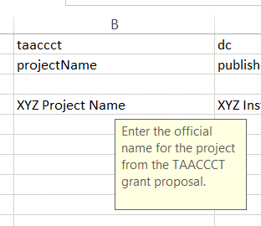 | Field Name: Project Name  Internal Metadata Name: taaccct.projectName  Instructions: Enter the official name for the project from the TAACCCT grant proposal  Required: No  Repeatable: No  Controlled Vocabulary: None
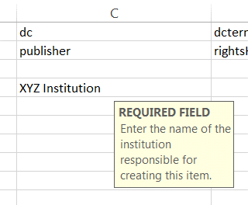 | Field Name: Grantee Institution  Internal Metadata Name: dc.publisher  Instructions: Enter the name of the institution responsible for creating this item.  Required: Yes  Repeatable: No  Controlled Vocabulary: Yes
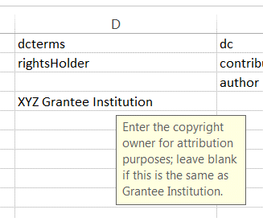 | Field Name: Copyright owner  Internal Metadata Name: dcterms.rightsHolder  Instructions: Enter the copyright owner for attribution purposes; leave blank if this is the same as Grantee Institution.  Required: No  Repeatable: No  Controlled Vocabulary: None
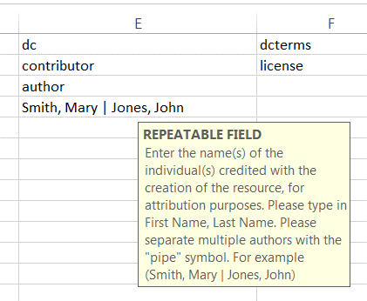 | Field Name: Authors  Internal Metadata Name: dc.contributor.author  Instructions: Enter the name(s) of the individual(s) credited with the creation of the resource, for attribution purposes. Please type in First Name, Last Name. Please separate multiple authors with the "pipe" symbol. For example (Smith, Mary | Jones, John)  Required: No  Repeatable: Yes  Controlled Vocabulary: None
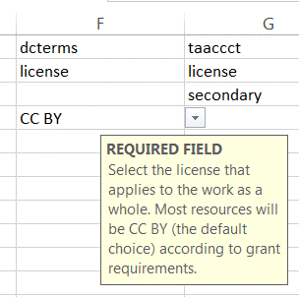 | Field Name: Primary License  Internal Metadata Name: dcterms.license  Instructions: Select the license that applies to the work as a whole. Most resources will be CC BY (the default choice) according to grant requirements.  Required: Yes  Repeatable: No  Controlled Vocabulary: Yes - you must choose one primary license from the dropdown menu.
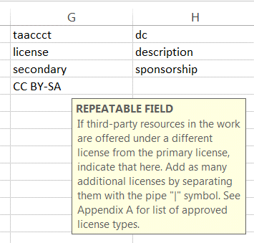 | Field Name: Additional licenses  Internal Metadata Name: taaccct.license.secondary  Instructions: If third-party resources in the work are offered under a different license from the primary license, indicate that here. Note that commercial, copyrighted works cannot be uploaded to the repository. If you have more than one license separate them with the pipe symbol (i.e. CC-BY | CC BY-SA | CC BY-ND)  Required: No  Repeatable: Yes  Controlled Vocabulary: Yes - Type any of the following and separate multiple entries with a pipe symbol:  - CC BY  - CC BY-SA  - CC BY-ND  - CC BY-NC  - CC BY-NC-SA  - CC BY-NC-ND  - CC0  - Public Domain  - Other
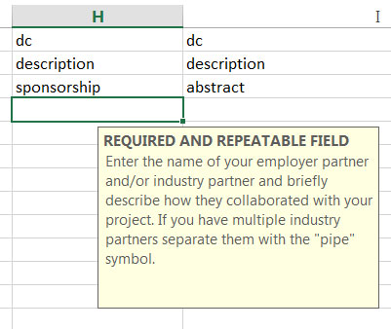 | Field Name: Industry Partner  Internal Metadata Name: dc.description.sponsorship  Instructions: Enter the name(s) of your employer partner and/or industry partner for this item, if you have one. If you have more than one industry partner enter them separated by the "pipe" symbol (i.e. NASA | NRP Partnerships | JPL )  Required: Yes  Repeatable: Yes  Controlled Vocabulary: None
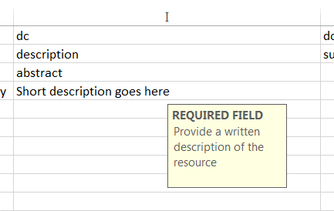 | Field Name: Description  Internal Metadata Name: dc.description.abstract  Instructions: Provide a written description of the resource.  Required: Yes  Repeatable: No  Controlled Vocabulary: None
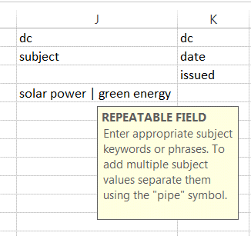 | Field Name: Subject Keywords  Internal Metadata Name: dc.subject  Instructions: Enter appropriate subject keywords or phrases separated by the "pipe" symbol (i.e. jet propulsion | rocket power | pulse-jet).  Required: No  Repeatable: Yes  Controlled Vocabulary: None
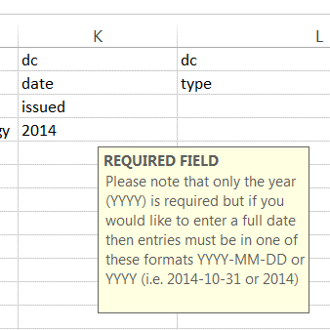 | Field Name: Date Created  Internal Metadata Name: dc.date.issued  Instructions: Please give the date the resource was created. You can leave out the day and/or month if they aren't applicable.  Required: Yes  Repeatable: No  Controlled Vocabulary: Yes - Please note that only the year (YYYY) is required but if you would like to enter a full date then entries must be in one of these formats YYYY-MM-DD or YYYY (i.e. 2014-10-31 or 2014)
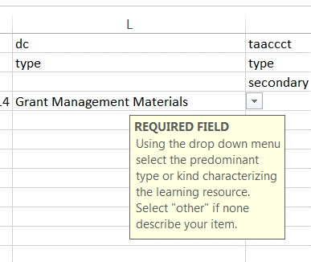 | Field Name: Primary Material Type  Internal Metadata Name: dc.type  Instructions: From the dropdown menu Select the predominant type or kind of material characterizing the learning resource, or 'Other' if none describe your item.  Required: Yes  Repeatable: No  Controlled Vocabulary: Yes - you must choose one primary material type from the dropdown menu.  [Articulation Processes and Agreement; Grant Management Materials; Instructor and/or Advisor/Case Manager Support Materials; Job Training/Fieldwork Experiences; Partnership Resources; Program; Program Assessment and Evaluation; Program Planning Resources; Quality Assurance Report – Accessibility Report; Quality Assurance Report – Course Design Report; Quality Assurance Report – Creative Commons Licensing Report; Quality Assurance Report -- Subject Matter Expert Report; Quality Assurance Report – Universal Design for Learning Report; Recruitment and Outreach; Student Support Materials]
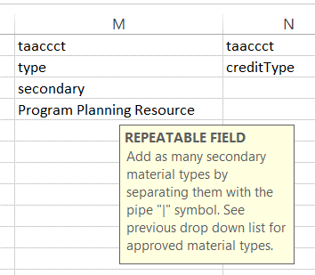 | Field Name: Secondary Material Types  Internal Metadata Name: taaccct.type.secondary  Instructions: Type in any secondary material types that describe this item. If you would like to add multiple secondary material types separate them using the pipe symbol (i.e. Animation | Assessment Tool | Assignment)  Required: No  Repeatable: Yes  Controlled Vocabulary: Yes - Type any of the following and separate multiple entries with a pipe symbol:  [Articulation Processes and Agreement; Grant Management Materials; Instructor and/or Advisor/Case Manager Support Materials; Job Training/Fieldwork Experiences; Partnership Resources; Program; Program Assessment and Evaluation; Program Planning Resources; Quality Assurance Report – Accessibility Report; Quality Assurance Report – Course Design Report; Quality Assurance Report – Creative Commons Licensing Report; Quality Assurance Report -- Subject Matter Expert Report; Quality Assurance Report – Universal Design for Learning Report; Recruitment and Outreach; Student Support Materials]
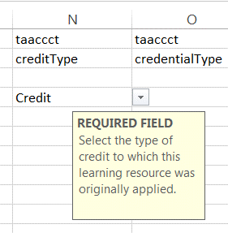 | Field Name: Credit Type  Internal Metadata Name: taaccct.creditType  Instructions: Select the type of credit to which this learning resource was originally applied.  Required: Yes  Repeatable: No  Controlled Vocabulary: Yes - you must select a credit type from the choices in the drop down menu.
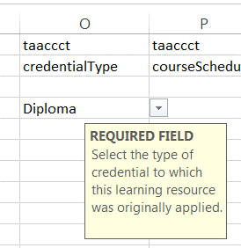 | Field Name: Credential Type  Internal Metadata Name: taaccct.credentialType  Instructions: Select the type of credential to which this learning resource was originally applied.  Required: Yes  Repeatable: Yes  Controlled Vocabulary: Yes – you must select a credential type from the choices in the drop down menu.  - Diploma  - Certificate  - Credential  - Stacked/latticed Credential Model  - Associate Degree  - Bachelors Degree  - Other  - None
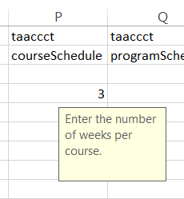 | Field Name: Number of weeks per course  Internal Metadata Name: taaccct.courseSchedule  Instructions: Enter the number of weeks per course  Required: No  Repeatable: No  Controlled Vocabulary: None
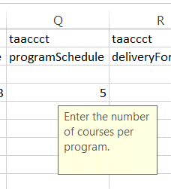 | Field Name: Number of courses in the program  Internal Metadata Name: taaccct.programSchedule  Instructions: Enter the number of courses per program  Required: No  Repeatable: No  Controlled Vocabulary: None
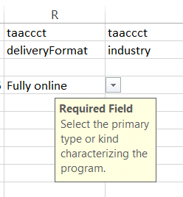 | Field Name: Program Delivery Format  Internal Metadata Name: taaccct.deliveryFormat  Instructions: Select the primary type of kind characterizing the program  Required: Yes  Repeatable: No  Controlled Vocabulary: Yes - you must select a program delivery format from the choices in the drop down menu.
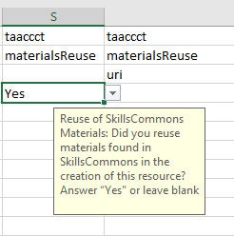 | Field Name: Reuse of SkillsCommons Materials  Internal Metadata Name: taaccct.materialsReuse  Instructions: Did you reuse materials found in SkillsCommons in the creation of this resource? Click “Yes” or leave blank.  Required: No  Repeatable: No  Controlled Vocabulary: None
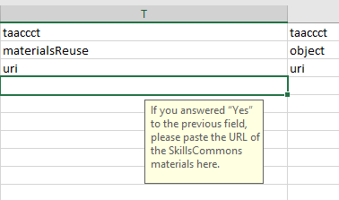 | Field Name: URL of SkillsCommons Materials  Internal Metadata Name: taaccct.materialsReuse.uri  Instructions: If you answered “yes” to the previous question, please paste the URL of the SkillsCommons materials here.  Required: No  Repeatable: No  Controlled Vocabulary: None
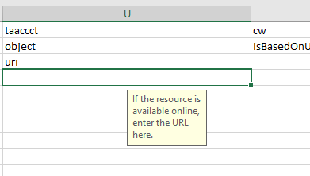 | Field Name: Additional Public Access To Materials  Internal Metadata Name: taaccct.object.uri  Instructions: If the resource is available online, enter the URL here.  Required: No  Repeatable: Yes  Controlled Vocabulary: Yes – your entry must be a valid URL
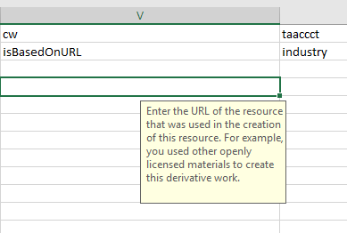 | Field Name: Derivative Work from Other’s Materials  Internal Metadata Name: cw.isBasedOnUrl  Instructions: Enter the URL(s) of the resource(s) that were used in the creation of this resource. The Based on URL can be linked to anything even a proprietary source that you are noting in the introduction of the deliverable.  Required: No  Repeatable: Yes  Controlled Vocabulary: Yes – your entry must be a valid URL
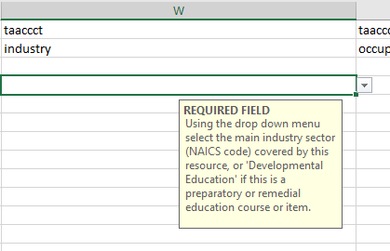 | Field Name: Industry Sector  Internal Metadata Name: taaccct.industry  Instructions: From the drop down menu select the main industry sector covered by this resource, or select 'Developmental Education' if this is a preparatory or remedial education course or item.  Required: Yes  Repeatable: No  Controlled Vocabulary: Yes - you must select an industry sector from the choices in the drop down menu.
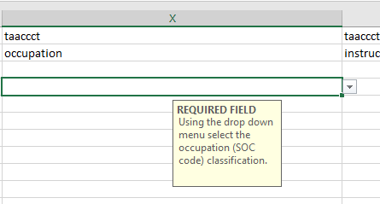 | Field Name: Occupation Classification  Internal Metadata Name: taaccct.occupation  Instructions: From the drop down menu select the occupation classification for this submission  Required: Yes  Repeatable: No  Controlled Vocabulary: Yes - you must select an occupation classification from the choices in the drop down menu.
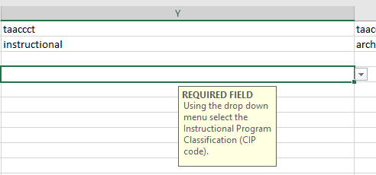 | Field Name: Instructional Program Classification  Internal Metadata Name: taaccct.instructional  Instructions: From the drop down menu select the instructional program classification for this submission.  Required: Yes  Repeatable: No  Controlled Vocabulary: Yes - you must select an instructional program classification from the choices in the drop down menu.
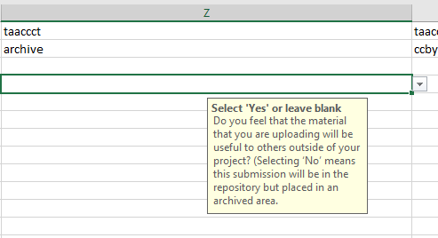 | Field Name: Likelihood of reuse  Internal Metadata Name: taaccct.archive  Instructions: Do you feel that the material that you are uploading will be useful to others outside of your project? (Selecting ‘No’ means this submission will be in the repository but placed in an archived area. The material will be accessible to users who select to include archived materials in their search results.)  Required: No  Repeatable: No  Controlled Vocabulary: None
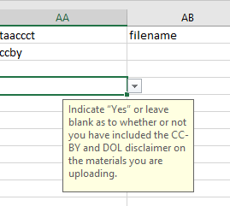 | Field Name: CC-BY License and DOL Disclaimer Requirement  Metadata Name: taaccct.ccby  Instructions: I have included the CC-BY license and DOL disclaimer on the materials I am uploading. Select “Yes” or leave blank  Required: No  Repeatable: No  Controlled Vocabulary: Yes – You must either select "Yes" from the dropdown menu or leave blank.

- After entering your data into Columns A through V, you will have the opportunity to add the file names that are associated with each submission. You will also need to provide your taaccct handle so that the submission and the files get uploaded to your community and collection.
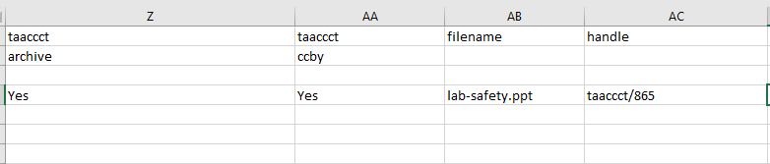
Enter the file name here. If you have multiple files separate file names with a pipe symbol.
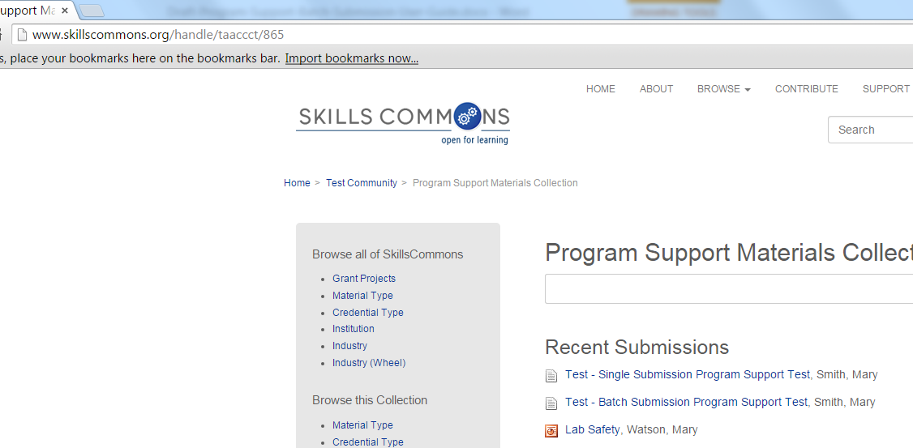
Enter the taaccct collection handle here. Your taaccct collection handle can be found at the end of your collections URL.
In this example the taaccct collection handle is “taaccct/865”
NOTE: Do not put the full URL, only the taaccct handle.
NOTE: Be sure this is your COLLECTION handle and not your Grant Project Community handle.

- Save your metadata-ps.xlsx file.
- Create a zip file folder.
- Place the metadata-ps.xlsx (it MUST be named metadata-ps.xlsx) file and all associated files in this zip folder.
- Go back to the Batch Upload page and browse and upload your zip file.

- After clicking “Upload” you will then see the Upload Status screen. This screen will show you the submissions from your metadata.xlsx. Click the “Process All Files” button to continue.
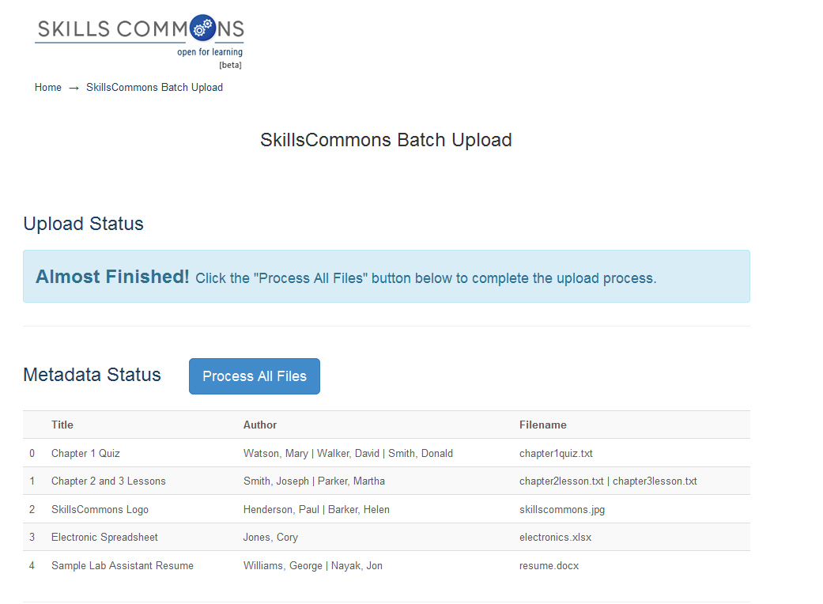
Click “Process All Files” button.
- Your files will be fully processed when you see the “Process Status” list show up at the bottom of the page.
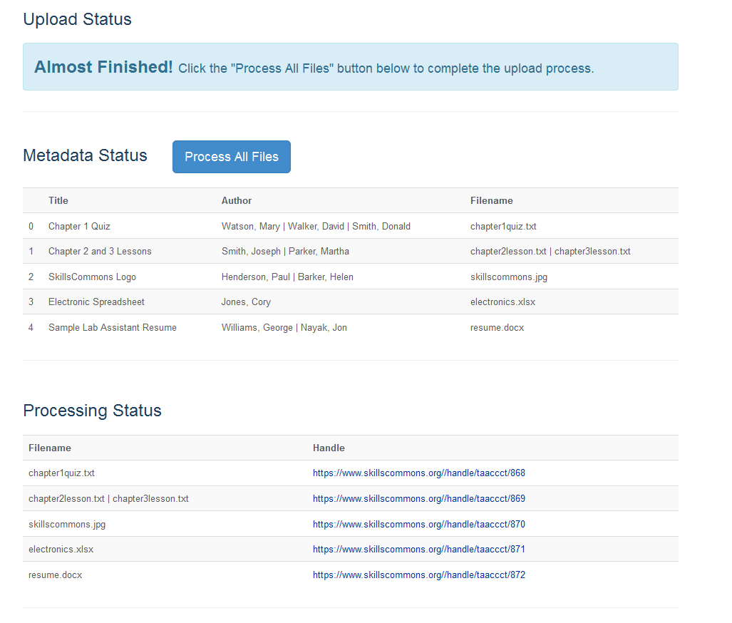
To EDIT or DELETE Submissions please visit the Contribute & Manage Materials page at:
http://support.taaccct.org/contribute-materials/
You will know that your submissions and files have been processed successfully when you see them listed in the Processing Status section.
By clicking on each link you will be taken to each submission.

Appendix A
Learning Resources Collection
Field Names, Metadata Names and Descriptions
http://support.skillscommons.org/home/contribute-manage/metadata-and-apprendices/appendix-a/

Appendix B
Program Support Materials Collection
Field Names, Metadata Names and Descriptions
http://support.skillscommons.org/home/contribute-manage/metadata-and-apprendices/appendix-b/

Appendix C
List of NAICS Codes
http://support.skillscommons.org/home/contribute-manage/metadata-and-apprendices/appendix-c/

Appendix D
List of SOC Codes
http://support.skillscommons.org/home/contribute-manage/metadata-and-apprendices/appendix-d/

Appendix E
List of CIP Codes
http://support.skillscommons.org/home/contribute-manage/metadata-and-apprendices/appendix-e/

This work is licensed under a Creative Commons Attribution 4.0 International License.
This workforce solution was created through a cooperative agreement between the U.S. Department of Labor's Employment and Training Administration and the California State University-Multimedia Educational Resource for Learning and Online Teaching (MERLOT).

