SkillsCommons Makeover:

Improving the Design, Interactivity, and Integrity of Assessments
Contributor: Air Washington
Collection: Aerospace College Readiness, Pre-employment, and Assembly
Material: Applied Math / Algebra Laws Overview
Item: Check Your Understanding Introduction to Algebra.pdf
MAKEOVER: Conversion of a quiz from static to dynamic format with improved capabilities for assessing student learning.
Original material was uploaded to Skills Commons as a PDF. While the PDF was a separate file, it was contained in a ZIP package of 900MB; the PDF contributing only 617KB.
In the absence of a PDF editor such as Adobe Acrobat Pro (commercial product), all one can do is print this file or reference it as is. If printed, the material can be changed through literal cut and paste.
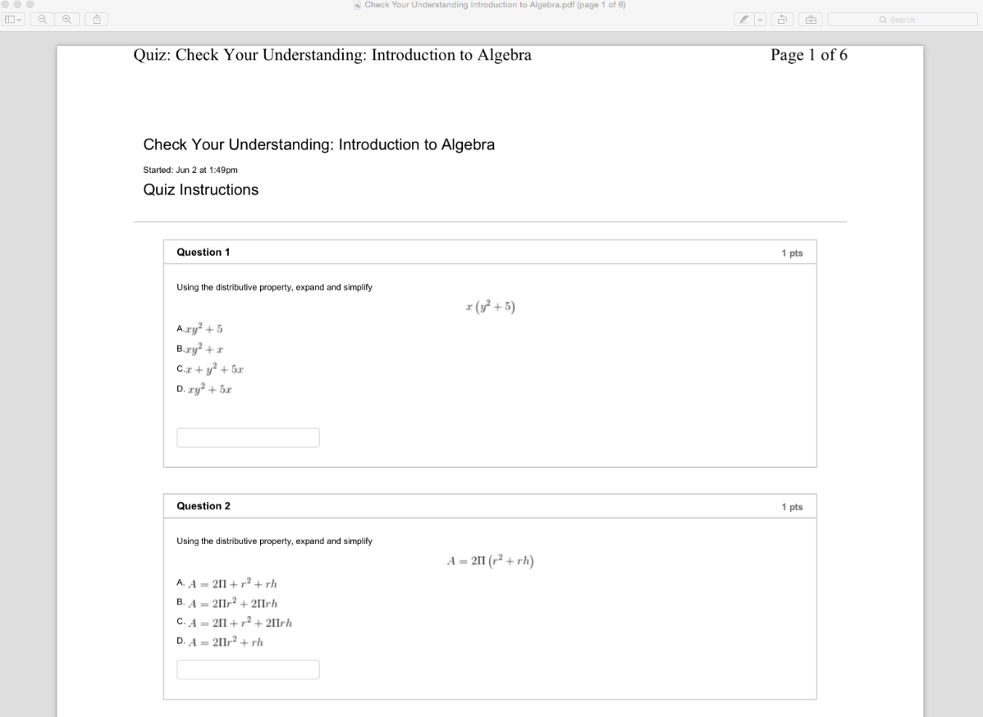
The PDF packaging does NOT allow the following:
- Edit question text
- Add text to speech
- Omit or add questions
- Reorder questions, including randomly
- Easily add institutional branding
- Machine grade questions; change the point values
- Send grades to a Learning Management System (LMS) grade book
- Use the quiz in a native LMS assessment system
- Allow for self-testing or for multiple attempts with feedback

Over time, Skills Commons will address the following:

- Easily discover material in the repository
- Easily share a question or the whole quiz group via a repository search
- Associate the quiz with curriculum standards metadata

If the quiz was available as, say, a Microsoft Word® document, it would be easy to:
- Edit question text
- Add text to speech
- Omit or add questions
- Easily add institutional branding

Rewriting the assessment as a SoftChalk Lesson offers the complete flexibility outlined above. For example, here we see the equation editor. Note the edit control where a textual description can be provided for greater accessibility.
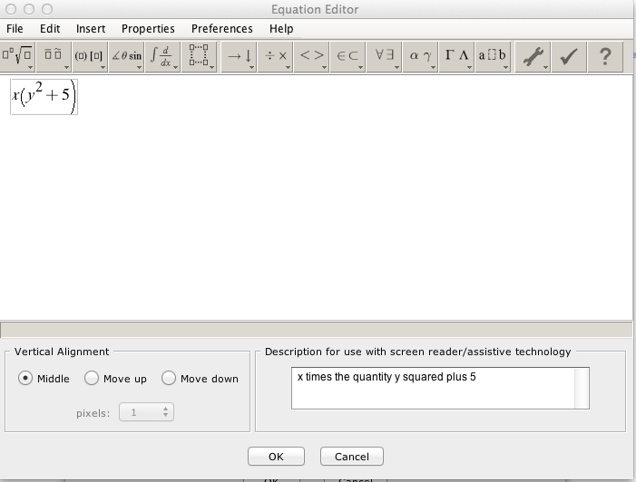
A variety of question types are possible, in the following case, a multiple-choice type lists different solution candidates. Note that specifying which is the correct answer allows the test to be machine-graded.
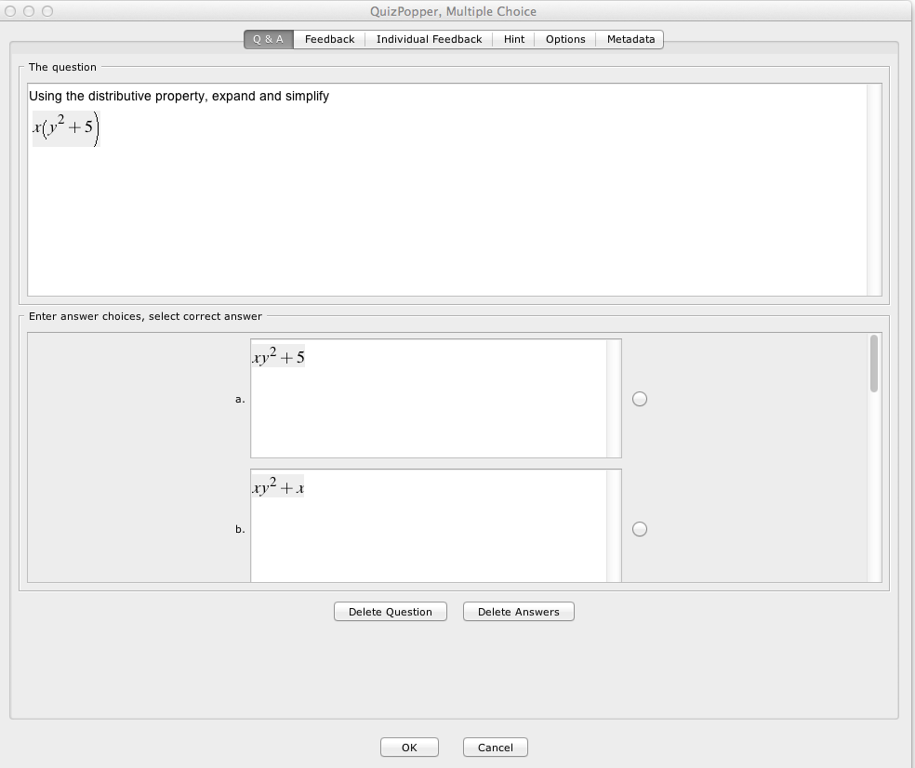
Note you can add overall feedback or per-question feedback. This kind of interactivity is, of course, more immediate than awaiting for a test to be graded and returned.

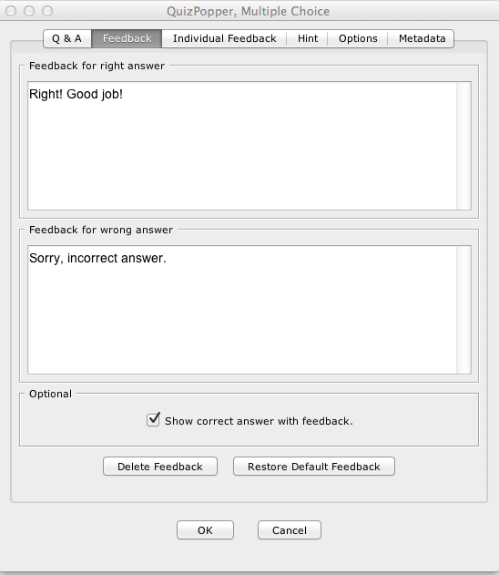
Questions can include an optional hint. Questions can be assigned different point values and multiple-attempts can be allowed.
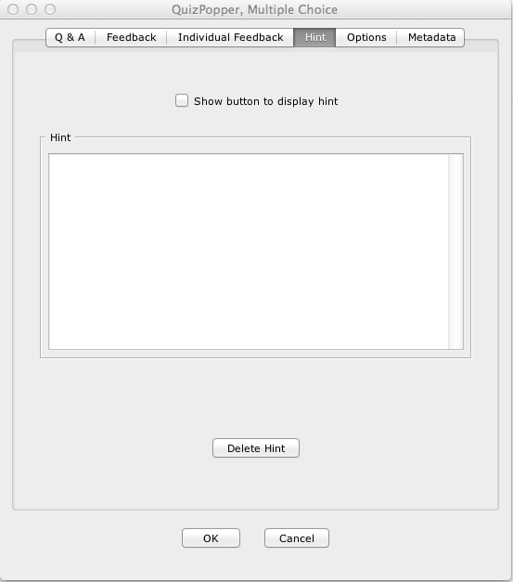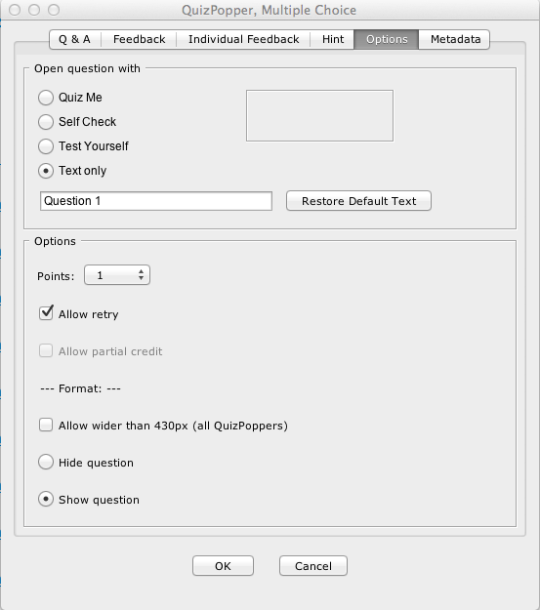
Additionally, the question can be described with a variety of metadata, including curriculum standards.
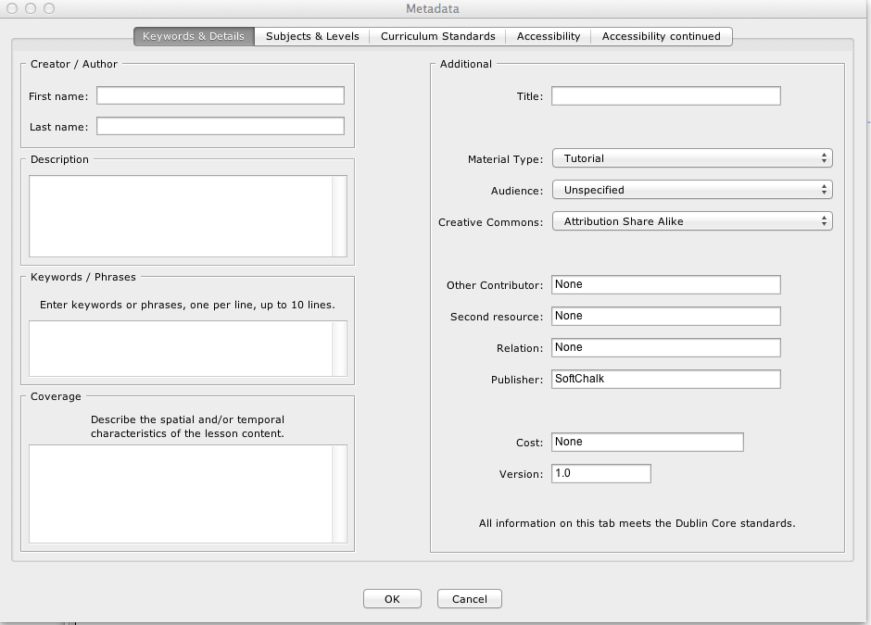
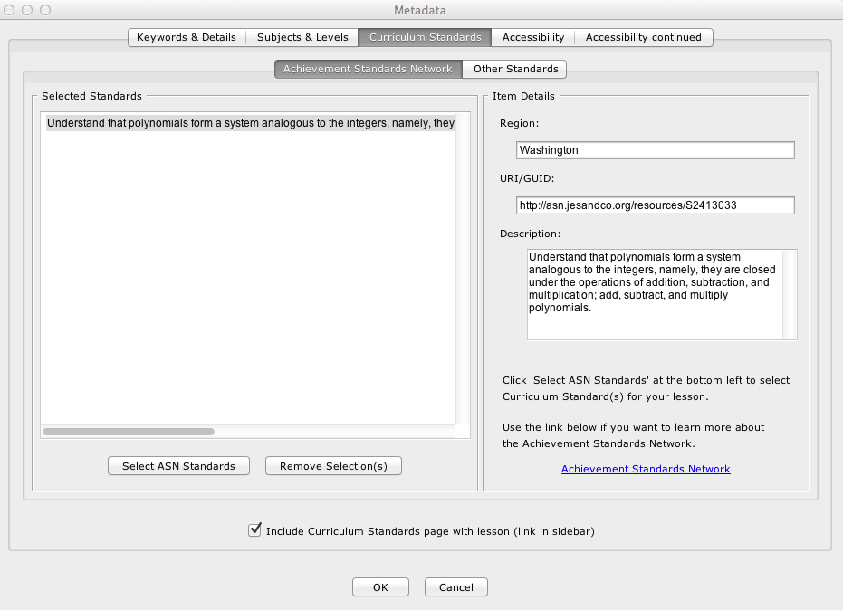
Questions can be stored in a library for easy reuse, publishing to a hosted sharing website, or arranged into a group of questions to be taken together. One virtue of the group is that questions can be presented in random order, allowing each student to take the quiz, but in a different sequence. As with the individual questions, the group can be described with metadata and also shared widely.
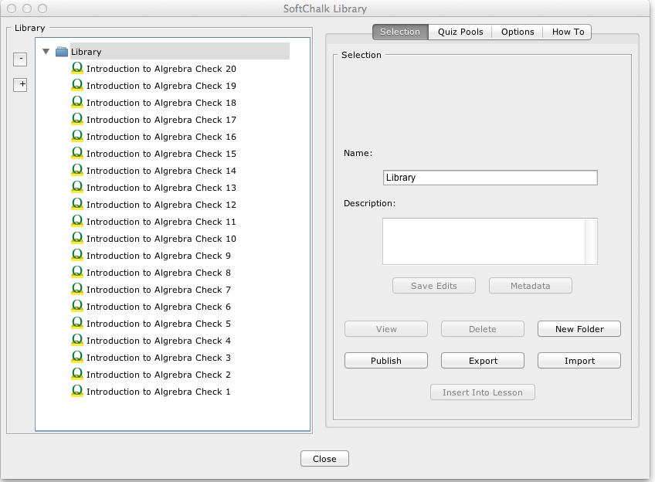
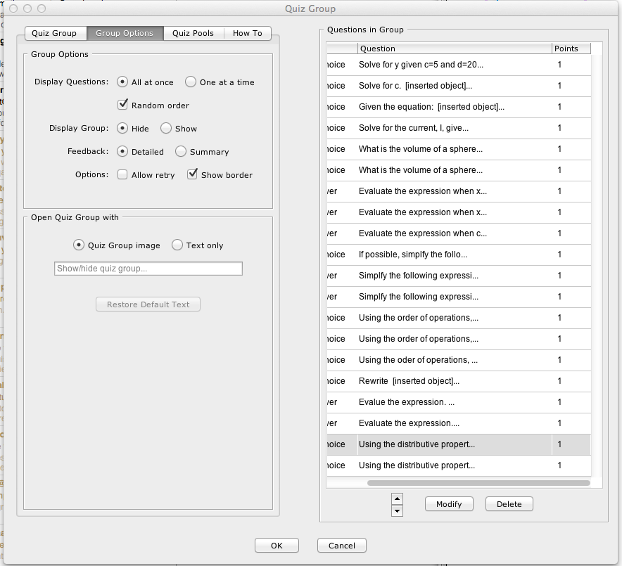

What follows is an example of the questions as they are rendered in a browser for the student, including the feedback.
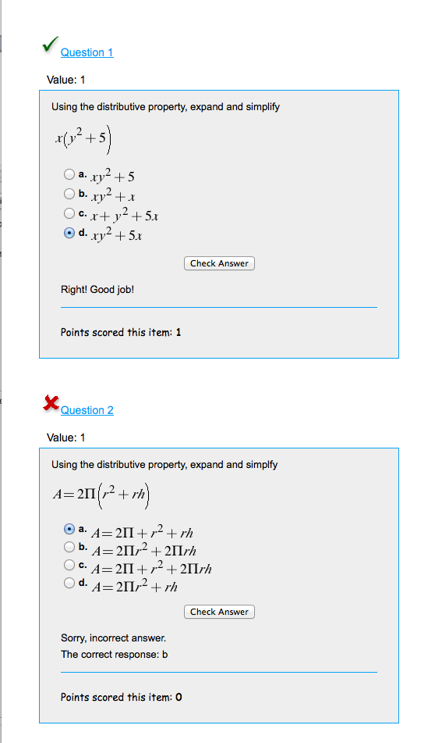

The quiz can be presented as a navigable web site, including institutional branding, a license statement, and a separate listing of curriculum standards.
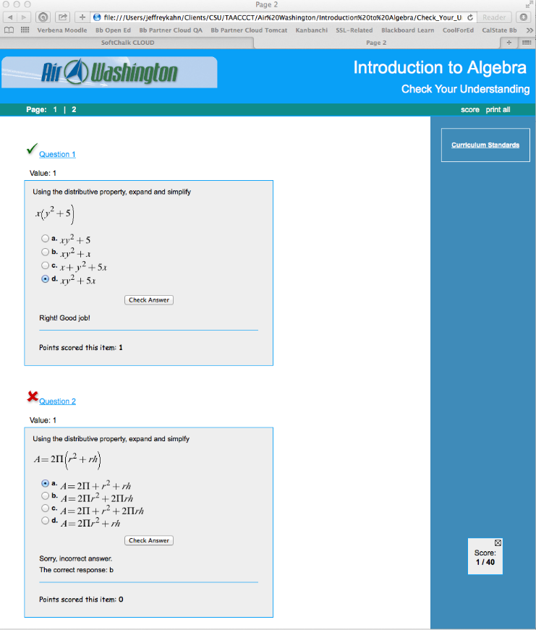
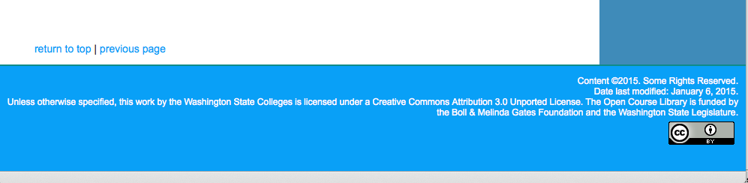

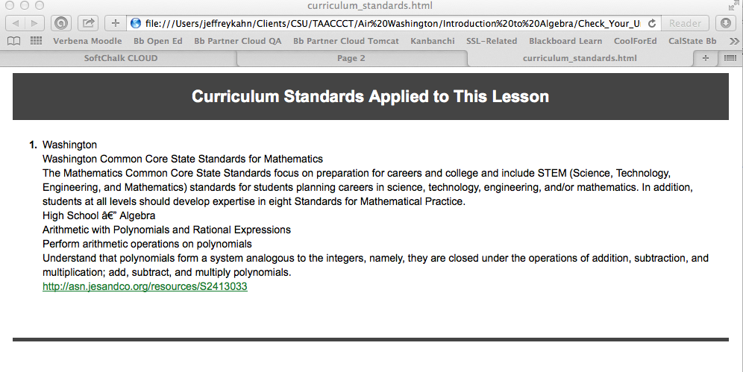
This work is licensed under a Creative Commons Attribution 4.0 International License.
This workforce solution was created through a cooperative agreement between the U.S. Department of Labor's Employment and Training Administration and the California State University-Multimedia Educational Resource for Learning and Online Teaching (MERLOT).

