Strategies for Submitting Large Files
The purpose of this document is to discussion options for packaging large files into submissions to Skills Commons. In short, rather than create a single submission composed of all the files, we recommend disaggregating the material into more manageable sizes. A single large file can be difficult to download on a slow network or simply discourage a potential adopter from taking a look for fear that there will be too much material to wade through.

Looking Before Leaping
All submissions should include a separate table of contents, syllabus, etc. These documents, which complement the title, description, and other metadata, allow potential adopters to review and inventory of the submission before committing to download and investigate further.

A Few Large or Many Small
As an example, let’s say a submission contained some readings. It may be important to the adopter whether there are 50 readings of 20 pages each or 4 readings of 250 pages each. This is particularly important if the readings are in a more difficult to edit form such as PDF. If the documents are editable, the adopter could choose to combine or disaggregate them as appropriate. For some courses, the length of each reading may not be of concern, but for others it will be and this information should not be hidden from the adopter. Similarly, many small videos is not the same as a few large ones.

Hosting Large Files
Particularly in the case of video, it may make a lot more sense to host this content than offer it to an adopter as a file. For the purposes of the Capture and Preserve mission of Skills Commons, a copy of the files is important, but may not be helpful to adopters. For the adopter, a link to hosted content is likely more convenient than having a copy of the file that then needs to be put somewhere for students to view.
As an example, the submitter could upload the file to YouTube (www.youtube.com) or a similar service. For example, a video was posted here.
https://www.youtube.com/watch?v=Tiw8mmmNFc0
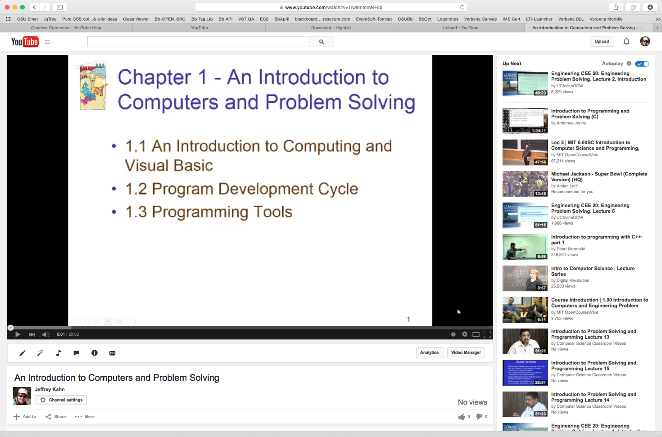

Be sure to include the appropriate Creative Commons License (https://support.google.com/youtube/answer/2797468?hl=en).

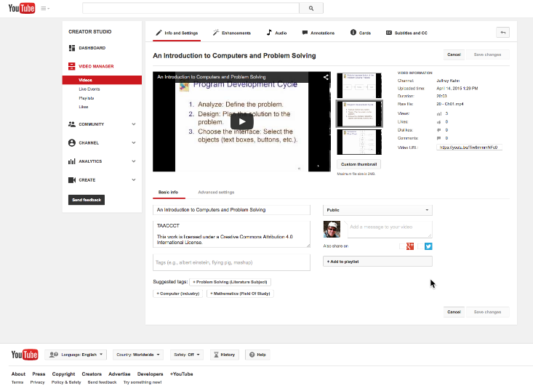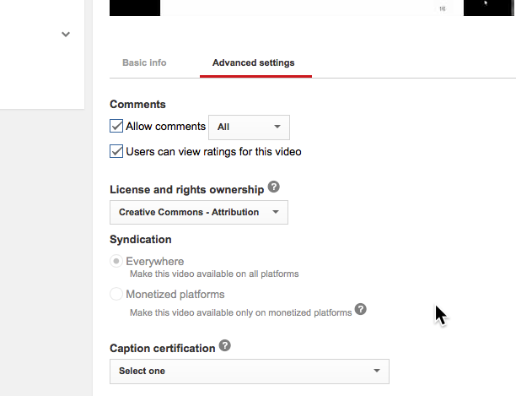

Skills Commons recommends that large video files be added as a separate submission; that the videos be uploaded to a service; and that links to the videos be provided in the course content. This accomplishes both the goal of capturing the assets and making them easy to adopt.
What is good for videos can also work for presentations. These can be uploaded to a service such as Slideshare (www.slideshare.net) or converted to a flip-book and hosted in the SoftChalk Cloud (www.softchalkcloud.com). In whichever case, the value is the same as with hosted video, namely the option to have the original material with the convenience of a link to a hosted version.
Here is an example of the PowerPoint in the native editor:
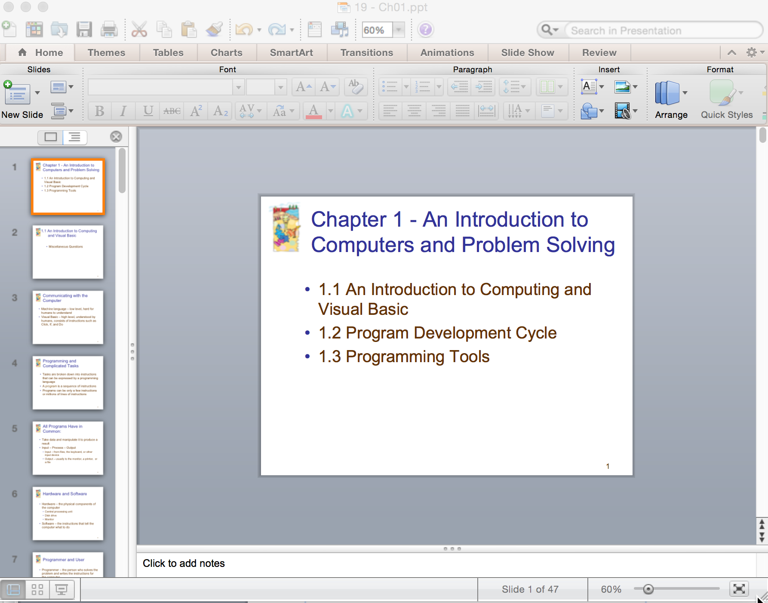

and here is the same presentation as a hosted photo album via SoftChalk Cloud. Note that we also have introduced institutional branding and a prominent Creative Commons License.

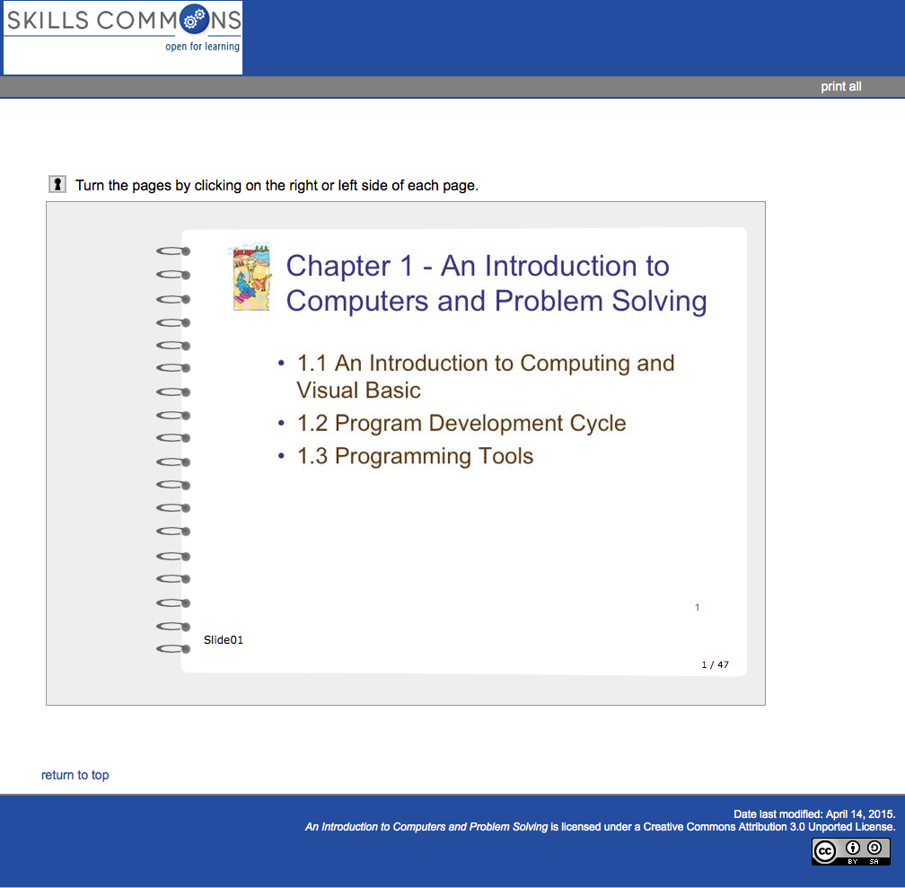

Specific Example

As a concrete example, Skills Commons contained a single submission for an Introduction to Visual Basic course at 127.3 MB, compressed. This is a large file. Here is what the file really contained:
7 assessments, 6 of which were about 70 Kbytes and one twice that.
8 discussion topics at about 500 bytes each.
2 web links at about 400 bytes each.
6 large PowerPoint presentations at a little under 10MB each.
6 large videos between 10 and 25MB each.
The course content was quite small if you remove the 114MB of video and 52MB of presentations, uncompressed. Each video and presentation could be uploaded separately and available in course materials as a simple web link.

This work is licensed under a Creative Commons Attribution 4.0 International License.
This workforce solution was created through a cooperative agreement between the U.S. Department of Labor's Employment and Training Administration and the California State University-Multimedia Educational Resource for Learning and Online Teaching (MERLOT).

