Content Import and Export To & From Canvas and SkillsCommons.org
Skills Commons (www.skillscommons.org) contains a variety of materials, including courses covering a particular subject. Instructors may want to adopt such a course in total or nearly so. One of the platforms to deliver such a course to students is Canvas (www.canvaslms.com), one of the leading Learning Management System (LMS) products in higher education.
Note that while Canvas is a commercial product, Canvas offers a no- cost platform as well (http://www.canvaslms.com/try-canvas). There is also Canvas Network a catalog of free online course (https://www.canvas.net).
The purpose of this document is to illustrate the steps to import a course that resides in Skills Commons in an interoperable format, especially the IMS Common Cartridge (http://www.imsglobal.org/cc/index.html). Common Cartridge is a mature file format specification developed by the members of IMS, primarily those from the LMS and publisher communities. The document will also discuss how to export a Canvas course in either a native or cartridge form. This document is intended for course instructors and designers. A system administrator has access to course import and export options from outside a course.
Common Cartridge solves an important challenge, namely how to author a course- sized body of material, including documents, web links, assessments, and discussion topics, only once and yet have that content be readily imported into a variety of LMS platforms. Prior to the arrival and adoption of Common Cartridge, publishers had to prepare a separate file set for each LMS, which is less efficient and economical than a single format.
Canvas exports courses in the IMS Common Cartridge format, but also includes some extra material that will be ignored by other LMS products but recognized by Canvas. This approach means that if the export file is imported into another instance of Canvas, the complete course content is available; if the file is imported into a different LMS, as much content as matches the Common Cartridge specification (files, assessments, discussions, and links) is available.

Importing Content into Canvas
The basic process is covered will in the Canvas documentation, here:
http://guides.instructure.com/m/4152/l/41324-how-do-i-import-a-canvas-course-export-package
First decide whether you want to import content into an existing course or have the material for the basis of new one course. To import into an existing course, open that course and continue with the instructions below; to import into a new course create or have the course created, open it, and then continue.
From within the course, select Settings from the left-hand-side navigation menu.
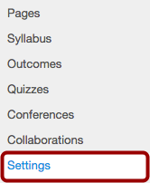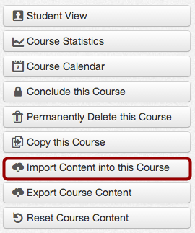

Next select Import Content into this Course from the right-hand-side menu.
Find out if this is the file you want to import. Note that Canvas supports import a variety of different formats, including native exports from some other LMS platforms. Make your selection from the choice of content types.

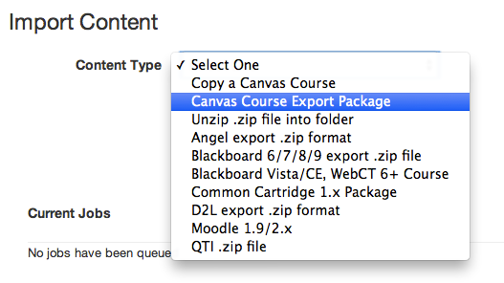
At this point, you are prompted whether to import all or some of the content and there may be additional options. Importing a course starts a process and you will be alerted when the process is complete.

Exporting a Course from Canvas

The basic process is covered in the Canvas documentation, here:
http://guides.instructure.com/m/4152/l/41323-how-do-i-export-a-canvas-course
From within the course, select Settings from the left-hand-side navigation menu.
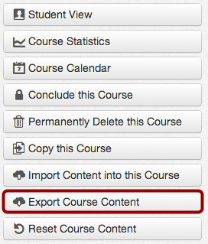

Next select Export Course Content from the right-hand-side menu.
Choose whether to export the entire course or quizzes. Exporting a course starts a process
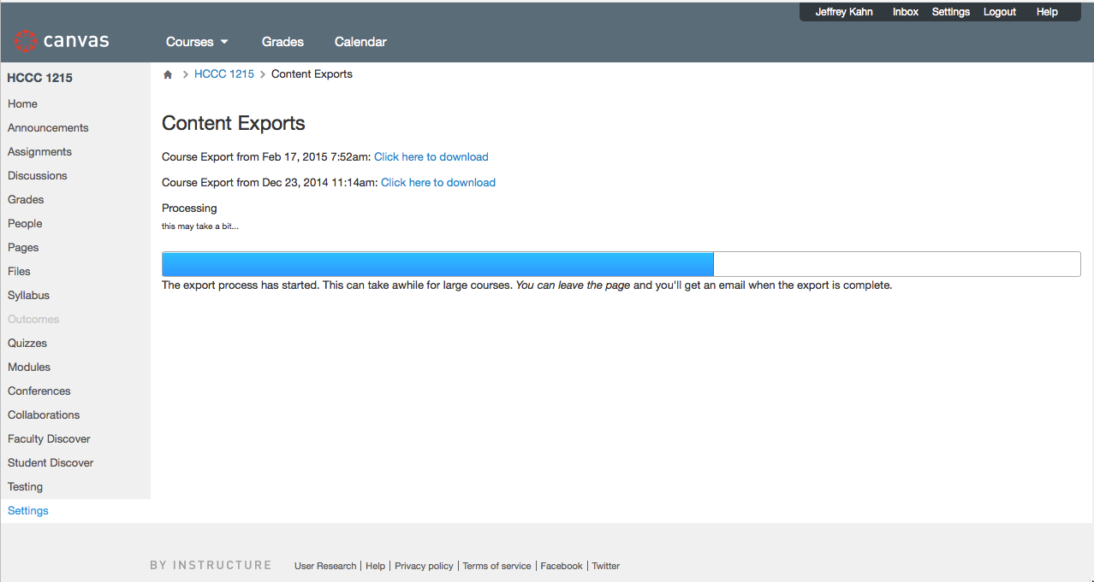
When complete, there is a link to download the course export. You should also get an email notification. The download file will have the extension “.imscc” and is an IMS Common Cartridge version 1.1 file. You can upload this file to Skills Commons.
Note that the process to export a quiz, except that the result is an IMS Question and Test Interoperability (QTI) file.
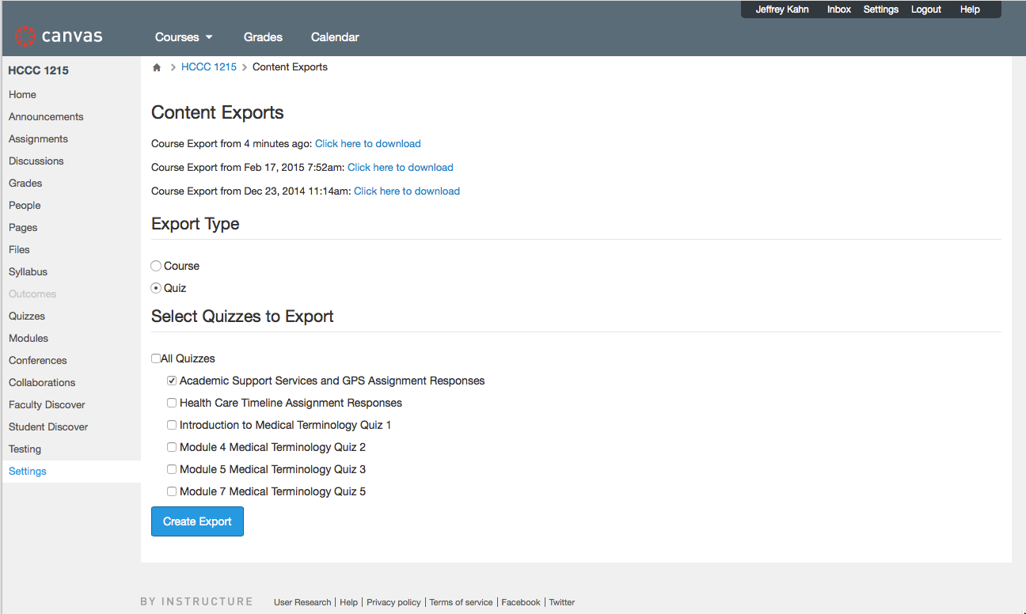

QTI files can be imported and exported into many assessment systems, including LMS platforms. You can find out more about QTI here:
http://www.imsglobal.org/question/index.html.

This work is licensed under a Creative Commons Attribution 4.0 International License.

This workforce product was funded by a grant awarded by the U.S. Department of Labor’s Employment and Training Administration. The product was created by the California State University, Office of the Chancellor/MERLOT and does not necessarily reflect the official position of the U.S. Department of Labor. The U.S. Department of Labor makes no guarantees, warranties, or assurances of any kind, express or implied, with respect to such information, including any information on linked sites and including, but not limited to, accuracy of the information or its completeness, timeliness, usefulness, adequacy, continued availability, or ownership.

This work is licensed under a Creative Commons Attribution 4.0 International License.
This workforce solution was created through a cooperative agreement between the U.S. Department of Labor's Employment and Training Administration and the California State University-Multimedia Educational Resource for Learning and Online Teaching (MERLOT).

