Content Import and Export To & From Moodle and SkillsCommons.org
Skills Commons (www.skillscommons.org) contains a variety of materials, including courses covering a particular subject. Instructors may want to adopt such a course in total or nearly so. One of the platforms to deliver such a course to students is Moodle (www.moodle.org), one of the leading open-source Learning Management System (LMS) products.
The purpose of this document is to illustrate the steps to import a course that resides in Skills Commons in an interoperable format, specifically the IMS Common Cartridge (http://www.imsglobal.org/cc/index.html). Common Cartridge is a mature file format specification developed by the members of IMS, primarily those from the LMS and publisher communities.
Common Cartridge solves an important challenge, namely how to author a course-sized body of material, including documents, web links, assessments, and discussion topics, only once and yet have that content be readily imported into a variety of LMS platforms. Prior to the arrival and adoption of Common Cartridge, publishers had to prepare a separate file set for each LMS, which is less efficient and economical than a single format.
Skills Commons recommends that teachers who are already using an LMS to deliver the content they wish to submit to the repository should provide two submissions: a native LMS export and an IMS Common Cartridge export (if supported). As a common denominator, Common Cartridge limits the range of content it supports to that set of features LMS vendors share. This means that a native export offer a higher level of fidelity than a Common Cartridge, although the cartridge offers significant value. In a few cases, an LMS will import the native export of another LMS (e.g. Canvas will import Desire2Learn), but this is the exception rather than the norm. The two-format recommendation is intended to offer the higher fidelity when the adopting teacher’s LMS is the same as the submitter’s and lower but still useful fidelity when the adopting teacher’s LMS and the submitter’s differ.

Importing Content Into Moodle
Note that there are many versions of Moodle and so the exact look and features in your instance may vary.
Login to Moodle and choose Restore from the Administration menu.
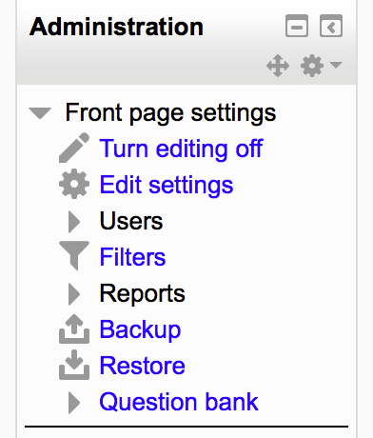
Specify the file to import, likely that you have downloaded from Skills Commons.

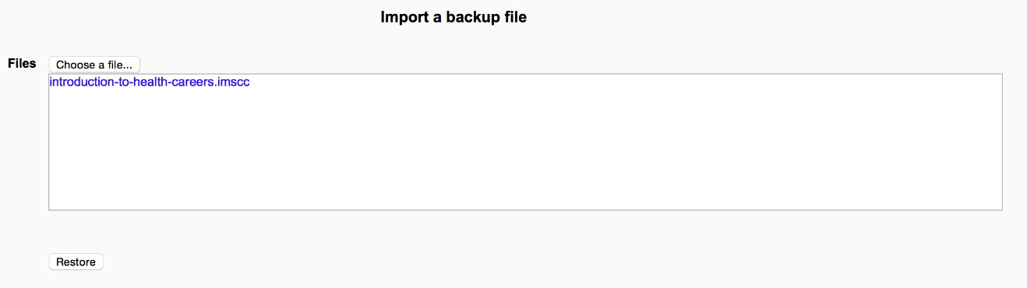

Note that Moodle can import a Moodle export or an IMS Common Cartridge (version 1.1) and will identify which kind of file was chosen automatically.

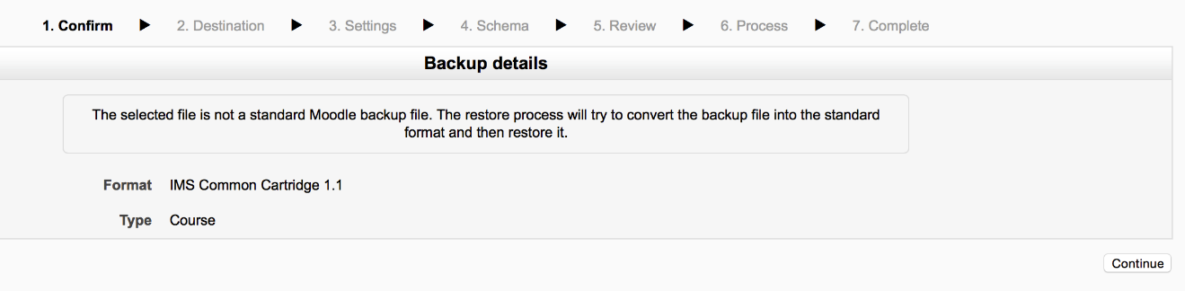

Follow the succession of screens, making choices about what content to import and whether to create a new course from it or fold the content into an existing course.

Exporting Content From Moodle
From within a course, from the course Administration menu, choose Backup. 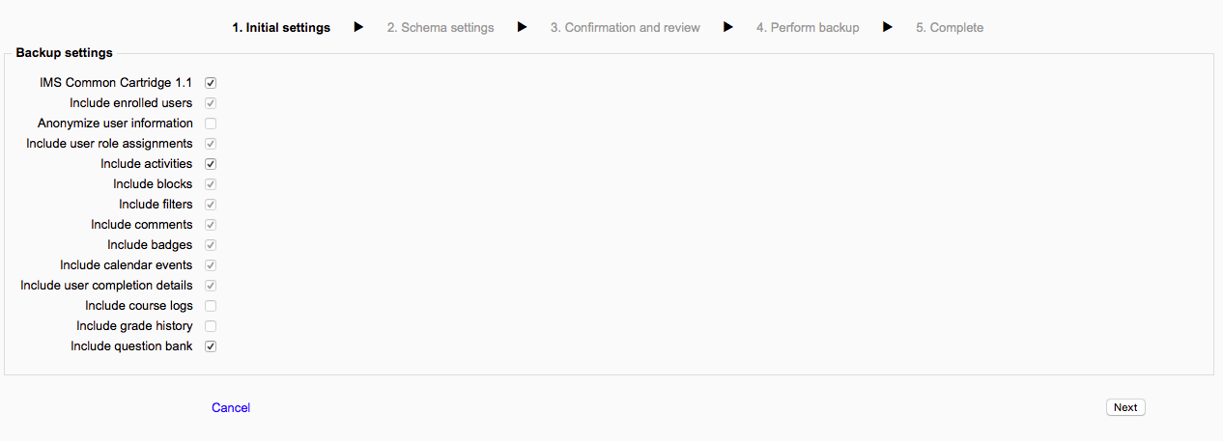

Select whether to export as a Common Cartridge or a native Moodle file. Follow the succession of screens, to complete the process.

This work is licensed under a Creative Commons Attribution 4.0 International License.
This workforce solution was created through a cooperative agreement between the U.S. Department of Labor's Employment and Training Administration and the California State University-Multimedia Educational Resource for Learning and Online Teaching (MERLOT).

