SkillsCommons User Guide - Embargo Process
What is an embargo? An embargo is a temporary access restriction placed on files attached to submissions.
This document was created to assist you in setting up embargo dates for your files. By setting an embargo date you can restrict the access to files you have uploaded that are attached to your submissions.
- Type http://skillscommons.org/ into your browser address bar.
- Click “CONTRIBUTE” located in the top menu.

- Sign in to the SkillsCommons Repository using your e-mail address and password..
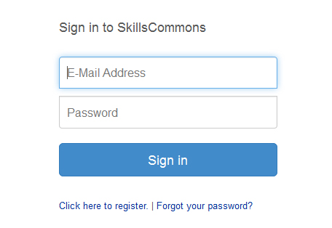
- Once you have signed in, click on the item that you wish to add the embargo date to. For our purposes we will edit the “Solar Power Quiz #1” item.
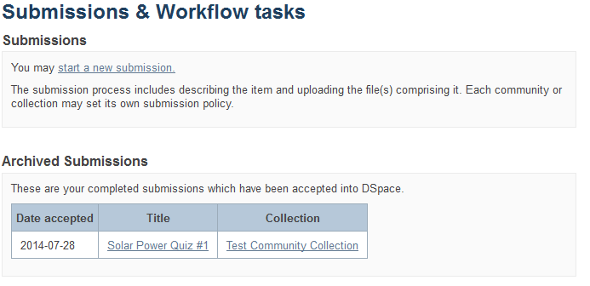
- Once on the item page click “Edit this item” in the “Context” box.
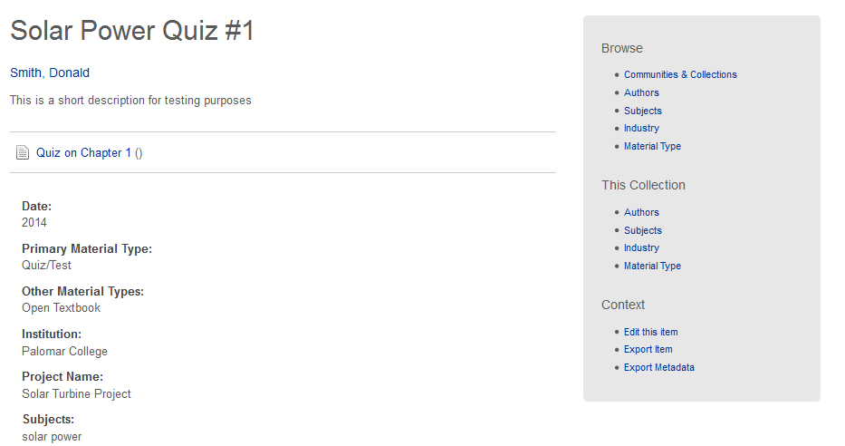
Click on “Edit this item” in the “Context” box.

- Next, click on “Item Bitstreams” to see the list of files attached to this submission.
Click on “Item Bitstreams”
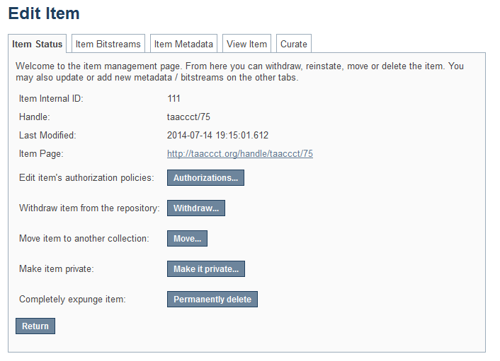

- Click on the name of the item you would like to add the embargo date to.
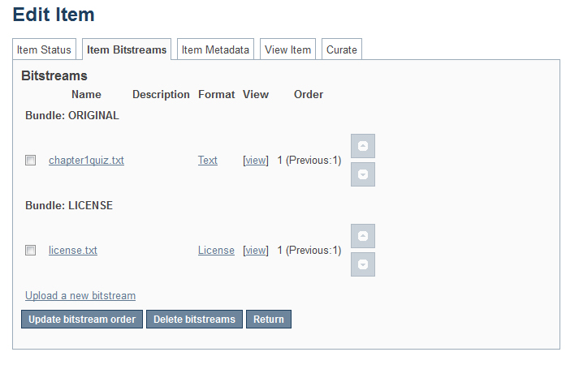
Click on the item you would like to add the embargo date to. In this case we will set an embargo date for the file “chapter1quiz.txt”

- Set your embargo date following the instructions below. Be sure to click “Save” to make sure your changes are in place.
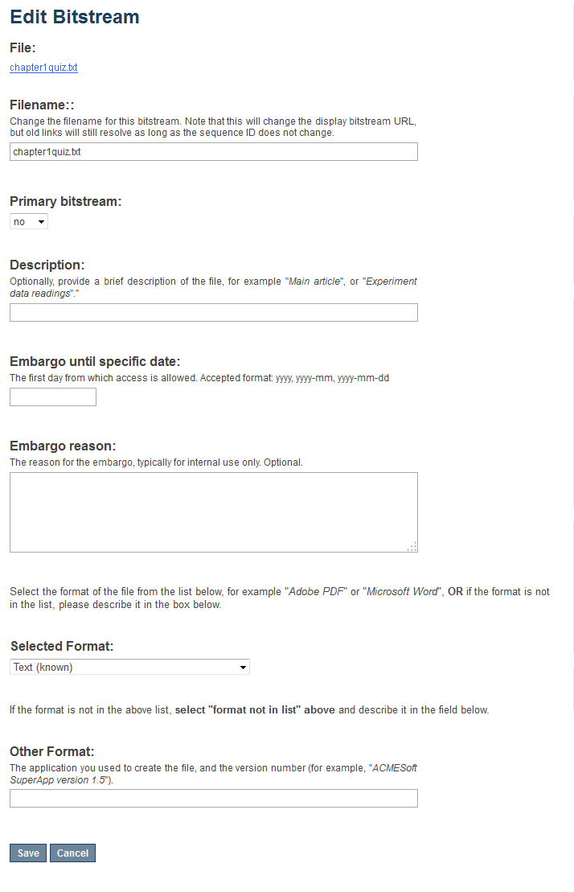
Click “Save”
Enter your embargo reason.
Click in the “Embargo until specific date” field and a calendar will pop up. Select the date that you wish to use.
- Your item has now been embargoed.
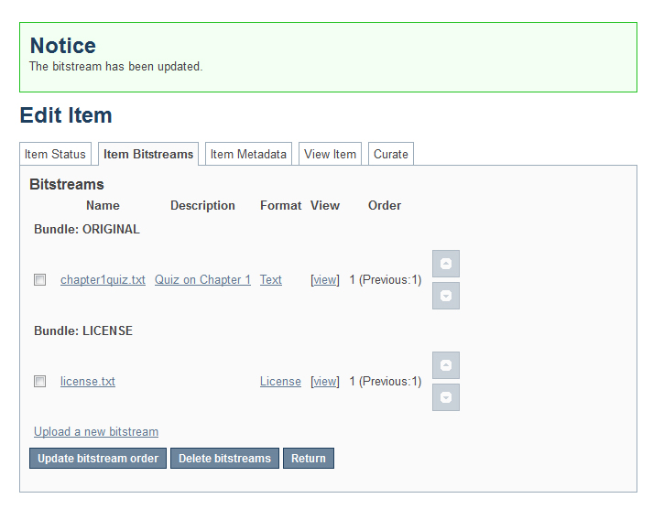

This work is licensed under a Creative Commons Attribution 4.0 International License.
This workforce solution was created through a cooperative agreement between the U.S. Department of Labor's Employment and Training Administration and the California State University-Multimedia Educational Resource for Learning and Online Teaching (MERLOT).

