SkillsCommons Repository User Guide

Deleting an Item in the Repository
- Type http://skillscommons.org/ into your browser address bar.
- Click “CONTRIBUTE” located in the top menu of the SkillsCommons Repository website.
- Sign in to the SkillsCommons (TAACCCT) Repository using your e-mail address and password.
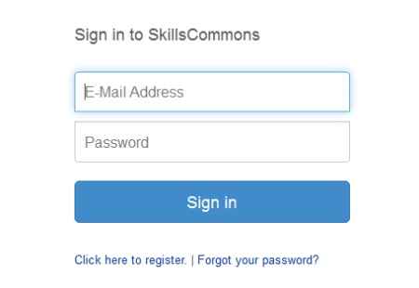
- Once you have signed in you will see your previous submissions in the “Archived Submissions” area. Click on the submission you wish to delete. For our purposes we will delete the “Solar Power Quiz #1” item.
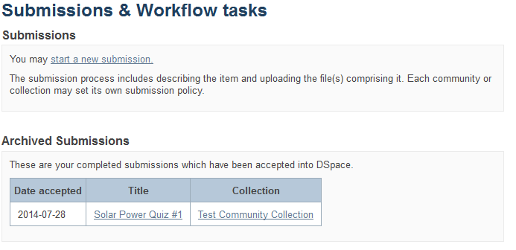
PLEASE NOTE: if there is an item you wish to delete but you are not the original creator of the item it will not show up in your Archived Submissions. To access this item please find the item in the repository and then follow the instructions beginning at step number 5 below.
- You are now on the item page. To delete this item click on “Edit this item” under the “Context” heading.
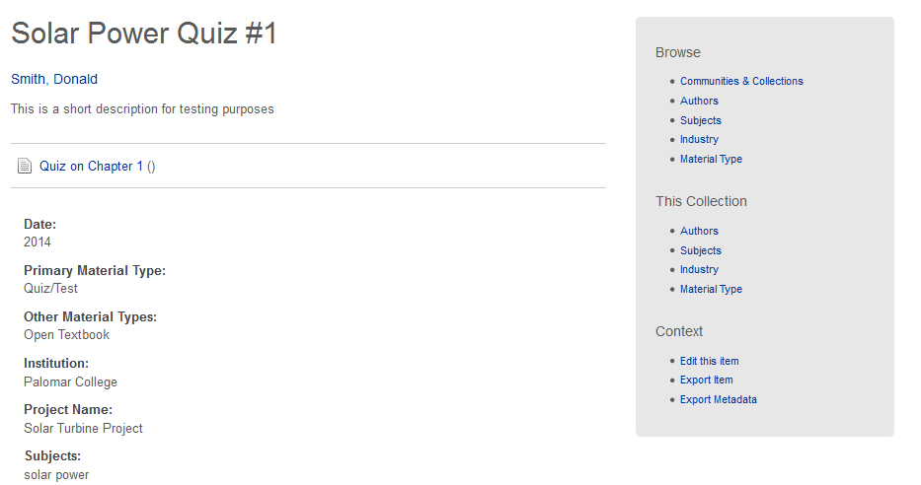
Click on “Edit this item” under the “Context” heading.
- After clicking on “Edit this item” you will be presented with the screen below. To delete this item click the “Permanently delete” button.
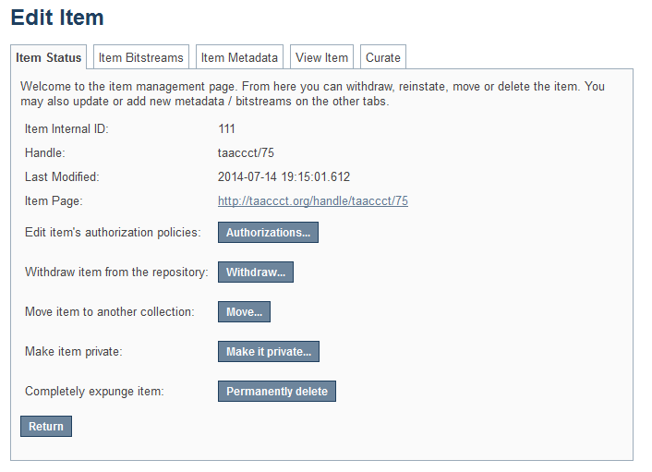
Click “Permanently delete” to remove this item from the repository.
- After clicking “Permanently delete” you will be presented with the full item record. Scroll to the bottom of the page and click “Delete” to permanently delete the item.
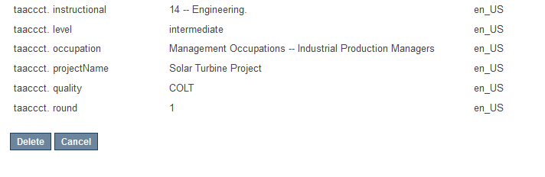
Click “Delete” to permanently delete the item. If you do not want to delete it at this time, click “Cancel”

Appendix A
Learning Resources Collection
Field Names, Metadata Names and Descriptions
http://support.skillscommons.org/home/contribute-manage/metadata-and-apprendices/appendix-a/

Appendix B
Program Support Materials Collection
Field Names, Metadata Names and Descriptions
http://support.skillscommons.org/home/contribute-manage/metadata-and-apprendices/appendix-b/

Appendix C
List of NAICS Codes
http://support.skillscommons.org/home/contribute-manage/metadata-and-apprendices/appendix-c/

Appendix D
List of SOC Codes
http://support.skillscommons.org/home/contribute-manage/metadata-and-apprendices/appendix-d/

Appendix E
List of CIP Codes
http://support.skillscommons.org/home/contribute-manage/metadata-and-apprendices/appendix-e/

This work is licensed under a Creative Commons Attribution 4.0 International License.
This workforce solution was created through a cooperative agreement between the U.S. Department of Labor's Employment and Training Administration and the California State University-Multimedia Educational Resource for Learning and Online Teaching (MERLOT).

