SkillsCommons Batch Import - Learning Resources Collection
This document was created to assist you with the batch import feature available in SkillsCommons.

What Is the Batch Import?
The Batch Import feature will allow you to make multiple submissions to the SkillsCommons repository at one time. Please note that this guide pertains to the “Learning Resources Collection” within SkillsCommons.

Why use the Batch Import?
If you have multiple submissions you may find it faster and more useful to use the Batch Import feature.

Choosing to use the Batch Import Feature
Before using the Batch Import feature we strongly encourage you to complete at least one submission using the Single Submission process. This will familiarize you with the fields, how your submission will be displayed and give you a greater understand of the repository and the submission process itself.
If you choose to use the Batch Import feature you will need to take the time to read and understand each of the fields, their metadata names and their specific requirements. Each of the fields and their requirements are outlined in this user guide.
BEFORE You Begin:
- Before using the BATCH Import feature we strongly suggest that you upload at least one submission via the Single Item Submission process.
- Read through this full guide before you start your batch submission.
- Don’t’ forget: Your first entry MUST start on Row 4
- The file names you list at the end of each row must match exactly with the files in the zip file. The field is case sensitive.

Let’s begin!

- Type http://skillscommons.org/ into your browser address bar.
- Click “batch upload” located under the “Contribute Course Materials” section on the homepage.

- Sign in using your SkillsCommons E-mail Address and Password.
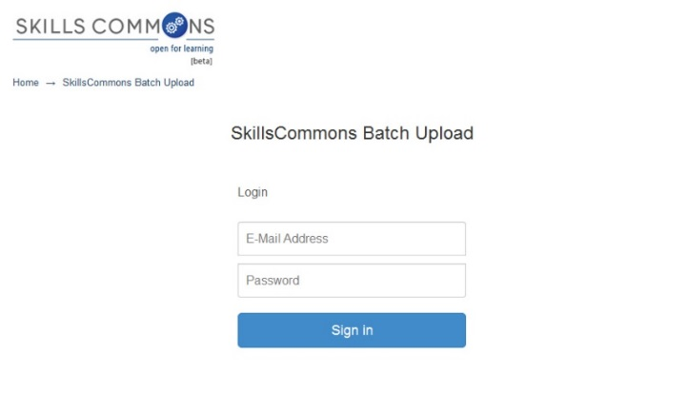
- Download the batch upload excel spreadsheet named “metadata.xlsx” and save it on your computer.
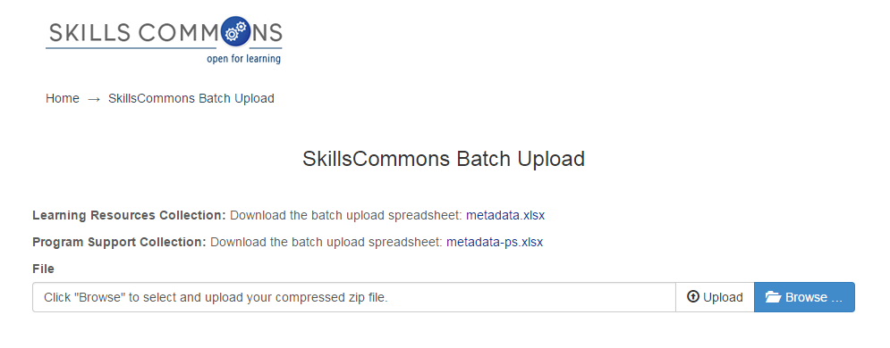
- Open the spreadsheet and fill in each cell with the appropriate data. Each submission item will have its own row. The first submission must start on Row 4. The last submission cannot exceed row 23. Rows 4 through 23 will allow for 20 batch submissions at a time. If you have more than 20 submissions please start a new batch process following these same steps.
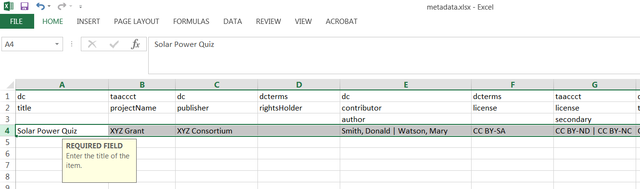
Note that when you click in each cell you will see directions specific to that cell.
Your first submission MUST start on row 4

PLEASE NOTE: The data you enter is not validated in any way. You are responsible for entering the data in the correct format.
If after reviewing this user guide you are still not sure of the correct format(s), please do NOT make changes. Contact support services at support@skillscommons.org for assistance.

REMINDERS:

- Before using the BATCH option we strongly suggest that you upload at least one submission via the Single Item Submission process
- Read through this full guide before you start your batch submission.
- Don’t’ forget: Your first entry MUST start on Row 4
- The file names you list at the end of each row must match exactly with the files in the zip file. The field is case sensitive.

Entering Your Data

Please follow the specific instructions below when entering information in each cell of the spreadsheet. Remember that your first submission must start on Row 4 and your last submission cannot go beyond Row 23.
Example | Description
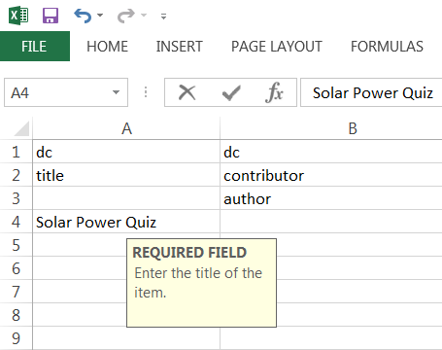 | Field Name: Title  Internal Metadata Name: dc.title  Instructions: Enter the title of the item  Required: Yes  Repeatable: No  Controlled Vocabulary: None
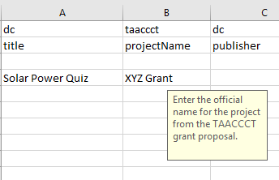 | Field Name: Project Name  Internal Metadata Name: taaccct.projectName  Instructions: Enter the name of the grant project  Required: No  Repeatable: No  Controlled Vocabulary: None
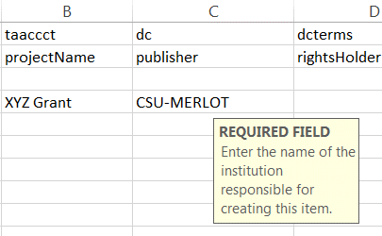 | Field Name: Grantee Institution  Internal Metadata Name: dc.publisher  Instructions: Enter the name of the institution responsible for creating this item.  Required: Yes  Repeatable: No  Controlled Vocabulary: None
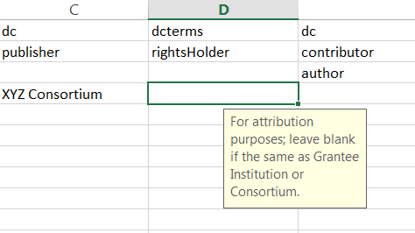 | Field Name: Copyright owner  Internal Metadata Name: dcterms.rightsHolder  Instructions: Enter the copyright owner for attribution purposes; leave blank if this is the same as Grantee Institution.  Required: No  Repeatable: No  Controlled Vocabulary: None
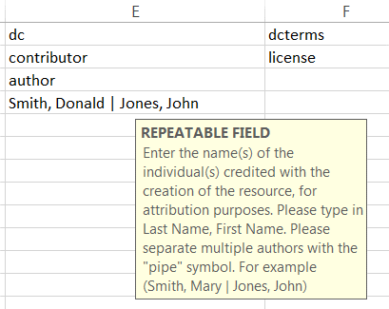 | Field Name: Authors  Internal Metadata Name: dc.contributor.author  Instructions: Enter the name(s) of the individual(s) credited with the creation of the resource, for attribution purposes.  Required: No  Repeatable: Yes - If you have multiple authors enter them separated by the pipe symbol (i.e. Smith, Donald | Watson, Mary)  Controlled Vocabulary: Yes - Enter Last Name, First name (i.e. Smith, Donald)
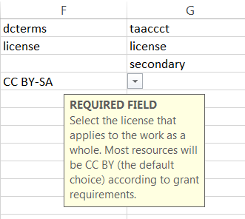 | Field Name: Primary license  Internal Metadata Name: dcterms.license  Instructions: From the drop down menu select the license that applies to the work as a whole. Most resources will be CC BY (the default choice) according to grant requirements.  Required: Yes  Repeatable: No  Controlled Vocabulary: Yes - you must choose one primary license from the dropdown menu.
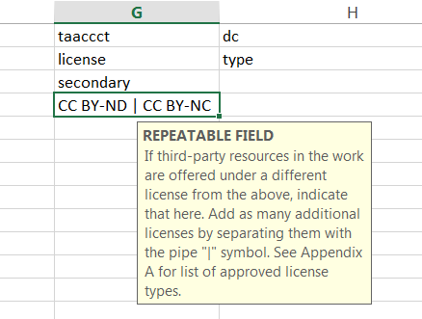 | Field Name: Additional licenses  Internal Metadata Name: taaccct.license.secondary  Instructions: If third-party resources in the work are offered under a different license from the primary license, indicate that here. Note that commercial, copyrighted works cannot be uploaded to the repository. If you have more than one license separate them with the pipe symbol (i.e. CC-BY | CC BY-SA | CC BY-ND)  Required: No Repeatable: Yes  Controlled Vocabulary: Yes - Type any of the following and separate multiple entries with a pipe symbol:  - CC BY  - CC BY-SA  - CC BY-ND  - CC BY-NC  - CC BY-NC-SA  - CC BY-NC-ND  - CC0  - Public Domain  - Other
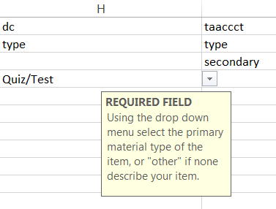 | Field Name: Primary Material Type  Internal Metadata Name: dc.type  Instructions: From the dropdown menu Select the predominant type or kind of material characterizing the learning resource, or 'Other' if none describe your item.  Required: Yes  Repeatable: No  Controlled Vocabulary: Yes - you must choose one primary license from the dropdown menu.
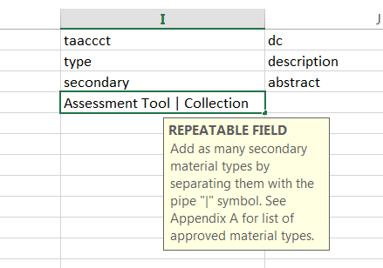 | Field Name: Secondary Material Types  Internal Metadata Name: taaccct.type.secondary  Instructions: Type in any secondary material types that describe this item. If you would like to add multiple secondary material types separate them using the pipe symbol (i.e. Animation | Assessment Tool | Assignment)  Required: No  Repeatable: Yes  Controlled Vocabulary: Yes - Type any of the following and separate multiple entries with a pipe symbol:  [Animation, Assessment Tool, Assignment, Case Study, Collection,  Development Tool, Drill and Practice, ePortfolio, Hybrid/Blended Course, Illustration/Graphic, Learning Object Repository, Online Course, Online Course Module, Open Journal-Article, Open Textbook, Photographic Image - Instructional, Presentation, Quiz/Test, Reference Material, Simulation, Social Networking Tool, Syllabus, Tutorial, Video - Instructional, Workshop and Training Material, Other]
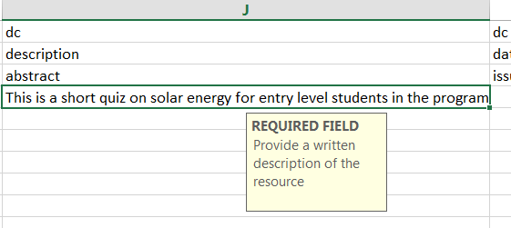 | Field Name: Description  Internal Metadata Name: dc.description.abstract  Instructions: Provide a written description of the resource.  Required: Yes  Repeatable: No  Controlled Vocabulary: None
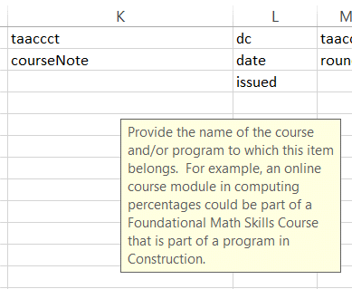 | Field Name: Course or Program Note  Internal Metadata Name: taaaccct.courseNote  Instructions: The name of the course or program to which this item belongs.  Required: No  Repeatable: No  Controlled Vocabulary: None
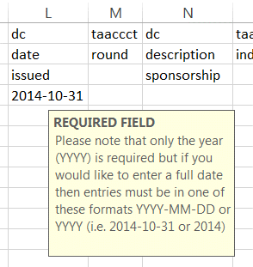 | Field Name: Date Created  Internal Metadata Name: dc.date.issued  Instructions: Please give the date the resource was created. You can leave out the day and/or month if they aren't applicable.  Required: Yes  Repeatable: No  Controlled Vocabulary: Yes - Please note that only the year (YYYY) is required but if you would like to enter a full date then entries must be in one of these formats YYYY-MM-DD or YYYY (i.e. 2014-10-31 or 2014)
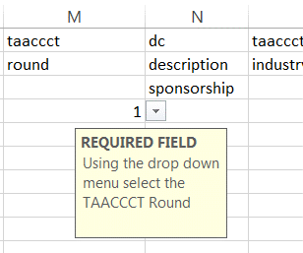 | Field Name: TAACCCT Round  Internal Metadata Name: taaccct.round  Instructions: Enter your TAACCCT round number  Required: Yes  Repeatable: No  Controlled Vocabulary: Yes - entries must be either 1, 2, 3 or 4 depending on the round of your grant.
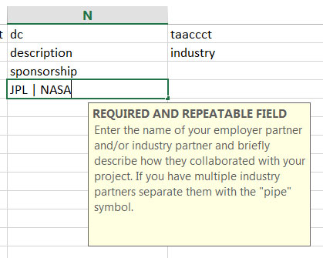 | Field Name: Industry Partner  Internal Metadata Name: dc.description.sponsorship  Instructions: Enter the name(s) of your employer partner and/or industry partner for this item, if you have one. If you have more than one industry partner enter them separated by the "pipe" symbol (i.e. NASA | NRP Partnerships | JPL )  Required: Yes  Repeatable: Yes  Controlled Vocabulary: None
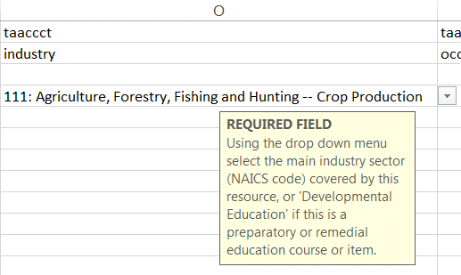 | Field Name: Industry Sector  Internal Metadata Name: taaccct.industry  Instructions: From the drop down menu select the main industry sector covered by this resource, or select 'Developmental Education' if this is a preparatory or remedial education course or item.  Required: Yes  Repeatable: No  Controlled Vocabulary: Yes - you must select an industry sector from the choices in the drop down menu.
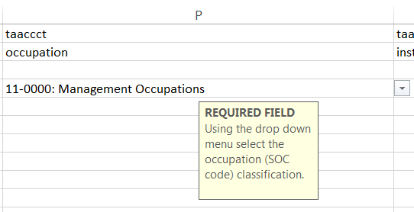 | Field Name: Occupation Classification  Internal Metadata Name: taaccct.occupation  Instructions: From the drop down menu select the occupation classification for this submission  Required: Yes  Repeatable: No  Controlled Vocabulary: Yes - you must select an occupation classification from the choices in the drop down menu.
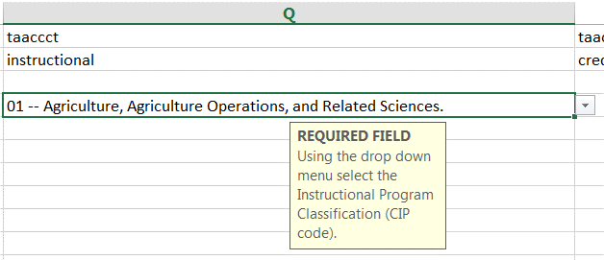 | Field Name: Instructional Program Classification  Internal Metadata Name: taaccct.instructional  Instructions: From the drop down menu select the instructional program classification for this submission.  Required: Yes  Repeatable: No  Controlled Vocabulary: Yes - you must select an instructional program classification from the choices in the drop down menu.
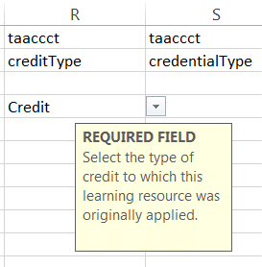 | Field Name: Credit Type  Internal Metadata Name: taaccct.creditType  Instructions: Select the type of credit to which this learning resource was originally applied.  Required: Yes  Repeatable: No  Controlled Vocabulary: Yes - you must select a credit type from the choices in the drop down menu.
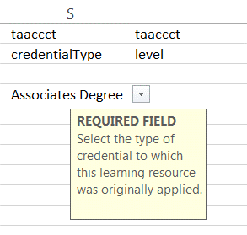 | Field Name: Credential Type  Internal Metadata Name: taaccct.credentialType  Instructions: Select the type of credential to which this learning resource was originally applied.  Required: Yes  Repeatable: Yes  Controlled Vocabulary: Yes – you must select a credential type from the choices in the drop down menu.  [Diploma, Certificate, Credential, Stacked/latticed Credential Model, Associate Degree, Bachelors Degree, Other, None]
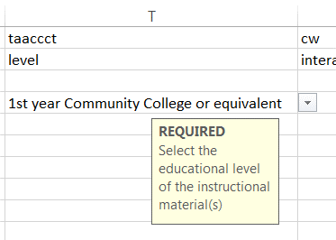 | Field Name: Level  Internal Metadata Name: taaccct.level  Instructions: Select from the drop down menu the level of the resource.  Required: Yes  Repeatable: No  Controlled Vocabulary: Yes – select one from the drop down menu.
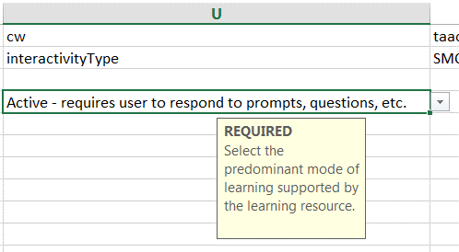 | Field Name: Interactivity type  Internal Metadata Name: cw.interactivityType  Instructions: Select the predominant mode of learning supported by the learning resource.  Required: Yes  Repeatable: No  Controlled Vocabulary: Yes – you must select from the choices in the drop down menu.
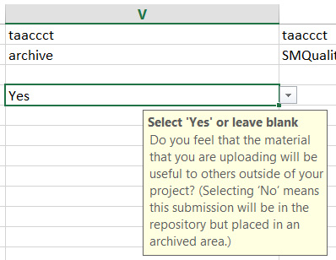 | Field Name: Likelihood of reuse  Internal Metadata Name: taaccct.archive  Instructions: Do you feel that the material that you are uploading will be useful to others outside of your project? (Selecting ‘No’ means this submission will be in the repository but placed in an archived area. The material will be accessible to users who select to include archived materials in their search results.)  Required: No  Repeatable: No  Controlled Vocabulary: None
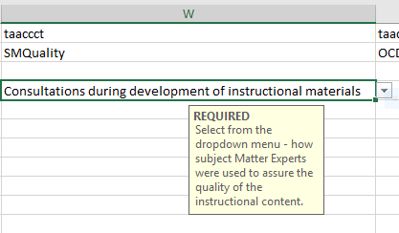 | Field Name: Quality of Subject Matter  Internal Metadata Name: taaccct.SMQuality  Instructions: Select from the drop down menu how Subject Matter Experts were used to assure the quality of the instructional content.  Required: Yes  Repeatable: No  Controlled Vocabulary: Yes – you must select from the choices in the drop down menu.
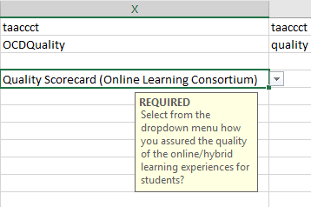 | Field Name: Quality of online/hybrid course design  Internal Metadata Name: taaccct.OCDQuality  Instructions: Select the way that your project used evaluation rubrics to assure the quality of the online/hybrid course DESIGN of the instructional materials. How did you assure that the quality of the online/hybrid learning experiences for students?  Required: Yes  Repeatable: No  Controlled Vocabulary: Yes – you must select from the choices in the drop down menu.
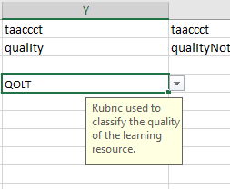 | Field Name: Quality Rubric  Internal Metadata Name: taaccct.quality  Instructions: From the drop down menu select the rubric used to measure the quality of the learning resource.  Required: No  Repeatable: No  Controlled Vocabulary: Yes - If you would like to indicate a rubric it must be selected from the choices in the drop down menu
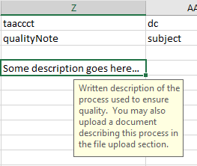 | Field Name: Quality Note  Internal Metadata Name: taaccct.qualityNote  Instructions: Enter a written description of the process used to ensure quality. You may also upload a document describing this process in the file upload section.  Required: No  Repeatable: No  Controlled Vocabulary: None
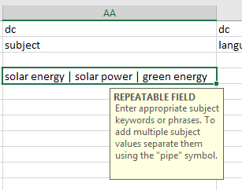 | Field Name: Subject Keywords  Internal Metadata Name: dc.subject  Instructions: Enter appropriate subject keywords or phrases separated by the "pipe" symbol (i.e. jet propulsion | rocket power | pulse-jet).  Required: No  Repeatable: Yes  Controlled Vocabulary: None
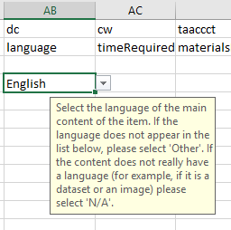 | Field Name: Language  Internal Metadata Name: dc.language  Instructions: From the drop down menu select the language of the main content of the item. If the language does not appear in the list below, please select 'Other'. If the content does not really have a language (for example, if it is a dataset or an image) please select 'N/A'.  Required: No  Repeatable: No  Controlled Vocabulary: Yes - If you are going to provide a language then it must be selected from any of the choices in the drop down menu.
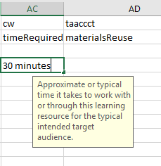 | Field Name: Time Required  Internal Metadata Name: cw.timeRequired  Instructions: Approximate or typical time it takes to work with or through this learning resource for the typical intended target audience.  Required: No  Repeatable: No  Controlled Vocabulary: None
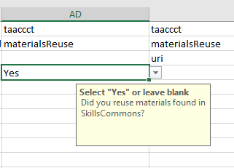 | Field Name: Reuse of SkillsCommons Materials  Internal Metadata Name: taaccct.materialsReuse  Instructions: Did you reuse materials found in SkillsCommons in the creation of this resource? Click “Yes” or leave blank.  Required: No  Repeatable: No  Controlled Vocabulary: None
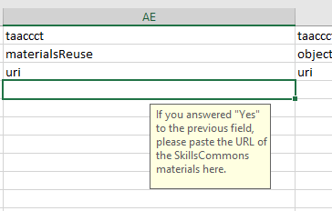 | Field Name: URL of SkillsCommons Materials  Internal Metadata Name: taaccct.materialsReuse.uri  Instructions: If you answered “yes” to the previous question, please paste the URL of the SkillsCommons materials here.  Required: No  Repeatable: No  Controlled Vocabulary: None
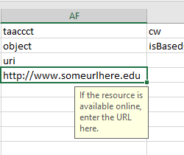 | Field Name: Additional Public Access To Materials  Internal Metadata Name: taaccct.object.uri  Instructions: If the resource is available online, enter the URL here.  Required: No  Repeatable: Yes  Controlled Vocabulary: Yes – your entry must be a valid URL
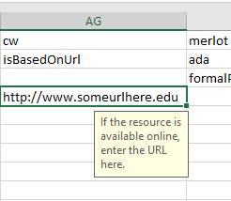 | Field Name: Derivative Work from Other’s Materials  Internal Metadata Name: cw.isBasedOnUrl  Instructions: Enter the URL(s) of the resource(s) that were used in the creation of this resource. The Based on URL can be linked to anything even a proprietary source that you are noting in the introduction of the deliverable.  Required: No  Repeatable: Yes  Controlled Vocabulary: Yes – your entry must be a valid URL
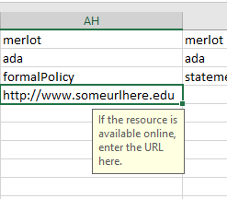 | Field Name: URL to Formal Accessibility Policy  Internal Metadata Name: merlot.ada.formalPolicy  Instructions: If your organization has a formal accessibility policy, enter the URL here.  Required: No  Repeatable: No  Controlled Vocabulary: Yes – your entry must be a valid URL
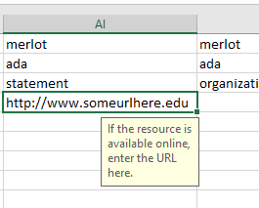 | Field Name: URL to Accessibility Statement  Internal Metadata Name: merlot.ada.statement  Instructions: If your organization has an accessibility statement, enter the URL here.  Required: No  Repeatable: No  Controlled Vocabulary: Yes – your entry must be a valid URL
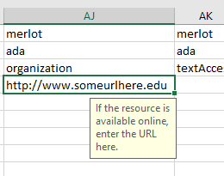 | Field Name: URL to Accessibility Evaluation Report  Internal Metadata Name: merlot.ada.organization  Instructions: If you have an Accessibility Evaluation Report for this item, enter the URL here.  Required: No  Repeatable: No  Controlled Vocabulary: Yes – your entry must be a valid URL
Follow the instructions for all remaining ADA fields.  Select “Yes” or leave blank. | Field Name: Text Access - Text to Speech  Internal Metadata Name: merlot.ada.textAccess  Instructions: Select “Yes” if the text of the digital resource is available to assistive technology that allows the user to enable text-to-speech (TTS) functionality.  Required: No  Repeatable: No  Controlled Vocabulary: Yes – You must either select "Yes" from the dropdown menu or leave blank.
Select “Yes” or leave blank. | Field Name: Text Adjust - Compatible  Internal Metadata Name: merlot.ada.textAdjustmentCompatible  Instructions: Select “Yes” if the text is compatible with assistive technology.  Required: No  Repeatable: No  Controlled Vocabulary: Yes – You must either select "Yes" from the dropdown menu or leave blank.
Select “Yes” or leave blank. | Field Name: Text Adjustment - Adjust Font and Colors  Internal Metadata Name: merlot.ada.textAdjustable  Instructions: Select “Yes” if the resource allows the user to adjust the font size and font/background color (or is rendered by an application such as a browser, media player, or reader) that offers this functionality).  Required: No  Repeatable: No  Controlled Vocabulary: Yes – You must either select "Yes" from the dropdown menu or leave blank.
Select “Yes” or leave blank. | Field Name: Reading Layout - Reflow the Text  Internal Metadata Name: merlot.ada.readingLayoutCompatible  Instructions: Select “Yes” if the text of the digital resource is compatible with assistive technology that allows the user to reflow the text by specifying the margins and line spacing (or is rendered by an application such as a browser, media player, or reader that offers this functionality).  Required: No  Repeatable: No  Controlled Vocabulary: Yes – You must either select "Yes" from the dropdown menu or leave blank.
Select “Yes” or leave blank. | Field Name: Reading Layout - Page numbers match printed material  Internal Metadata Name: merlot.ada.readingLayoutPageNumbers  Instructions: Select “Yes” if the digital resource is an electronic alternative to printed materials, the page numbers correspond to the printed material.  Required: No  Repeatable: No  Controlled Vocabulary: Yes – You must either select "Yes" from the dropdown menu or leave blank.
Select “Yes” or leave blank. | Field Name: Reading Layout – Page Number Reflow the Text  Internal Metadata Name: merlot.ada.readingLayoutPageNumbersAlt  Instructions: Select “Yes” if this correspondence is also preserved when a reflow function is enabled  Required: No  Repeatable: No  Controlled Vocabulary: Yes – You must either select "Yes" from the dropdown menu or leave blank.
Select “Yes” or leave blank. | Field Name: Reading Order - Digital resource layout  Internal Metadata Name: merlot.ada.readingOrder  Instructions: Select “Yes” if the reading order for digital resource content logically corresponds to the visual layout of the page when rendered by assistive technology.  Required: No  Repeatable: No  Controlled Vocabulary: Yes – You must either select "Yes" from the dropdown menu or leave blank.
Select “Yes” or leave blank. | Field Name: Reading Order - Digital resource layout  Internal Metadata Name: merlot.ada.readingOrder  Instructions: Select “Yes” if the reading order for digital resource content logically corresponds to the visual layout of the page when rendered by assistive technology.  Required: No  Repeatable: No  Controlled Vocabulary: Yes – You must either select "Yes" from the dropdown menu or leave blank.
Select “Yes” or leave blank. | Field Name: Structural Markup - Navigation Text  Internal Metadata Name: merlot.ada.structuralMarkupText  Instructions: Select “Yes” if the text of the digital resource includes markup (e.g. tags or styles) that allows for navigation by key structural elements (chapters, headings, pages) using assistive technology (or is rendered by an application such as a browser, media player, or reader that offers this functionality) directly to the text content that is compatible with assistive technology.  Required: No  Repeatable: No  Controlled Vocabulary: Yes – You must either select "Yes" or leave blank.
Select “Yes” or leave blank. | Field Name: Structural Markup - Lists  Internal Metadata Name: merlot.ada.structuralMarkupLists  Instructions: Select “Yes” if the text of the digital resource includes markup for bullets and numbered lists that is compatible with assistive technology (or is rendered by an application such as a browser, media player, or reader that offers this functionality).  Required: No  Repeatable: No  Controlled Vocabulary: Yes – You must either select "Yes" from the dropdown menu or leave blank.
Select “Yes” or leave blank. | Field Name: Structural Markup - eReader application  Internal Metadata Name: merlot.ada.structuralMarkupReaders  Instructions: Select “Yes” if the text of the digital resource is delivered within an ebook reader application, a method is provided that allows users to bypass the reader interface and move directly to the text content that is compatible with assistive technology.  Required: No  Repeatable: No  Controlled Vocabulary: Yes – You must either select "Yes" from the dropdown menu or leave blank.
Select “Yes” or leave blank. | Field Name: Table Markup  Internal Metadata Name: merlot.ada.tableMarkup  Instructions: Select “Yes” if the data tables include markup (e.g. tags or styles) that identifies row and column headers in a manner that is compatible with assistive technology (or are rendered by an application such as a browser, media player, or reader that offers this functionality).  Required: No  Repeatable: No  Controlled Vocabulary: Yes – You must either select "Yes" from the dropdown menu or leave blank.
Select “Yes” or leave blank. | Field Name: Hyperlinks  Internal Metadata Name: merlot.ada.hyperlinkActive  Instructions: Select “Yes” if the URLs (website or email addresses) within the text of the digital resource are rendered as active hyperlinks allowing them to be detected and activated with assistive technology (or are rendered by an application that offers this functionality).  Required: No  Repeatable: No  Controlled Vocabulary: Yes – You must either select "Yes" from the dropdown menu or leave blank.
Select “Yes” or leave blank. | Field Name: Color  Internal Metadata Name: merlot.ada.color  Instructions: Select “Yes” if all information within the digital resource that is conveyed using color is also available in a manner that is compatible with assistive technology. Required: No  Repeatable: No  Controlled Vocabulary: Yes – You must either select "Yes" from the dropdown menu or leave blank.
Select “Yes” or leave blank. | Field Name: Color  Internal Metadata Name: merlot.ada.color  Instructions: Select “Yes” if all information within the digital resource that is conveyed using color is also available in a manner that is compatible with assistive technology. For example, when a table contains negative values, these values should be conveyed with a leading ‘minus’ character in addition to (or instead of) formatting them in red.  Required: No  Repeatable: No  Controlled Vocabulary: Yes – You must either select "Yes" from the dropdown menu or leave blank.
Select “Yes” or leave blank. | Field Name: Contrast  Internal Metadata Name: merlot.ada.contrast  Instructions: Select “Yes” if the visual presentation of text and images of text in the digital resource has a contrast ratio of at least 4.5:1.  Required: No  Repeatable: No  Controlled Vocabulary: Yes – You must either select "Yes" from the dropdown menu or leave blank.
Select “Yes” or leave blank. | Field Name: Language - Markup  Internal Metadata Name: merlot.ada.languageMarkup  Instructions: Select “Yes” if the text of the digital resource includes markup that declares the language of the content in a manner that is compatible with assistive technology.  Required: No  Repeatable: No  Controlled Vocabulary: Yes – You must either select "Yes" from the dropdown menu or leave blank.
Select “Yes” or leave blank. | Field Name: Language - Passage markup  Internal Metadata Name: merlot.ada.languageMarkupAlt  Instructions: Select “Yes” if the digital resource includes passages in a foreign language, these passages include markup that declares the language in a manner that is compatible with assistive technology.  Required: No  Repeatable: No  Controlled Vocabulary: Yes – You must either select "Yes" from the dropdown menu or leave blank.
Select “Yes” or leave blank. | Field Name: Images - Non-Decorative  Internal Metadata Name: merlot.ada.imageAltText  Instructions: Select “Yes” if Non-decorative images have alternative text that is compatible with assistive technology (or is rendered by an application such as a browser, media player, or reader that offers this functionality).  Required: No  Repeatable: No  Controlled Vocabulary: Yes – You must either select "Yes" from the dropdown menu or leave blank.
Select “Yes” or leave blank. | Field Name: Images - Decorative  Internal Metadata Name: merlot.ada.decorativeImages  Instructions: Select “Yes” if decorative images are marked with null alternate text or contain markup that allows them to be ignored by assistive technology.  Required: No  Repeatable: No  Controlled Vocabulary: Yes – You must either select "Yes" from the dropdown menu or leave blank.
Select “Yes” or leave blank. | Field Name: Images - Complex  Internal Metadata Name: merlot.ada.complextImageText  Instructions: Select “Yes” if complex images, charts, and graphs have longer text descriptions that are compatible with assistive technology (or are rendered by an application such as a browser, media player, or reader) that offers this functionality).  Required: No  Repeatable: No  Controlled Vocabulary: Yes – You must either select "Yes" from the dropdown menu or leave blank.
Select “Yes” or leave blank. | Field Name: Multimedia - Text track  Internal Metadata Name: merlot.ada.multimediaTextTrack  Instructions: Select “Yes” if a synchronized text track (e.g. open or closed captions) is provided with all video content.  Required: No  Repeatable: No  Controlled Vocabulary: Yes – You must either select "Yes" from the dropdown menu or leave blank.  Field Name: Multimedia - Transcript  Internal Metadata Name: merlot.ada.multimediaTranscript  Instructions: A transcript is provided with all audio content.  Required: No  Repeatable: No  Controlled Vocabulary: Yes – You must either select "Yes" from the dropdown menu or leave blank.
Select “Yes” or leave blank. | Field Name: Multimedia - Assistive player  Internal Metadata Name: merlot.ada.multimediaTranscript  Instructions: Select “Yes” if audio/video content is delivered via a media player that is compatible with assistive technology. This includes support for all criteria listed in Section 15 below.  Required: No  Repeatable: No  Controlled Vocabulary: Yes – You must either select "Yes" from the dropdown menu or leave blank.
Select “Yes” or leave blank. | Field Name: Non flickering content  Internal Metadata Name: merlot.ada.stemMarkup  Instructions: Select “Yes” if the digital resource content does not contain anything that flashes more than three times in any one-second period.  Required: No  Repeatable: No  Controlled Vocabulary: Yes – You must either select "Yes" from the dropdown menu or leave blank.
Select “Yes” or leave blank. | Field Name: STEM - Markup  Internal Metadata Name: merlot.ada.noFlickering  Instructions: Select “Yes” if the STEM content (e.g. Mathematics, Chemistry) is marked up in a manner that is compatible with assistive technology (or is rendered by an application such as a browser, media player, or reader that offers this functionality).  Required: No  Repeatable: No  Controlled Vocabulary: Yes – You must either select "Yes" from the dropdown menu or leave blank.
Select “Yes” or leave blank. | Field Name: STEM - Notation markup Internal  Metadata Name: merlot.ada.stemNotationMarkup  Instructions: Select “Yes” if the resource conveys both the notation (presentation) and meaning (semantics) of the STEM content.  Required: No  Repeatable: No  Controlled Vocabulary: Yes – You must either select "Yes" from the dropdown menu or leave blank.
Select “Yes” or leave blank. | Field Name: Interactive - Keyboard  Metadata Name: merlot.ada.keyboardInteractive  Instructions: Select “Yes” if each interactive element (e.g. menu, hyperlink, button) and function (e.g. annotations) allows keyboard-only operation both with and without assistive technology.  Required: No  Repeatable: No  Controlled Vocabulary: Yes – You must either select "Yes" from the dropdown menu or leave blank.
Select “Yes” or leave blank. | Field Name: Interactive - Markup  Metadata Name: merlot.ada.interactiveMarkup  Instructions: Select “Yes” if each interactive element conveys information to assistive technology regarding the element’s name, type, and status (e.g. “Play, button, selected”).  Required: No  Repeatable: No  Controlled Vocabulary: Yes – You must either select "Yes" from the dropdown menu or leave blank.
Select “Yes” or leave blank. | Field Name: Interactive - Text prompts  Metadata Name: merlot.ada.interactivePromptText  Instructions: Select “Yes” if all instructions, prompts, and error messages necessary to complete forms are conveyed as text to assistive technology (or are rendered by an application such as a browser, media player, or reader that offers this functionality).  Required: No  Repeatable: No  Controlled Vocabulary: Yes – You must either select "Yes" from the dropdown menu or leave blank.
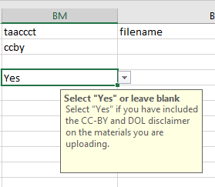 | Field Name: CC-BY License and DOL Disclaimer Requirement  Metadata Name: taaccct.ccby  Instructions: I have included the CC-BY license and DOL disclaimer on the materials I am uploading. Select “Yes” or leave blank  Required: No  Repeatable: No  Controlled Vocabulary: Yes – You must either select "Yes" from the dropdown menu or leave blank.

- After entering your data into Columns A through BM you will have the opportunity to add the file names that are associated with each submission. You will also need to provide your taaccct handle so that the submissions and the files get uploaded to your community and collection.
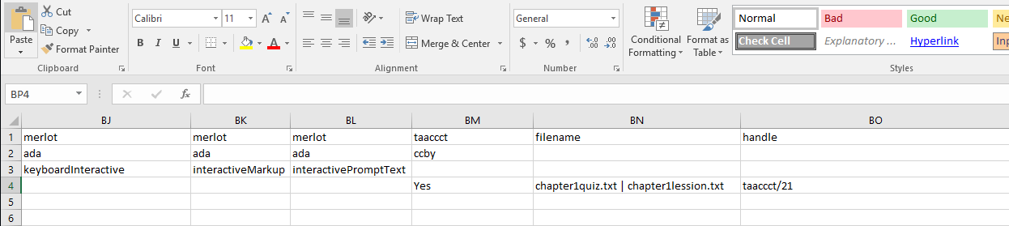
Enter the file name(s) here. Separate file names with a pipe symbol. The file names must match EXACTLY to the files you are uploading.
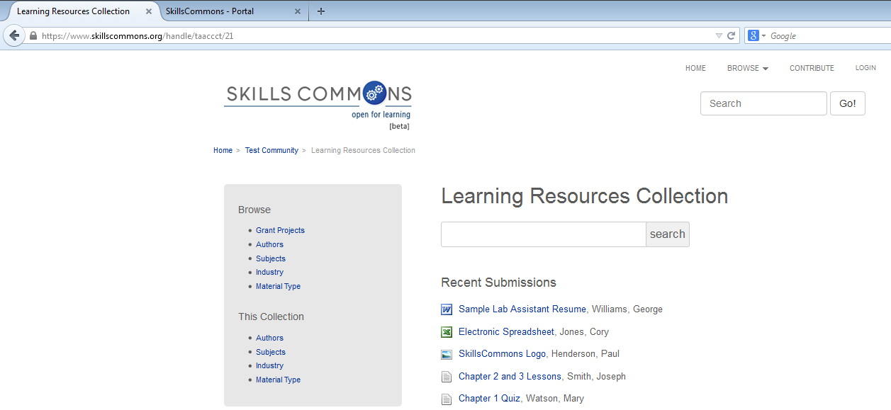
Enter the taaccct collection handle here. Your taaccct collection handle can be found at the end of your collections URL.
In this example the taaccct collection handle is “taaccct/21”
NOTE: Do not put the full URL, only the taaccct handle.
NOTE: Be sure this is your COLLECTION handle and not your Grant Project Community handle.
- Save your metadata.xlsx file.
- Create a zip file folder.
- Place the metadata.xlsx (it MUST be named metadata.xlsx) file and all associated files in this zip folder.
- Go back to the Batch Upload page and browse and upload your zip file.
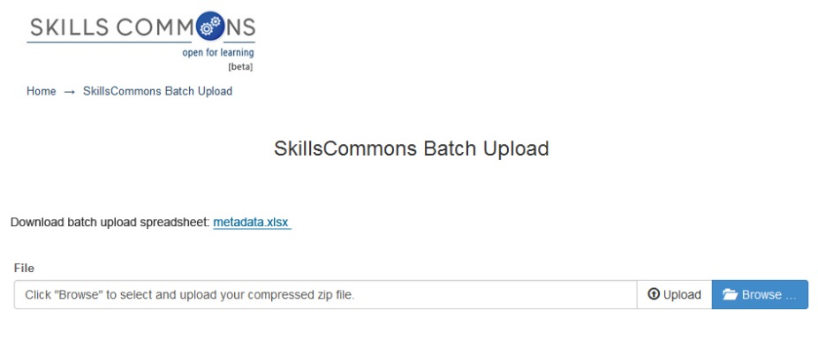
- After clicking “Upload” you will then see the Upload Status screen. This screen will show you the submissions from your metadata.xlsx. Click the “Process All Files” button to continue.
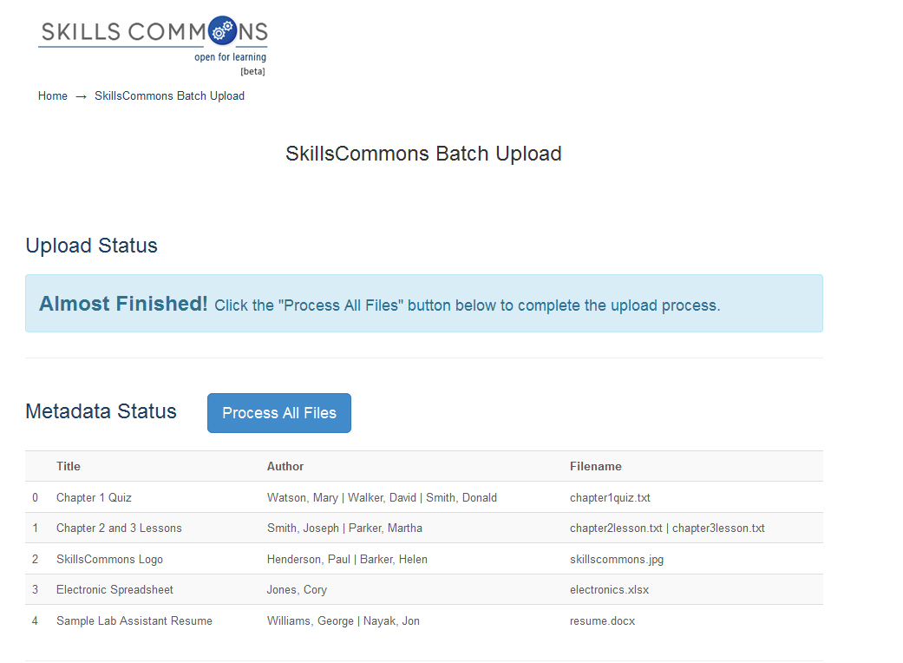
Click “Process All Files” button.
- Your files will be fully processed when you see the “Process Status” list show up at the bottom of the page.
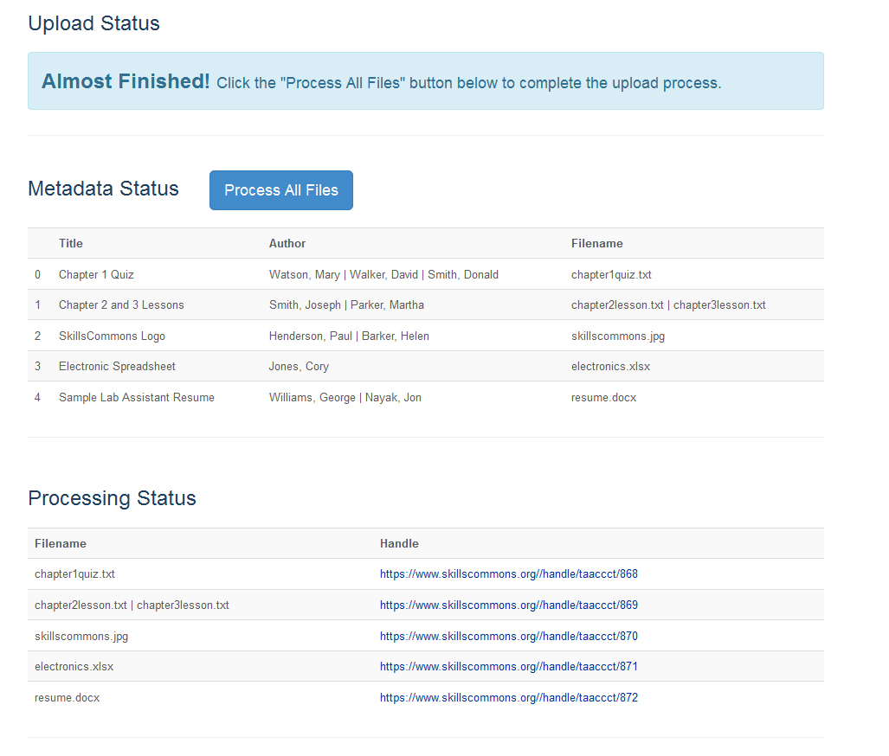
To EDIT or DELETE Submissions please visit the Contribute & Manage Materials page at:
http://support.taaccct.org/contribute-materials/
You will know that your submissions and files have been processed successfully when you see them listed in the Processing Status section.
By clicking on each link you will be taken to each submission.

Appendix A
Learning Resources Collection
Field Names, Metadata Names and Descriptions
http://support.skillscommons.org/home/contribute-manage/metadata-and-apprendices/appendix-a/

Appendix B
Program Support Materials Collection
Field Names, Metadata Names and Descriptions
http://support.skillscommons.org/home/contribute-manage/metadata-and-apprendices/appendix-b/

Appendix C
List of NAICS Codes
http://support.skillscommons.org/home/contribute-manage/metadata-and-apprendices/appendix-c/

Appendix D
List of SOC Codes
http://support.skillscommons.org/home/contribute-manage/metadata-and-apprendices/appendix-d/

Appendix E
List of CIP Codes
http://support.skillscommons.org/home/contribute-manage/metadata-and-apprendices/appendix-e/

This work is licensed under a Creative Commons Attribution 4.0 International License.
This workforce solution was created through a cooperative agreement between the U.S. Department of Labor's Employment and Training Administration and the California State University-Multimedia Educational Resource for Learning and Online Teaching (MERLOT).

