Adding a Creative Commons License to a Learning Management System Course
All submissions to Skills Commons (www.skillscommons.org) should contain a Creative Commons license (www.creativecommons.org).
General guidelines on how to mark content with a license can be found here on their website https://wiki.creativecommons.org/Marking/Users.
For the specific case of a course export from a Learning Management System (LMS) such as Blackboard Learn, Canvas by Instructure, Desire2Learn, etc, you should add a content item to the course. This item, which becomes part of the course, will be included in the export and will be imported by anyone adopting the materials out of the Skills Commons repository.
In the LMS course, create a content item with the following HTML.
<p><a rel="license" href="http://creativecommons.org/licenses/by/4.0/" target="_blank"><img alt="Creative Commons License" style="border-width: 0;" src="https://i.creativecommons.org/l/by/4.0/88x31.png" /></a><br /><br />This work is licensed under a <a rel="license" href="http://creativecommons.org/licenses/by/4.0/" target="_blank">Creative Commons Attribution 4.0 International License</a>.</p>
The method for adding a content item varies by LMS, but the item will look something like this:
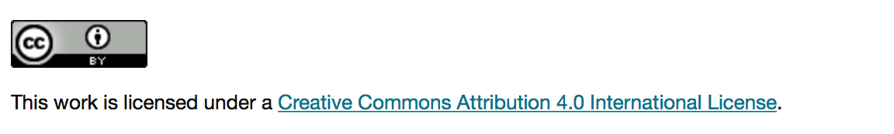
Note that your LMS may offer additional ways to add licensing information to the course metadata.

This work is licensed under a Creative Commons Attribution 4.0 International License.
This workforce product was funded by a grant awarded by the U.S. Department of Labor’s Employment and Training Administration. The product was created by the California State University, Office of the Chancellor/MERLOT and does not necessarily reflect the official position of the U.S. Department of Labor. The U.S. Department of Labor makes no guarantees, warranties, or assurances of any kind, express or implied, with respect to such information, including any information on linked sites and including, but not limited to, accuracy of the information or its completeness, timeliness, usefulness, adequacy, continued availability, or ownership.

